Textbook Rental Shipping Label Instructions:

Summer Rentals Are Due Back: Monday, August 10th
At The Campus You Rented From

Go to www.nvcc.bncollege.com and choose the campus you rented your book at. Remember if your books were for an ELI course you must click on the ELI link, not the Alexandria link if you rented via the ELI site.
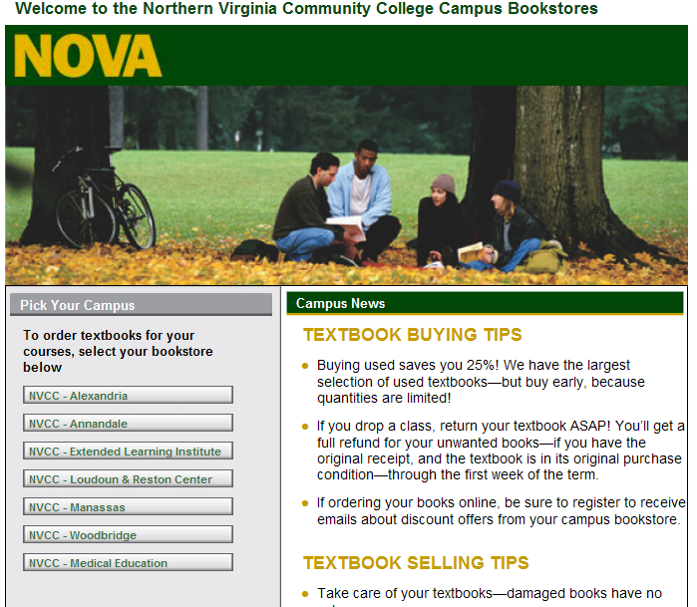

Once you have selected your campus a new window will open, at that window scroll down all the way to the bottom. Under Textbooks click on Textbook Rentals:
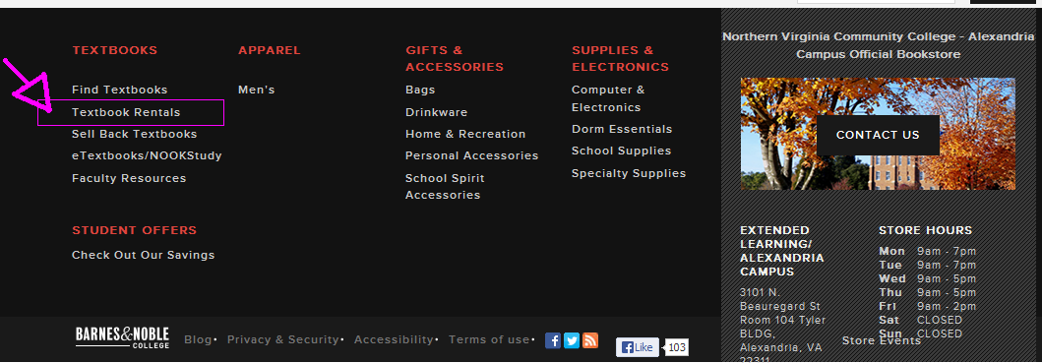

After clicking on Textbook Rentals a new screen will open, scroll down mid way and click on Rental Return.
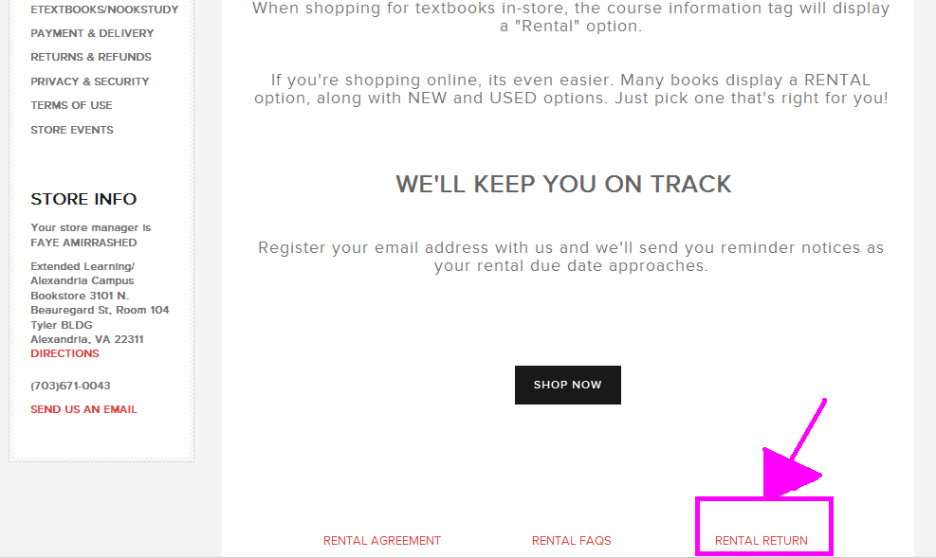

Once you click on Rental Return a new screen will pop up, at that screen you will enter your order number and e-mail address you used to rent your textbook. If you don’t know your order number please e-mail us at SM650@BNCOLLEGE.COM with ALL of the following information:
The full name, e-mail address, and phone number used when renting the book. Also state if your book was for an Alexandria on campus course or if it was for an ELI course. We will respond within 24 business hours.

WARNING: Once you start the process you must be able to print your shipping label at that time, as the shipping label will not generate a second time.
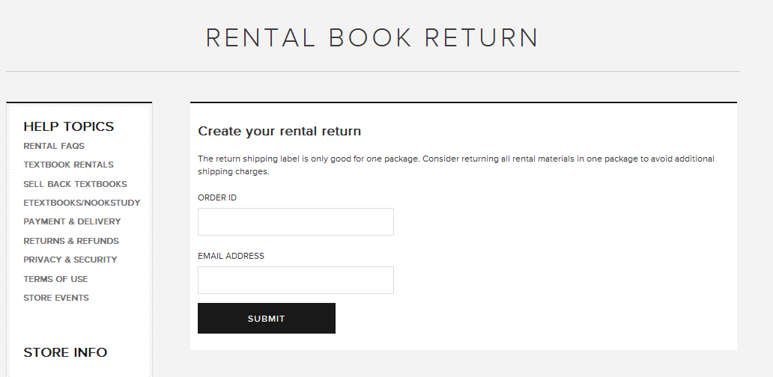

The website will walk you through the rest of the steps.
If for whatever reason you choose not to use our pre-paid shipping label and would like to ship your rentals on your own please make sure you send it to the following address:

Barnes & Noble #650
Attn: Rental Check In / Tyler BLDG
4925 East Campus Drive
Alexandria, VA 22311

Also make sure you include a note that states that you’re checking in a rental, along with the full name, phone number, and e-mail address used when you rented the book. If possible also include your order number.

Please keep in mind all shipped rental check-ins must be shipped on or before August 10, 2015. Postmark should be no later than August 10, 2015.

Send rental check-ins via prepaid shipping. The Bookstore will not accept packages via COD. We are not responsible for lost packages. Therefore, we highly recommend that you insure any mailed packages. Also you may want to use mailing services that provide tracking numbers. Please keep in mind that USPS does not deliver directly to the Bookstore, they drop it off at NOVA’s mail room, which is NOT proof of delivery to the Bookstore.

