Calculate Anticipated Aid Based on Actual Enrollment

- Log in to NOVAConnect by clicking on myNOVA on the NOVA home page.
- Click on VCCS SIS: Student Information System.
- Click on Self Service.
- Click on Student Center.

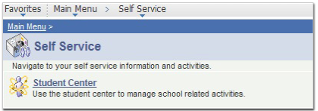
- Under My Account, click on the Account Inquiry link.
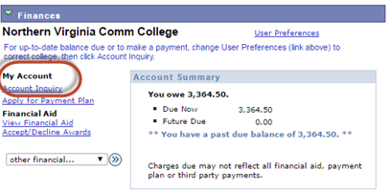

- Click the pushbutton to calculate the pending Financial Aid based on actual enrollment.
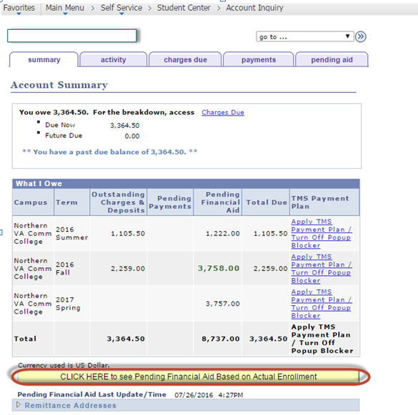
Important Notes:
- Regardless whether or not the Pending Financial Aid awards amount is enough to cover tuition account balance, the Total Due amount for the involved term will show until the Financial Aid awards are disbursed and posted to student’s account.
- Classes that don’t apply to program of study (major) are not eligible for financial aid and are not included in the Pending Financial Aid calculation.

