View Financial Aid Ineligible Classes
- Log in to NOVAConnect by clicking on myNOVA on the NOVA home page.
- Click on VCCS SIS: Student Information System.
- Click on Self Service.
- Click on Student Center.
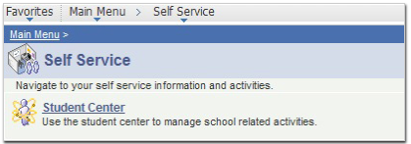

- Under the Finances section, click on the View Financial Aid link.

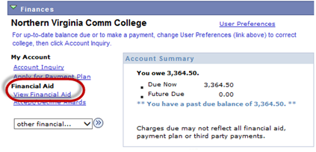
- Click on the desired aid year to view your financial aid awards

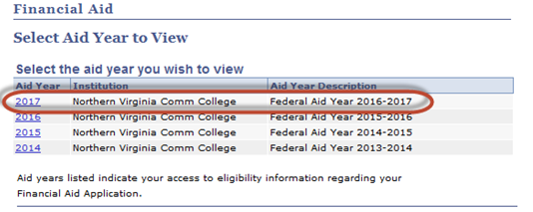

- Scroll down to the involved Term and click on the View Course Eligibility link.

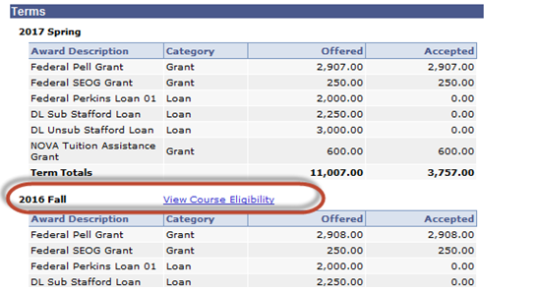

- The FA Course Eligibility page displays as demonstrated below:

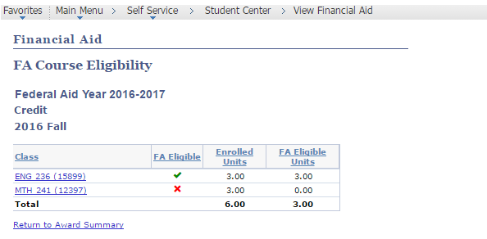
- Eligible courses will be marked with
- Ineligible courses will be marked with
- Courses that have not yet been evaluated by the Financial Aid Course Audit process (which is generally run nightly) will be marked with

