View messages in Message Center
- Log in to NOVAConnect by clicking on myNOVA on the NOVA home page.
- Click on VCCS SIS: Student Information System.
- Click on Self Service.
- Click on Student Center.
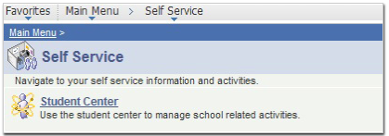

- Click on the Message Center link.

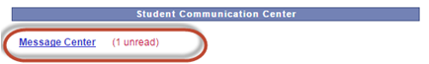

- Click on the message hyperlink to view the message.

