Calculate Anticipated Aid Based on Actual Enrollment

Why Should I Review My Anticipated Financial Aid?
If you are awarded Financial Aid before the semester begins, your award will be based on anticipated full-time enrollment in at least 12 credits. If you choose to enroll in less than 12 credit hours, your Financial Aid award may be adjusted. Please follow the steps below to learn how to view award adjustments based on actual enrollment.

Log in to Your MyNOVA Account to View the Anticipated Financial Aid

Step 1: Log in to NOVA Connect by clicking on MyNOVA on the NOVA home page: www.nvcc.edu
Step 2: Click on VCCS SIS: Student Information System
- Click on Self Service
- Click on Student Center
- Scroll down to the Finances tab and click on Account Inquiry
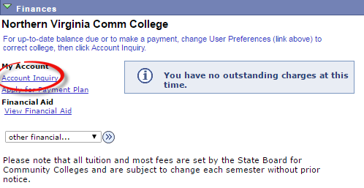

Step 3: Click the yellow button that reads, “CLICK HERE to see Pending Financial Aid Based on Actual Enrollment”
