Complete the Online Verification Process

What is the Online Verification Process?
Verification is the Federal requirement that schools must verify certain information included on the Free Application for Federal Student Aid (FAFSA) before a student can potentially be awarded financial aid. Students who have been chosen for verification will have a FAS Online Verification checklist item placed on their MyNOVA To-Do List. An email with the FAS Online Verification login information will be sent once the verification process is available to the email address listed on the student’s FAFSA. If you have other checklist items listed on your MyNOVA To-Do List, you will need to complete those checklist items prior to receiving the login instructions for your FAS Online Verification.

Log in to the School Servicing Center to Complete Verification

Step 1: Go to the School Servicing Center website: www.sscwp.org
Step 2: Click on the Students tab to log in
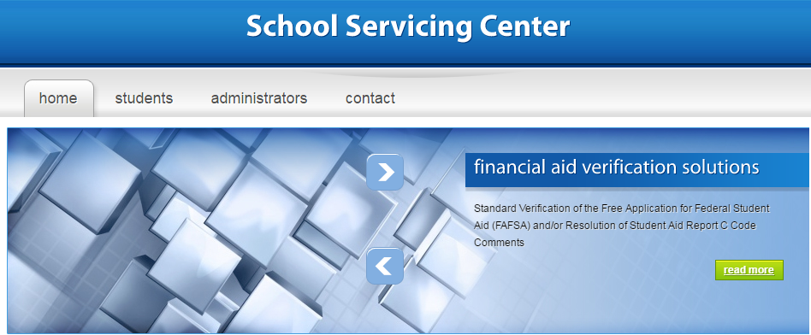

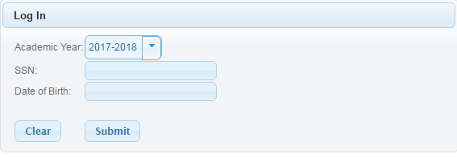
Step 3: Select the correct academic year and use your social security number and date of birth to login.
Step 4: Review the “Information Needed from You” tab. Complete the “Online Verification.”
Step 5: Once the FAS Online Verification is complete, log in to your email account to open the E-Signature email from the School Servicing Center. Use the FAS PIN (6-digit number created by the student) to electronically sign the PDF attachment. For dependent students, one of your parents must also open the PDF through his or her email and use the FAS PIN to electronically sign. Remember to upload or fax requested information. Check back regularly for additional documentation and interview requests. Allow 3-5 days for processing.

