Create an FSA ID

What is the FSA ID?
An FSA ID is a username and password that you must use to log in to certain U.S. Department of Education (ED) websites. Your FSA ID identifies you as someone who has the right to access your own personal information on ED websites such as the Free Application for Federal Student Aid (FAFSA®) at https://fafsa.ed.gov.

Does a Parent Need an FSA ID?
If you are a parent of a dependent student, you will need your own FSA ID to sign your child's FAFSA electronically. If you have more than one child attending college, you can use the same FSA ID to sign all applications. Please note: Each FSA ID user must have a unique e-mail address. The student should not create an FSA ID on her parent’s behalf, and a parent should not create an FSA ID the student’s behalf.

Dependent Student: A student who does not meet any of the criteria for an independent student. An independent student is one of the following: at least 24 years old, married, a graduate or professional student, someone on active duty in the U.S. Armed Forces for purposes other than training, a U.S. Armed Forces veteran, someone who provides more than 50% of the support for their children or dependents who live with them, someone who was an orphan or a ward of the court or in foster care after turning age 13, an emancipated minor, someone with a court-appointed legal guardian, or someone who is homeless or at risk of becoming homeless. More details are provided on the FAFSA.

How Can I Create an FSA ID? | How Can I Reset My FSA ID Password?
If you do not have an FSA ID, visit https://FSAID.ed.gov and click “Create an FSA ID” | If you already have an FSA ID, but you forgot your password:  - Visit https://FSAID.ed.gov  - Then click “Forgot My Password”
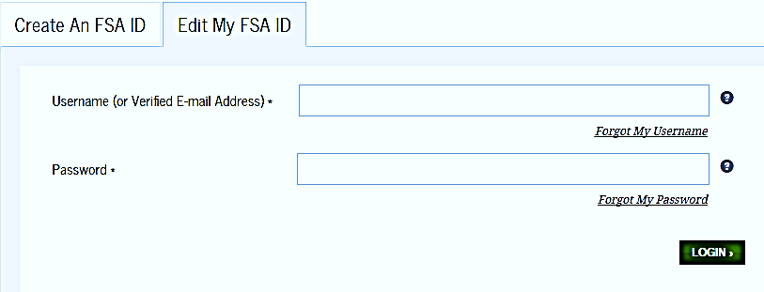

The Federal Student Aid Information Center can help.
Visit https://studentaidhelp.ed.gov/ to send a message or ask a live agent your questions via a web chat.

