Accept Loans, Complete Entrance Counseling and Submit Master Promissory Note

How Do I Accept Financial Aid Loans Online?
Only borrow what you need and can afford to repay. When you visit the Accept/Decline Awards link on your MyNOVA account, you have the option to edit the loan amount before you accept your loan(s). The subsidized loan will not collect interest until 6 months after you leave school, graduate, or drop down to less than half-time enrollment. The unsubsidized loan will begin collecting interest as soon as it is disbursed.

Step 1: Log in to NOVA Connect by clicking on MyNOVA on the NOVA home page: www.nvcc.edu
Step 2: Click on VCCS SIS: Student Information System
- Click on Self Service
- Click on Student Center
- Scroll down to the Finances tab and click on Accept/Decline Awards

How Do I Complete the Entrance Counseling and Master Promissory Note?

To receive the loan(s) you have accepted, you will need to complete the Direct Loan Entrance Counseling and the Direct Loan Master Promissory Note. Entrance Counseling is a resource that can help you learn about managing finances and understanding the debt you assume when you accept student loans. The Master Promissory Note is your agreement to repay the student loans that you borrow.

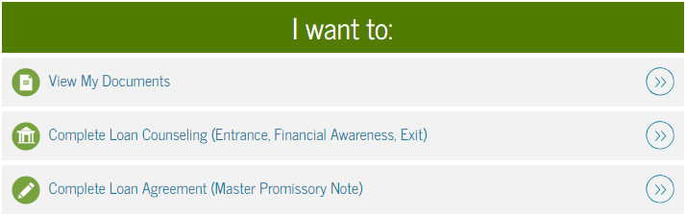
Step 1: To complete the Entrance Counseling and Master Promissory Note go to https://studentloans.gov. You will log in with your FSA ID and update your communication preferences. If you do not know or do not have your FSA ID go to: https://fsaid.ed.gov/.

Step 2: The Main Menu page will appear after you log in and update your communication preferences. When you select your communication preferences, you should use contact information that will remain active for years to come. Use an email address that you will continue to use after you finish school. Consider using the text option if you do not check your email often.

Accept Loans, Complete Entrance Counseling and Submit Master Promissory Note

Step 3: Click “Complete Loan Counseling” to complete your Entrance Counseling. Entrance Counseling can take 30 to 60 minutes to complete. You should complete the undergraduate Direct Subsidized/Unsubsidized Entrance Counseling.

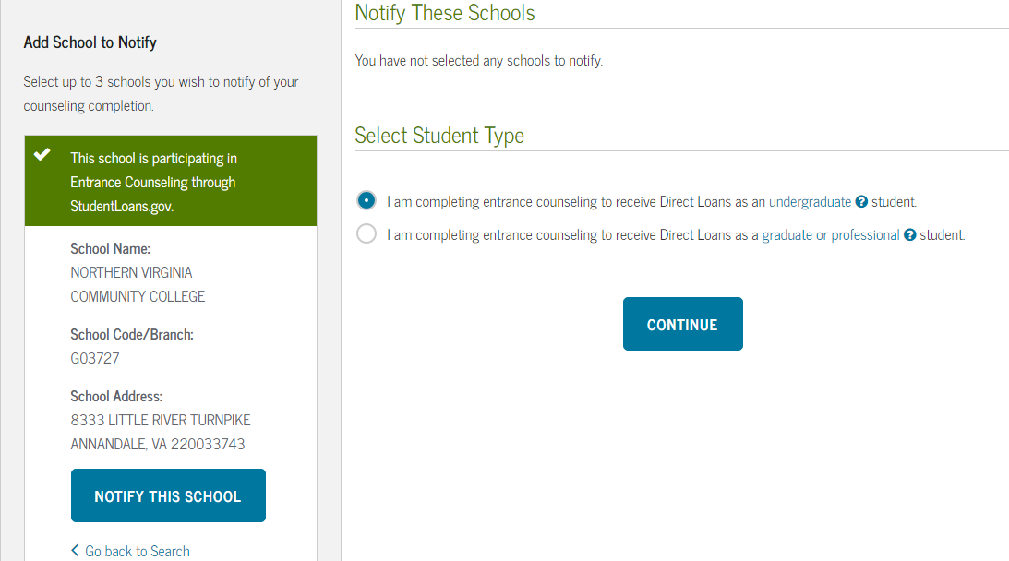
Step 4: When you are asked to select a school, select “Northern Virginia Community College” (school code/branch: G03727). Do not select the option with a campus designation. You will receive an error message if you select Northern Virginia Community College with a designated campus. Repeat this step when you begin your Master Promissory Note.

Step 5: Next click on “Complete Loan Agreement” to complete your Master Promissory Note. You will want to complete the undergraduate Direct Subsidized/Unsubsidized Master Promissory Note.
