Apply for Financial Aid in 3 Easy Steps for 2017-2018!

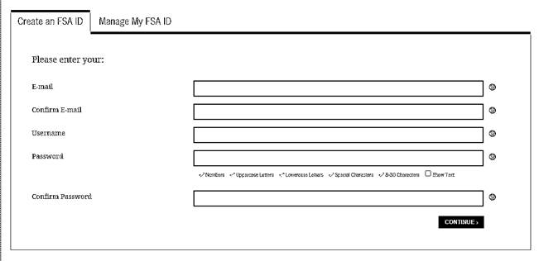***STEP ONE:*** Create a Federal Student Aid ID or FSA ID by visiting <https://fsaid.ed.gov/>. If you were born on or after 1/1/1994 and considered a dependent student, your parent must also create a FSA ID using a separate email address. This FSA ID will be used every year to complete and sign your Free Application for Federal Student Aid (FAFSA) for NOVA or any other college.

**\*Keep your FSA ID and password safe and secure.**

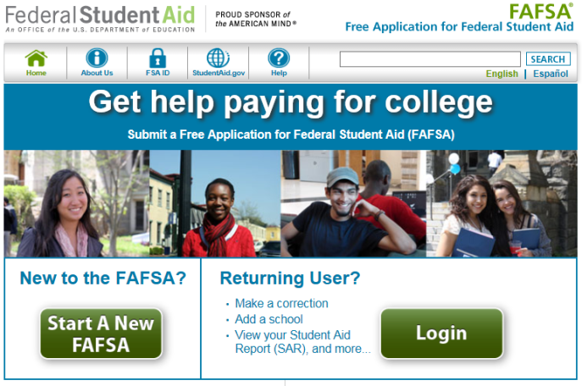***STEP TWO:*** Complete the 2017-2018 FAFSA by choosing “Start A New FAFSA” at <https://fafsa.ed.gov/>. Northern Virginia Community College’s School Code is **003727**. Allow 3-5 business days for NOVA to receive it.

**\*Returning students can renew their FAFSA by choosing the “Login” option.**

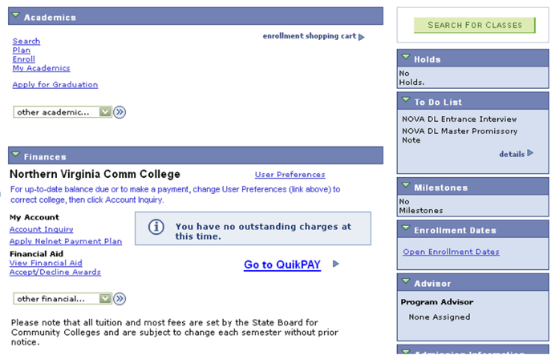***STEP THREE:*** Once your FAFSA is received by NOVA, log into ***myNOVA*** at <http://www.nvcc.edu> and check your “To Do List” in your Student Center to determine if any additional documentation is required.

Awards are usually posted about two weeks after all documents are received and the verification process is completed (if required). Review your award in ***myNOVA*** > Student Center > Financial Aid > View Financial Aid > 2018.

**\*An email will be sent to your NOVA email account 3-5 business days after submitting your FAFSA. Continue checking your NOVA email account and your *myNOVA* Message Center for any updates.**

**Contact NOVA’s Financial Aid Support Center (open 24/7) at**

**1-855-323-3199 if you have any questions.**

What Do I Need to Complete the 2017-2018 FAFSA?

There are several items you will need to complete the FAFSA. The 2017-2018 FAFSA covers Fall 2017, Spring 2018 and Summer 2018. For 2017-2018, you will need financial information from 2015. **All students will need the following information to complete the FAFSA application:**

◻ Your social security number (SSN)

◻ Your name and date of birth must match your records with the Social Security Administration

◻ Your 2015 federal tax return (IRS Form 1040, 1040A, 1040EZ or foreign tax return)

◻ Your 2015 W-2 forms and other records of money earned in 2015 (if any)

◻ Your 2015 untaxed income records, if applicable (i.e. child support received, interest income,

contributions to retirement accounts, untaxed IRA distributions (excluding rollovers), etc.

◻ Your current bank statements

◻ Your current assets (excluding retirement account balances and the home you live in)

◻ Your alien registration or permanent registration card, if applicable (if you are not a U.S. citizen)

◻ **2015 federal income tax return and current asset information for your spouse if you are married**

**Dependent students**, will also need to provide the following information for their **parent(s)**:

◻ Parent(s) 2015 federal tax return (IRS Form 1040, 1040A, 1040EZ or foreign tax return)

◻ Parent(s) 2015 W-2 forms and other records of money earned in 2015 (if any)

◻ Parent(s) 2015 untaxed income records, if applicable (i.e. child support received, interest

income, contributions to retirement accounts, untaxed IRA distributions (excluding rollovers), etc.

◻ Parent(s) bank statements

◻ Parent(s) other current assets (excluding retirement accounts and the home they live in)

◻ Parent(s) name, SSN, and date of birth that matches the Social Security Administration’s records

◻ Date your parents were married, widowed, divorced or separated

*Note: A dependent student is a student who does not meet any of the criteria for an independent student. An independent student is defined as someone who is at least one of the following:*

*Born before 1/1/1994, married, a graduate or professional student, someone on active duty in the U.S. Armed Forces for purposes other than training, a U.S. Armed Forces veteran, someone who will provide more than 50% of the support for their children or dependents who live with them from 7/1/17 – 6/30/18, someone who was an orphan or a ward of the court or in foster care after turning age 13, an emancipated minor, someone with a court-appointed legal guardian, or someone who is homeless or at risk of becoming homeless. More details are provided on the 2017-2018 FAFSA.*

* Navigating to the “To Do List”: www.nvcc.edu> myNOVA> VCCS SIS> Student Center> To Do List
* NOVA’s Financial Aid Support Center Contact Number (Open 24/7): 1-855-323-3199
* FAS Online Verification (School Servicing Center) Contact Number: 1-855-328-4400
* **The FAS Online Verification can be completed at** [**www.sscwp.org**](http://www.sscwp.org) **by signing in under “Students”.**