Complete Exit Counseling Before You Leave NOVA

What Is Exit Counseling?
Exit Counseling is required before you withdraw, graduate, or drop below half-time attendance (even if you plan to transfer to another school). Exit Counseling is designed to help you understand your rights and responsibilities as a student loan borrower. It also provides useful tips and information to help you manage your loans and prepare for repayment.

How Do I Complete the Exit Counseling?

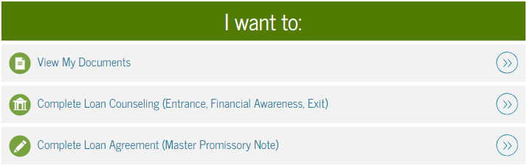
Step 1: To complete the Exit Counseling go to https://studentloans.gov. You will log in with your FSA ID and update your communication preferences. If you do not know or do not have your FSA ID go to: https://fsaid.ed.gov/.

Step 2: The Main Menu page will appear after you log in and update your communication preferences.
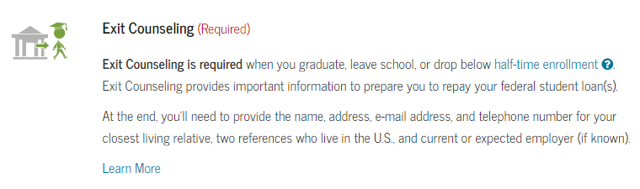
Step 3: Click “Complete Loan Counseling” to complete your Exit Counseling. You should complete the undergraduate Direct Subsidized/Unsubsidized Exit Counseling.

Step 4: When you are asked to select a school, please select “Northern Virginia Community College” (school code/branch G03727). Do not select the option with a campus designation. You will receive an error message if you select Northern Virginia Community College with a designated campus.
Step 5: If you are transferring to another school, resubmit your FAFSA application with the new school code.

