Get the Tax Return Transcript

What is the Tax Return Transcript?
The Tax Return Transcript shows most line items including your adjusted gross income (AGI) from your original tax return (Form 1040, 1040A or 1040EZ) as filed, along with any forms and schedules. It doesn’t show changes made after you filed your original return. If you are selected for verification and you were not able to use the IRS Data Retrieval Tool on your FAFSA, you may be required to submit a Tax Return Transcript to www.SSCWP.org.

How Can I Get a Tax Return Transcript?

Option 1: Go to https://www.irs.gov/ and click “Get Tax Transcript”. There are two options available. You may click “Get Transcript ONLINE” to immediately access a PDF version.
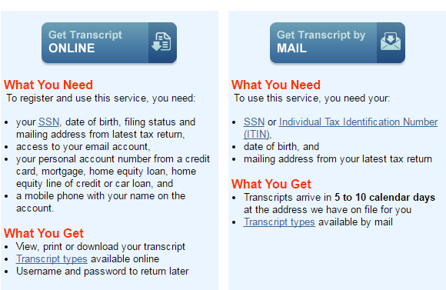

Option 2: If you are unable to register or you prefer not to use "Get Transcript Online," you may order a tax return transcript using Get Transcript by Mail or call 800-908-9946. Please allow 5 to 10 calendar days for delivery.

Option 3: You may also request any transcript type listed below by faxing/mailing Form 4506-T, Request for Transcript of Tax Return as instructed on the form: https://www.irs.gov/pub/irs-pdf/f4506t.pdf

Option 4: Visit a local IRS office to request the Tax Return Transcript. You must contact the office to make an appointment before you visit: https://www.irs.gov/help-resources/contact-your-local-irs-office

Get the Tax Return Transcript

How Can I Submit the Tax Return Transcript to the School Servicing Center?
If you are selected for verification, you may be required to submit tax information. If you amended your taxes, you must submit the signed and dated 1040x Amended Tax Return and the Tax Return Transcript. If you did not amend your taxes, you would submit your Tax Return Transcript.

Step 1: After you have downloaded the tax return transcript, save it as a PDF to your Desktop. If you ordered the Tax Return Transcript by mail or picked it up at an IRS office, you may scan these documents, and save them to your Desktop as a PDF. If you do not have a scanner at home, please visit a Financial Aid office for assistance. Note: If you are not using a private computer, make sure that you delete this PDF from the computer immediately after you complete the upload process.
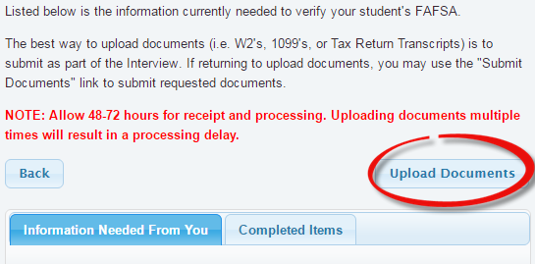

Step 2: Log in to the School Servicing Center at www.SSCWP.org and click on “Upload Documents.”

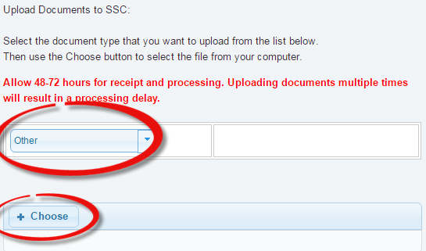

Step 3: Select the type of document you are uploading from the dropdown menu.

Step 4: Click on the “+ Choose” button, select your file, and click “open.”

Step 5: The account will take 3-5 business days to update.

