Get the Verification of Non-filing

What is the Verification of Non-filing?
The Verification of Non-filing Letter serves as proof from the IRS that you did not file a tax return for the year requested. There are no availability restrictions on prior year requests. Most requests will be processed within 10 business days. You may be required to submit a Verification of Non-filing Letter to www.SSCWP.org during your verification process.
How Can I Get the Verification of Non-filing?

Option 1: Go to www.IRS.gov and click “Get Tax Transcript”. There are two options available. You may click “Get Transcript ONLINE” to immediately access a PDF version.
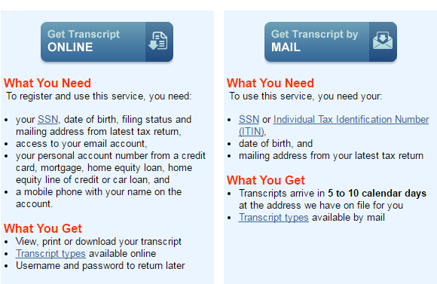

Option 2: If you are unable to register or you prefer not to use "Get Transcript Online," you may order a Verification of Non-filing letter by mail. Click "Get Transcript by Mail" or call 800-908-9946. Please allow 5 to 10 calendar days for delivery.

Option 3: You may also request Verification of Non-filing by faxing/mailing Form 4506-T, Request for Transcript of Tax Return. You must select option 7 for the Verification of Non-filing Letter as instructed on the form: https://www.irs.gov/pub/irs-pdf/f4506t.pdf You may also make an appointment at a local IRS office to request the Verification of Non-filing. You must contact the office to make an appointment before you visit: https://www.irs.gov/help-resources/contact-your-local-irs-office

Get the Verification of Non-filing

How Can I Submit the Verification of Non-filing to the School Servicing Center?
If you are selected for verification, you may be required to submit proof that you did not file taxes. If you did not file taxes, you would submit the Verification of Non-filing.

Step 1: After you have downloaded the Verification of Non-filing, save it as a PDF to your Desktop. If you ordered the Tax Return Transcript by mail or picked it up at an IRS office, you may scan these documents, and save them to your Desktop as a PDF. If you do not have a scanner at home, please visit a Financial Aid office for assistance. Note: If you are not using a private computer, make sure that you delete this PDF from the computer immediately after you complete the upload process.
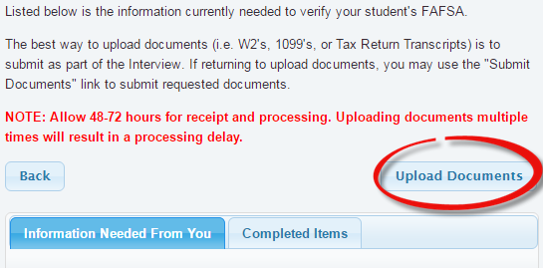

Step 2: Log in to the School Servicing Center at www.SSCWP.org and click on “Upload Documents.”

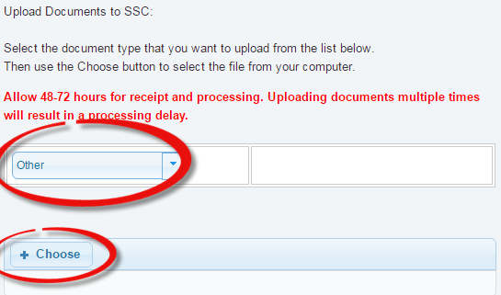

Step 3: Select the type of document you are uploading from the dropdown menu.

Step 4: Click on the “+ Choose” button, select your file, and click “open.”

Step 5: The account will take 3-5 business days to update.

