View Financial Aid Eligible Courses

Why Should I Review the Eligibility of my Courses?
Financial Aid can only be used to pay for courses that are required for your program of study. If you rely on Financial Aid to cover the cost of your courses, it is important to check whether your courses are eligible for Financial Aid. You must pay out-of-pocket to cover the tuition and fees of ineligible courses.

How Can I Check My Academic Requirements for Future Enrollment?

Step 1: Log in to NOVAConnect by clicking on MyNOVA on the NOVA home page: www.nvcc.edu
Step 2: Click on VCCS SIS: Student Information System
- Click on Self Service
- Click on Student Center
- Scroll down to the Academics tab and click on select Academic Requirements from the drop down menu items. Then click the double arrow button beside the drop down menu. Click view as a PDF.

How Can I Check My Current Course Eligibility?
Reminder: This method is only available after you have been awarded Financial Aid.

Step 1: Log in to NOVA Connect by clicking on MyNOVA on the NOVA home page: www.nvcc.edu
Step 2: Click on VCCS SIS: Student Information System.
- Click on Self Service.
- Click on Student Center.
- Scroll down to the Finances tab and click on View Financial Aid.
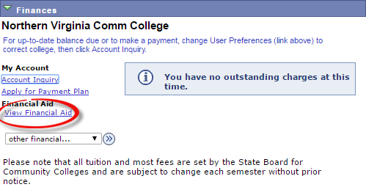

View Financial Aid Eligible Courses

Step 3: Select the appropriate award year.

Step 4: Scroll down to select the current term and click on View Course Eligibility.
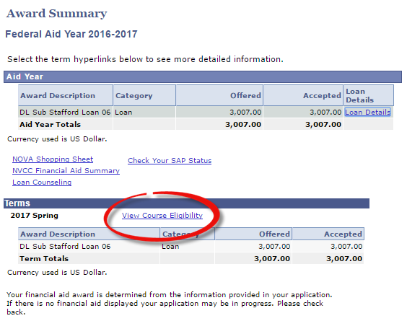

Step 5: The table will display a mark to the right of each course to demonstrate course eligibility.

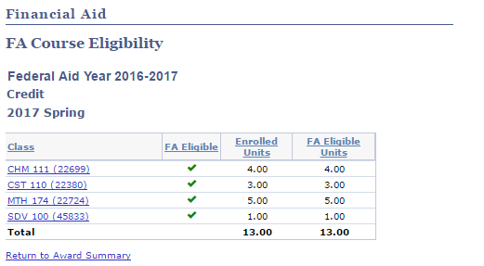

ELIGIBLE COURSES
iNELIGIBLE COURSES
NOT YET EVALUATED ?

