Student Tutorials - https://www.nvcc.edu/NovaConnect/students/tuts/index.html

Uploading Financial Aid Documents from the To Do List

- Log in to NOVAConnect by clicking on myNOVA on the NOVA home page.
- Click on VCCS SIS: Student Information System.
- Click on Self Service.
- Click on Student Center.
- Under the To Do List, click on the outstanding item.
Note: the outstanding item is in bold until submitted.
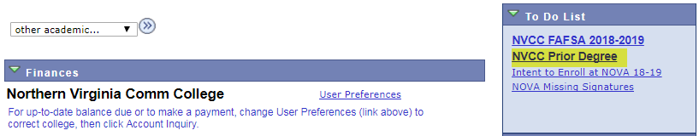

- To upload the file, click .
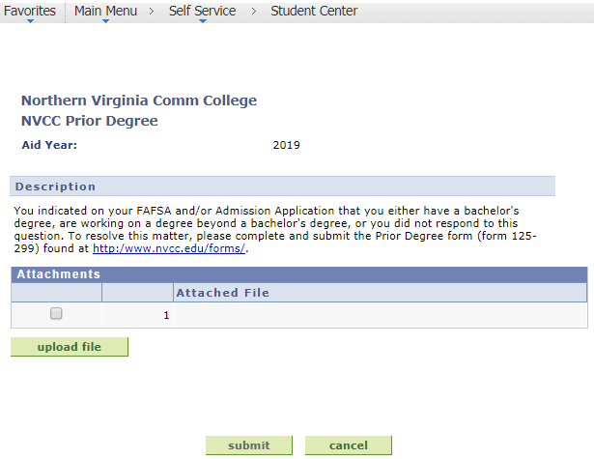

- Browse to a file that you would like to upload. Then, click .
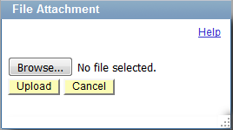

Important:
- Depending on the requirements of the To Do List item, you may need to submit multiple documents to complete one item. You will NOT be able to upload additional documents or make any adjustments to the submitted documents once you click . Please review all uploaded documents carefully before submitting.
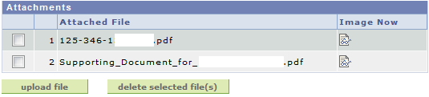

- When you are finished uploading the file, click 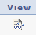 to review all documents.
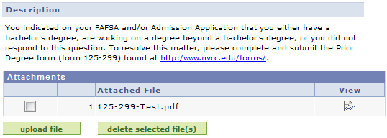

- After reviewing, click .
The To Do List item will no longer be in bold type.
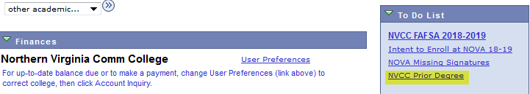

- The To Do List item will also be marked as “Received” with the date and time the document was submitted.
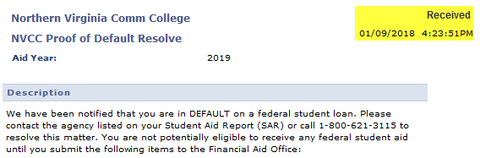

Note: Please continue to check your To Do List. If documents are rejected, the To Do List item will be set back to Initiated, which requires you to resubmit the correct and complete documents.

