Use the Data Retrieval Tool to Transfer Tax Information

What is the Data Retrieval Tool?
The IRS Data Retrieval Tool is an option provided by the IRS that allows you to transfer your tax information from the IRS and insert this information into your FAFSA. From this point forward, when you transfer your IRS tax return information, questions that are populated are marked with “Transferred from the IRS.” For your protection, IRS tax return information is not displayed on the FAFSA.
How Do I Use the IRS Data Retrieval Tool on My FAFSA?

- Click on the Financial Information tab on your FAFSA.
- Answer the following questions to determine your eligibility to use the Data Retrieval Tool:
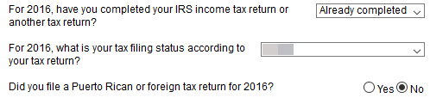

- If you are eligible to use the Data Retrieval Tool, you will be presented with an option to “Link to the IRS.”
- Enter your FSA ID and password. Parents will need to enter their FSA ID if requesting parental IRS information. Click the “Link to IRS” button.
- Click “Proceed to IRS Site” to leave FAFSA website and enter the IRS Data Retrieval Tool website.
- Click “OK” to accept the IRS Data Retrieval Tool terms of use agreement.
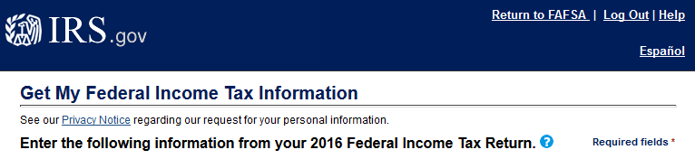

- Enter your address exactly as it appears on your tax return. Example: If you abbreviated “road” as “Rd” on the tax return, abbreviate it on the DRT. Click the “Submit” button.
- Check the box beside “Transfer My Tax Information into The FAFSA” and click “Transfer Now.”
- Answer additional FAFSA questions. Continue to the Sign & Submit tab on your FAFSA. Check that you agree to the terms of use agreement, click the “Sign” button, and click “Submit My FAFSA Now.”

