Complete the Verification Process Online

What is the Verification Process?
Verification is the federal requirement that schools must verify certain information included on the Free Application for Federal Student Aid (FAFSA) before a student can potentially be awarded financial aid. Students who are chosen for verification will have the “FAFSA Verification” checklist placed on their MyNOVA To Do List. Once the verification process is available for you to complete on the School Servicing Center (SSC) website, www.sscwp.org, an email with login information will be sent to the email address listed on your FAFSA. If other items are shown on your MyNOVA To Do List, you will need to complete those items prior to receiving the login instructions to complete verification.

Log in to the School Servicing Center Website to Complete Verification

Step 1: Go to the School Servicing Center website: www.sscwp.org
Step 2: Click on the Students tab to log in.
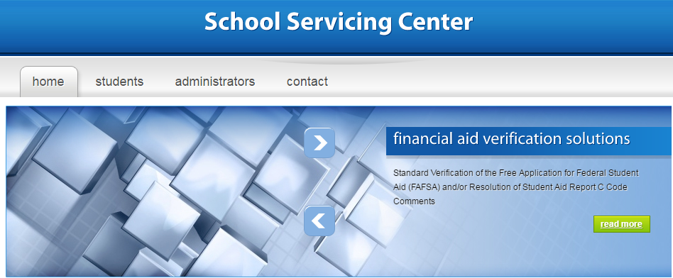

Step 3: Select the correct academic year and use your social security number and date of birth to login.

Step 4: Review the “Information Needed from You” tab. Click “Upload Documents” to provide requested documentation to the School Servicing Center (SSC) or fax requested documents to SSC at 866-258-8362.
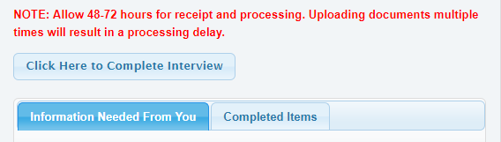
Step 5: Select “Click Here to Complete Interview” to begin. Once the verification process is complete, log in to your email account to open the E-Signature email from the School Servicing Center. Use the “eSign password” (which is at least a 4-digit number created by the student on the www.sscwp.org website) to electronically sign the PDF attachment. For dependent students, one of your parents must also open the PDF through his or her email and use the eSign password to electronically sign. If you are a dependent student and both parents did not file a tax return, then both parents must electronically sign the verification interview using the eSign password.
Check back regularly for additional documentation and interview requests. Please allow 3-5 days for processing.

Questions? Call the School Servicing Center at 855-328-4400.
8:00 a.m. – 8:00 p.m. Monday – Thursday (EST) and 8:00 a.m. – 5:00 p.m. Friday

Acceptable Documents to Verify Income & Tax Information

If you are selected for verification, you (and your parents or spouse, if applicable) should complete the verification process at www.sscwp.org and provide any requested items, including the documents shown below, to the School Servicing Center.

For the 2019-2020 FAFSA, provide 2017 tax year information.
For the 2020-2021 FAFSA, provide 2018 tax year information.
Tax Filing Status | Acceptable Documentation
Tax Filers | - Use the IRS Data Retrieval Tool (IRS DRT) to transfer unchanged tax data into your FAFSA. If you already submitted your FAFSA, you may try to correct your FAFSA at https://fafsa.gov to use the IRS DRT; or  - Provide a Tax Return Transcript from the IRS for the applicable year; or  - Provide a signed copy of the Federal Tax Return (IRS Form 1040) for the applicable year.  - The tax return must be signed by the tax filer (at least one of the tax filers must sign it in the case of a joint tax return) or it must contain the tax preparer’s information (to include the tax preparer’s SSN, EIN, or PTIN and the tax preparer’s signed, stamped, typed, or printed name and address); or  - Provide a transcript from the foreign tax authority or a signed copy of the foreign tax return (translated into English with all figures converted to U.S. Dollars) for individuals who filed their taxes overseas.
Non-Tax Filers:  - Independent Students &  - Parents of Dependent  Students | - Provide IRS form W2, 1099, or an equivalent document, for each source of employment income received in the applicable year; and  - Provide the Verification of Non-Filling (VNF) Letter for the applicable tax year as indicated in the Get the Verification of Non-filing tutorial; or  - If non-tax filers try to get the VNF Letter and are unable to obtain it from the IRS or from other tax authorities, they may submit a signed statement certifying that they:  - Attempted to obtain the VNF from the IRS or other tax authorities and were unable to obtain the required documentation; and  - Have not filed and are not required to file an income tax return for the applicable year; and  - Provide a listing of the source of any income earned in the applicable year along with the amount earned from each source.
Non-Tax Filers:  - Dependent Students | - Provide IRS form W2, 1099, or an equivalent document, for each source of employment income received in the applicable year; and  - List the source and the amount of all income earned for the applicable year when completing the verification interview at www.sscwp.org.

