Apply for Financial Aid in 3 Easy Steps for 2020-2021!

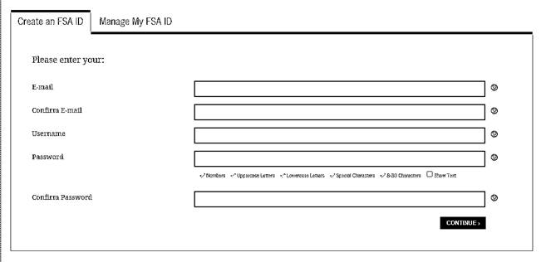***STEP ONE:*** Create a Federal Student Aid ID or FSA ID by visiting <https://fsaid.ed.gov/>. If you were born on or after 1/1/1997 and considered a dependent student, your parent must also create a FSA ID using a separate email address. This FSA ID will be used every year to complete and sign your Free Application for Federal Student Aid (FAFSA) for NOVA or any other college.

**\*Keep your FSA ID and password safe and secure.**

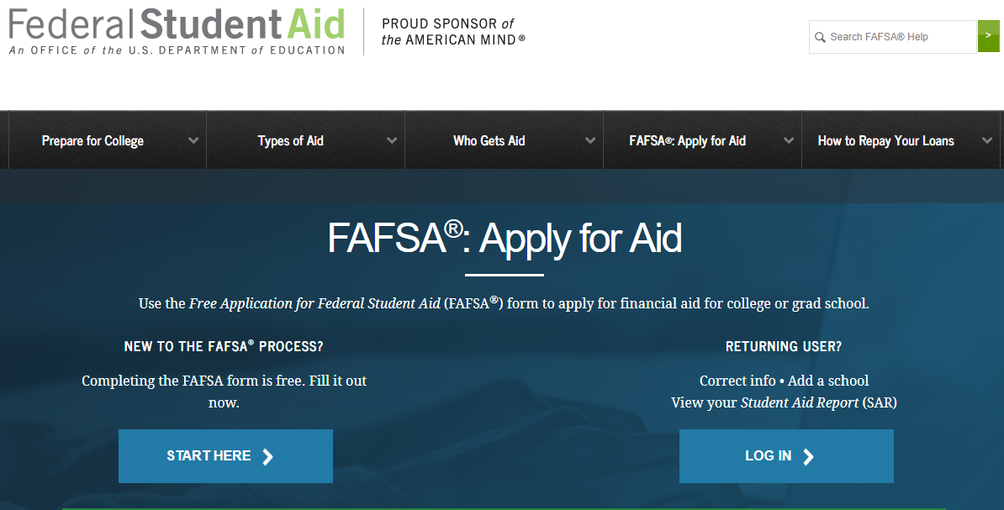

***STEP TWO:*** Complete the 2020-2021 FAFSA by clicking “Start Here” at <https://fafsa.ed.gov/>.

Northern Virginia Community College’s School Code is **003727**. Allow 3-5 business days for NOVA to receive it.

**\*Returning students can renew their FAFSA by choosing the “Log In” option.**

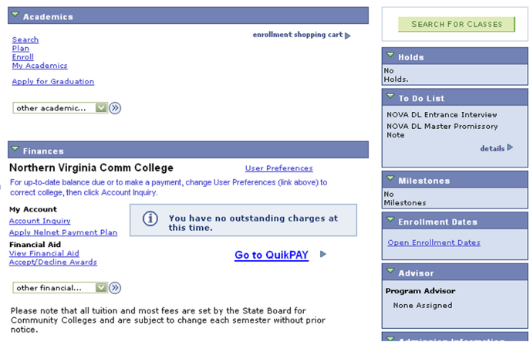***STEP THREE:*** Once your FAFSA is received by NOVA, log into ***myNOVA*** at <https://www.nvcc.edu> and check your “To Do List” in your Student Center to determine if any additional documentation is required.

Awards are usually posted about two weeks after all documents are received and the verification process is completed (if required). Review your award in ***myNOVA*** > Student Center > Financial Aid > View Financial Aid > 2021.

**\*An email will be sent to your NOVA email account 3-5 business days after submitting your FAFSA. Continue checking your NOVA email account and your *myNOVA* Message Center for any updates.**

**Contact NOVA’s 24-Hour Student Support Center at**

**1-855-323-3199 if you have any questions.**

What Do I Need to Complete the 2020-2021 FAFSA?

There are several items you will need to complete the FAFSA. The 2020-2021 FAFSA covers Fall 2020, Spring 2021 and Summer 2021. For 2020-2021, you will need financial information from 2018. **All students will need the following information to complete the FAFSA application:**

◻ Your social security number (SSN)

◻ Your name and date of birth must match your records with the Social Security Administration

◻ Your 2018 federal tax return (IRS Form 1040 or foreign tax return)

◻ Your 2018 W-2 forms and other records of money earned in 2018 (if any)

◻ Your 2018 untaxed income records, if applicable (i.e. child support received, interest income,

contributions to retirement accounts, untaxed IRA distributions (excluding rollovers), etc.

◻ Your current bank statements

◻ Your current assets (excluding retirement account balances and the home you live in)

◻ Your alien registration or permanent registration card, if applicable (if you are not a U.S. citizen)

◻ **2018 federal income tax return and current asset information for your spouse if you are married**

**Dependent students**, will also need to provide the following information for their **parent(s)**:

◻ Parent(s) 2018 federal tax return (IRS Form 1040 or foreign tax return)

◻ Parent(s) 2018 W-2 forms and other records of money earned in 2018 (if any)

◻ Parent(s) 2018 untaxed income records, if applicable (i.e. child support received, interest

income, contributions to retirement accounts, untaxed IRA distributions (excluding rollovers), etc.

◻ Parent(s) bank statements

◻ Parent(s) other current assets (excluding retirement accounts and the home they live in)

◻ Parent(s) name, SSN, and date of birth that matches the Social Security Administration’s records

◻ Date your parents were married, widowed, divorced or separated

*Note: A dependent student is a student who does not meet any of the criteria for an independent student. An independent student is defined as someone who is at least one of the following:*

*Born before 1/1/1997, married, a graduate or professional student, someone on active duty in the U.S. Armed Forces for purposes other than training, a U.S. Armed Forces veteran, someone who will provide more than 50% of the support for their children or dependents who live with them from 7/1/20 – 6/30/21, someone who was an orphan or a ward of the court or in foster care after turning age 13, an emancipated minor, someone with a court-appointed legal guardian, or someone who is homeless or at risk of becoming homeless. More details are provided on the 2020-2021 FAFSA.*

* Navigating to the “To Do List”: [www.nvcc.edu](http://www.nvcc.edu) > myNOVA > VCCS SIS > Student Center > To Do List
* NOVA’s 24-Hour Student Support Center is available 24/7 at [https://mysupport.nvcc.edu](https://mysupport.nvcc.edu/) or 1-855-323-3199.
* Verification can be completed at [www.sscwp.org](http://www.sscwp.org) (if required) by signing in under “Students”.
* If you have questions about completing verification, call the School Servicing Center at 1-855-328-4400.