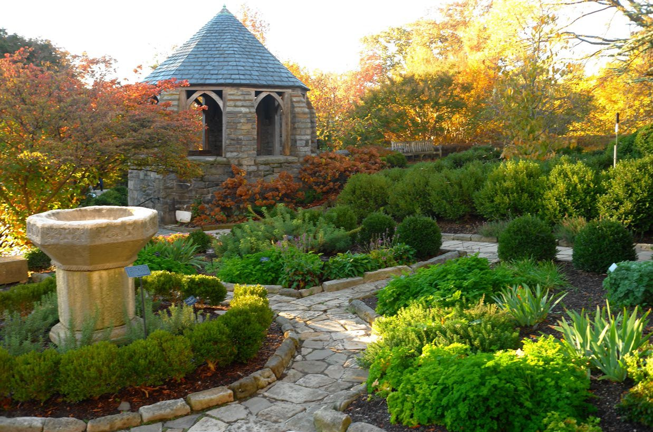Washington National Cathedral 3101 Wisconsin Ave NW Washington, D.C. 20016

3 Horticulture Internships Available Summer, Full-time

Apply by March 24, 2025

Compensation: $17.50/hour Housing not provided Contact: Addie Schopf

Email: [aschopf@cathedral.org](mailto:aschopf@cathedral.org) Phone: 202-537-5773

The Washington National Cathedral, along with St. Albans School, National Cathedral School, and Beauvoir, The National Cathedral Elementary School, is located on a campus of 57 acres of landscaped grounds in the heart of the nation’s Capital. This internship program provides instruction and hands-on gardening experience. Under the direction of the horticulture staff, interns will participate in the installation, maintenance, conservation, and preservation of the Bishop’s Garden and the Cathedral grounds. Areas of emphasis include an ornamental herb garden, herbaceous perennial borders, a rose garden, 5-acre native woodland, and a classroom vegetable garden. Proper horticulture techniques will be emphasized, including weeding, staking, pruning, watering, plant identification, and using IPM methods of insect and disease control.

Interns will work Monday through Friday from 6:30 am to 3:00 pm. To enhance the educational experience, interns will visit public gardens in the surrounding Metro DC area.

Preference will be given to applicants who are pursuing a degree in horticulture, landscape maintenance, or a related field. Applicants must be able to work outside in inclement weather such as rain and extreme heat, must be able to perform physical work including bending, stooping, reaching, and standing for extended periods of time, must be able to lift, carry, and push at least 30 lbs. Housing is not provided and there is no housing allowance. The internship is 12 weeks, with flexible start and end dates. May through August preferred.

Interested applicants should visit **pecf.org**. Click on Employment, Opportunities – scroll down to “Click here for PECF Opportunities” to apply. Please submit a resume and cover letter no later than **March 24, 2025.**