ART 154: Ceramics II
Northern Virginia Community College Alexandria Campus Spring 2016
Instructor: Jessica Gardner Room: AT-210
E-mail: jggardner@nvcc.edu Office phone: 703-845-6273

Course Description:
Presents problems in the design and production of functional and non-functional ceramic works. Includes hand building the potter's wheel and clays and glazes. Lecture 2 hours. Studio instruction 4 hours. Total 6 hours per week.

General Course Purpose:
The purpose of the ceramic course is to introduce the student to the various wheel throwing techniques utilized in studio pottery, to make the student aware of relationships between the artist potter and ceramic industry and to prepare the student for further study in ceramics. Emphasis will be on craftsmanship and creativity with special attention given to total concept from idea to finished product. The course is a studio option under the fine arts major. It is the end of the first year sequence of Ceramics I-II.

Course Prerequisites/Corequisites Prerequisite: ART 153 or permission of instructor

Objectives:
Development and understanding of basic wheel throwing techniques as they relate to functional and nonfunctional forms.

Major Topics To Be Included:
• Basic cylinder form • Bowl forms • Bottle forms • Lidded forms • Trimming and finishing wheel thrown forms

Course Requirements:
Students are responsible for meeting class deadlines. All assignments are expected to be completed by their due dates without exception.
No amount of talent can replace hard work. It takes time to make art. Prioritize your goals and time. Be persistent. Students are also expected clean up after themselves and participate in end of class clean up.
It is a health issue if the studio is not clean and everyone needs to be diligent!

Attendance Statement: Attendance at every class is mandatory and is taken at the beginning of each class. If you are enrolled in a class and do not attend the first and second class meetings, you will be asked to drop the class. Classes begin at stated times and lateness is unacceptable.
Leaving early or arriving late is counted as a partial absence. Missing more an ½ of a class perido will equal a full absence. If you come to class late, it is your responsibility to notify me after class that you were late, not absent, and to request a change in the attendance record from absent to late. If you fail to do this, be aware that your attendance record remains as an absence. Your final grade will be reduced by one letter grade for each and every absence after the third absence. There are no “excused” absences. It would be wise to save your 3 allowable absences in anticipation of emergencies. You will be held responsible for the material covered in the missed class and must consult with your fellow students to receive all instruction and information covered in the class.

3 Lates Or Leaving Early occurrences = 1 Absence You Are Allowed 3 Absences Only.
If You Go Over 3 Absences, Your Grade Will Be Lowered One Letter For Each Additional Absence.

Grading:
Grades will be issued within 1 week of the assignments due date.
Grades for each assignment will be determined by the following criteria:
- Completion of the assignment (including following the criteria and due dates given)
- Technical and design skills
- Quality and craftsmanship of the finished work
- Effort and experimentation
- Overall growth and development
Late work will immediantly be docked a letter grade unless there is a medically documented emergency or family loss. Students who find that a religious holiday or family obligation falls on a due date should make arrangements to submit assignments early.

Your Final Grade is Broken Down as Follows:
A: 90-100 Excellent, went above and beyond class requirements
B: 80-89 Good, fulfilled class requirements with exceptional effort
C: 70-79 Average, completed class requirements with fair effort
D: 60-69 Did not complete all class requirements or show effort
F: below 6o Unacceptable, failure

* I do not “round up” grades, you will receive the grade you earn*

Critiques:
There will be both in-progress and formal critiques throughout the semester. Attendance for critiques is mandatory. Your participation grade will be deducted for absences from critiques or for lack of participation in critiques. Unfinished work will not be discussed or graded. Participation in the discussion is very important in the learning process for both the artist and their peers. Your sincere, thoughtful and enthusiastic participation, or lack of it, affects your grade.
All students are expected to conduct themselves in person, in print, and online in a responsible way. When critiquing work, comments are expected to be thoughtful and constructive. Feedback should include suggestions not just criticism.

Projects, Idea Files and Sketchbooks:
- Projects and homework should be completed before the class begins on the day it is due. Each project will address a number of visual elements and design principles, they will be incremental and will build on each other becoming progressively more complex throughout the semester. Projects will be worked on during class time AND outside of class. This includes library time, supply shopping, sketching, and working. Make sure you understand what the objectives are for all of the projects. If you are not sure, don’t hesitate to ask.
- Keep your sketchbooks up to date with what is going on in class.
- Sketchbooks/ Idea Files will be reviewed in class pierdocially and collected at the end of the semester.
- Sketchbooks/ Idea Files should contain: class notes, research, life references, ideas, cutout scribbles, questions, critique notes, homework, handouts, notes and sketches on project progress and documentation, etc.
- Sketchbooks are an opportunity to show me your thought process and efforts that might not be so easily seen in your class work and will be factored into your grade.

Communication:
Students are asked to check your Blackboard account and student email regularly, but are required to sign in at least once a week. This will be our primary method of communication outside of the classroom. Important information regarding this course will be posted, and you are responsible for these communications.
I will communicate with you using Blackboard and your student e-mail address (no outside e-mail accounts).

Room Use and Storage:
The studio is a shared and heavily used classroom space. You are required to clean up after yourself every time you use the studio (during class time and outside of class time). Maintaining a clean workspace is a matter of health, safety, and common courtesy; not doing so will affect your grade. If you leave materials and artwork in the studio not properly stored, it will be thrown away. The last fifteen minutes of each class will be dedicated to cleanup.
Leave everything in better shape than you found it!

Open Studio Hours:
Hours will be posted at the beginning of every semester. Students found using the studio outside of posted hours will be subject to grade reduction and if nessicary college judicial action.

Classroom Etiquette:
Please be respectful to other students, do not touch or move another student's work (unless assisting with kiln loading or unloading), this could lead to accidental breakage. If for any reason you need to move another students work ask for assistance from an instructor or a studio assistant.
***If you accidently break someone’s work. Please leave the broken piece with an apology note***
Students may use headphones during work times only if they keep one ear piece out so they do not miss anything. ABSOLUTELY NO CELL PHONES during class hours. This means no ringing, conversations, or text messaging in the classroom.
Disruptive behavior will not be tolerated and in extreme cases will result in the expulsion of the student from class. Examples of disruptive behavior include, but are not limited to, habitually arriving late or leaving early from class, talking during instruction, offending fellow students, and failure to listen to directions.

Safety:
Students must use all equipment in a safe manner. Read all material labels carefully and follow directions. The Instructor has the right to suspend any student from using a material or piece of equipment if the student uses materials or equipment in an unsafe manner. (ex. sanding greenware in -doors) Always ask for assistance if you have any concerns about the proper and safe use of any tool or material.
Emergencies can occur to anyone, anytime, anywhere. Emergency procedures posters are located throughout all NOVA campuses and facilities. Students should take the time to read one as it provides important information to help prepare for an emergency. If an emergency does occur, immediately call 911 and the college police at 703-764-5000. Always follow all directions given by emergency response personnel. For more emergency preparedness information, please visit NOVA’s Office of Emergency Planning and Management (OEPM) at www.nvcc.edu/emergency . Specific procedures for various emergencies as well as an informative safety video can also be found at http://www.nvcc.edu/about-nova/emergency/campus/index.html . Fire/Emergency Evacuation Procedures – “In case of emergency, please follow the emergency procedure as discussed on the first day of class and as posted in the classroom.”

Academic Honesty:
Each student is expected to complete his or her own artwork from start to finish. The student will automatically receive an "F" for the course if the instructor determines that someone other than the student performs any work. This includes projects, written assignments, and sketchbooks. Students are expected to work on their projects during class as well as outside of class time. Plan on spending at least three hours of work outside of class for every one-hour spent in class. Do not wait until the last minute!
The college does not tolerate academic dishonesty. As outlined in more detail in The Student Handbook, academic dishonesty includes many things including cheating on an exam or quiz and plagiarism. Students who are not honest in their academic work will face disciplinary action along with an appropriate grade penalty. Procedures for disciplinary measures and appeals are outlined in the current NOVA Student Handbook at http://www.nvcc.edu/students/handbook/. In extreme cases, academic dishonesty may result in dismissal from the College.

Plagiarism:
According to the NOVA Student Handbook, plagiarism "is the act of appropriating passages from the work of another individual, either word for word or in substance, and representing them as one's own work. This includes any submission of written work other than one's own." In short, plagiarism means using the exact words, opinions, or factual information from another person without giving that person credit.
Credit should be given through accepted documentation styles, such as parenthetical citation, footnotes, or endnotes; a simple listing of books and articles is not sufficient. Credit not only direct quotations but also paraphrases and summaries of opinions or factual information formerly unknown to the writers or which the writers did not discover themselves. (The library web site has examples of proper citations.)
Also, give credit to the source of information and graphics accessed electronically through the Internet. This material includes e-mail (don't cite or forward someone else's e-mail without permission); newsgroup material; and information from Web sites, including graphics. Even if you give credit, you must get permission from the original source to put any graphic that you did not create on your web page.
Good academic work must be based on honesty. Plagiarism is dishonest and cannot be tolerated in an academic setting. The consequences of plagiarizing are detailed in the NOVA Student Handbook. In short, when such misconduct is established as having occurred, the student faces possible disciplinary actions ranging from admonition to dismissal, along with any grade penalty the instructor might impose.

Student Rights and Responsibilities:
Familiarize yourself with the college's specific expectations concerning the conduct of its students. These expectations apply to all students (part-time or full-time) attending NOVA. Student Rights and Responsibilities are outlined in the NOVA Student Handbook.

Disabilities:
It is the policy of NOVA to accommodate students with disabilities in accordance with federal and state laws. Students with a disability who need accommodations to succeed in their studies should contact the campus Disability Support Services counselor and provide appropriate documentation of the disability. Once accommodations are approved, it is the student’s responsibility to deliver the letter from the counselor to the instructor listing permitted accommodations and discuss how they will be implemented. If students with accommodations have difficulty accessing any part of the course materials or activities for the class, they should contact the instructor immediately. Accommodations for test taking should be arranged in advance of the date of the test. For more information, visit the NOVA Disability Services website at http://www.nvcc.edu/disability-services/
Student Mental Health and Behavior:
Northern Virginia Community College cares about its students’ emotional and physical well-being as well as their academic success. NOVA has developed campus assessment, response, and evaluation (CARE) teams that are committed to helping its students succeed while maintaining a safe community. The CARE team’s mission is to provide a systematic and professional response in instances where students’ behavior is concerning or disruptive. While NOVA does not provide mental health services (per the policy of the Virginia Community College System), it does provide faculty, staff, and students with resources and referrals. As warranted, the college may take appropriate disciplinary actions for violations of the Student Code of Conduct. If you have a concern about behavior, please complete and submit the NOVACares: NOVA Concerning Behavior online form at http://www.nvcc.edu/novacares/

Inclement Weather/Cancelled Class Policy:
Students are expected to immediately activate their official NOVA email account at https://nvcc.my.vccs.edu/jsp/userconfig.jsp?action=reset if they have not already done so. They must check for messages on a frequent and consistent basis, and they must use their NOVA email account, not their personal email account, when communicating with instructors and other college personnel.

Closings and emergencies are announced on the NOVA homepage. However, you can receive notification by cell phone or email if you register for NOVA Alert at https://www.getrave.com/login/nvcc/

In addition, it is recommended that you review the college policies regarding emergency closings and late openings at https://www.nvcc.edu/emergency/closing/index.html

If this course is canceled due to a weather event or other unforeseen situation, students should check the course Blackboard site as soon as possible for instructions and assignments so that they will not fall behind in their work. Students are expected to be up to date with all assignments the next time the class meets.

Required Materials:
You will need to come to class each day prepared and with supplies. You will be responsible for purchasing your own supplies from the bookstore, art supply stores, hardware stores etc.
Tools- (see pictures)
A basic pottery tool kit must be purchased, it will include:
Small yellow sponge, Wire tool, Metal rib, Wooden rib, Pin tool, Wooden knife and 2 loop tools (trimming tools)
You will also need:
Paintbrushes- (suggested) 1 medium Bamboo brush, 1small and 1medium Hake brush
Apron, towel or smock- it gets messy!
A container to keep tools and water
Plastic Bags- Kitchen Garbage or Dry Cleaning Bags (Food Store Bags Do Not Work)
Sketchbook- around 8"x 10" is fine, you are required complie all sketchbook assignments here and bring it to every class
Clay- avaiable at the NOVA book store and Clayworks Supplies

*** recommend clay- bookstore Standard 200 or Phoenix*** You will also need a small amount of Soldate later in the semesteer to participate in Raku.

NOVA bookstore carries Standard 200 which is $19.98+ tax and tool kits for $11.98+ tax

You may also want:
A spray bottle
Serrated rib
Fettling Knife
A softer rubber rib (large or small, your choice)

Tools
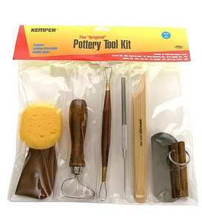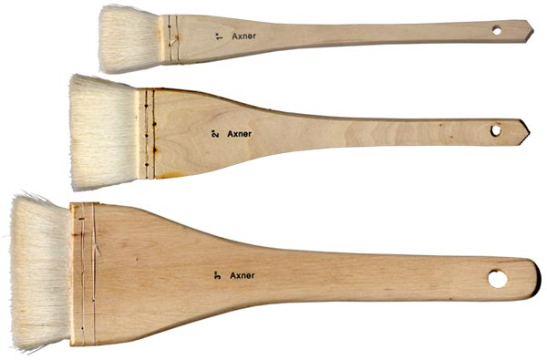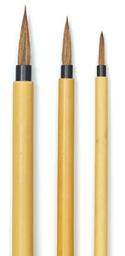

Kemper-Pottery Tool Kit or other starter kit- can be purchased at Clayworks Supplies and other retailers.
Hake and Bamboo Brushes are in the ink section at art supply stores or at Clay Works Supplies.

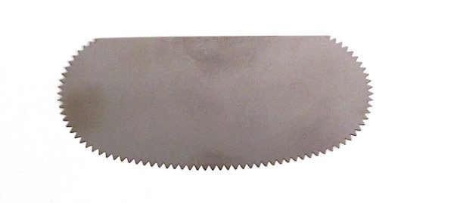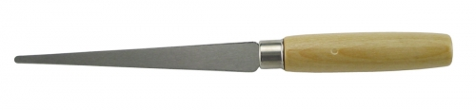
Soft Rib tool, Serrated Rib Tool, Fettling Knife

Total Points Assigned for Semester: 100
Project Title | Points Available
Project 1- Cylinders | 10
Project 2- Cups and Mugs | 15
Project 3- Bowls | 15
Project 4- Bottles/Vases | 20
Take Home Quiz | 5
Project 5- Lidded Forms | 25
Sketch book/Idea File | 5
Participation | 5
Extra Credit- Artist Statement | 5

***The course syllabus provides a general plan for the course; deviations may be necessary***

Safety and General Rules for Ceramics

General
- Think before you act. If it looks dangerous, don’t do it or ask the instructor. Do not ask another student, as they may not know the correct safety procedures or may just give you bad advice.
- Wash your hands after working with clay or glaze. Do not ingest or inhale the clay and glaze materials.
- Never throw clay or shake dirty canvas, keep the clay out of the air.
- No clay down sinks! Use slurry buckets as needed.
- Only those enrolled in class can work in the lab or have their work fired.
- Work will not be fired if not properly prepared and marked with initials and date.
- Enrolled students can only work in the lab during posted open studio and class hours.

Housekeeping
- Each student is responsible for cleaning up after themselves. This includes all areas you have worked in – tables, floor, spray booth, sink, and wheels. The cleaner the lab is, the safer it is. Please be respectful of others using the lab.
- Immediately wipe up any spills to avoid a slipping accident.
- Always mop floors. Do not sweep the floors and put dust into the air.
- Never use glass containers in the lab. Glass is slippery when wet and breaks easily if it fall to the concrete floors.
- Working on canvas allows for easier cleanup.
- Wear an apron or work shirt to protect your street clothes and keep dust from leaving the lab.

Wheels
- Turn the wheels off when not in use. Unplug them before mopping.
- Keep electrical cords away from water.
- Do not plug a cord into the socket with wet hands or while standing in water.
- Keep loose clothing or long hair away for the revolving wheel head.
- Read instructions or ask directions from the instructor before using the wheels or other pieces of equipment. If the instructor is not available, wait until you get the help you need.
- Clean the wheel and the area around it after you use it.
- Clean and return the bats to their rack. Place wet bats under others so they will dry flat.

Kilns
- Never sit anything on the kiln lids.
- Never touch the outside of the kiln when it is firing.
- Never touch the electrical elements.
- Never load, unload or run the kiln alone unless you have received training and permission from the instructor.
- Lift the kiln shelves with bent knees to protect your back.
- Use two hands on the outside rim of the shelves when loading for control.
- Never look into the peep holes of the kiln without dark shades glasses (shade number 1.7 to 3.0).
- Never unload a kiln unless it is under 400 degrees.(excluding raku with supervision and proper training)
- Wear gloves when unloading hot pots.
- Drink lots of water and take breaks when you are firing a gas kiln to avoid dehydration.
- Do not hang out in the kiln room when the kilns are firing.

Slab Roller
- Keep all hands away from the rolling pin.
- Stand clear of the bed while rolling slabs, black grease coasts the steel cables.

Glazes and Spray Booth
- Always re-mix glaze before using.
- Never put glaze in slurry buckets.
- Face masks should be worn when using the spray booth, mixing clay or glaze and when using the grinder. The best practice is to keep one in a plastic bag in your locker and use it when needed.
- Never stick your hands in liquid glaze. Some chemicals can be absorbed through the skin.
- Do not glaze directly from the bucket or jar when using more than one glaze you can contaminate the whole batch.
- Wash your hands well after glazing.
- Shower after glazing to remove glaze dust from your hair and skin.
- Never eat clay or glaze.
- Never spray lead glazes
- Clean the guns immediately after using them by running water through the spray nozzle. Turn off the air and fan. Clean up the turntable.
- Put unused glaze back in the glaze bucket and cover the bucket with a lid. Put the glaze back up on the shelf.
- Wipe up any glaze spilled on the floor to avoid a slipping hazard.

Raku Firing
- Wear a non-flammable safety outfit that covers your entire body. Heavy denim jeans and a leather or wool coat or heavy cotton work shirt or sweatshirt are good protection.
- Keep your hair pulled back and under a hood.
- Wear heat resistant gloves.
- Wear leather style footwear – tennis shoes or work boots. Absolutely no sandals or flip-flops.
- Never touch the elements with the metal tongs.

Gas Kilns
- Be sure the gas gauges are in the off position before beginning the firing.
- Be sure the dampers are open before beginning the firing.

Summary
- Attend all classes so you see demonstrations of equipment use and safety precautions.
- If you get tired, stop and rest. Most accidents occur when you are tired or in a hurry.
- If you see something you think may be a hazard or see a technical problem inform whoever is supervising the studio.
- If you see a fire, injury or emergency, call 911.

