**ART 236: Sculptural Ceramics**

Northern Virginia Community College Alexandria Campus Fall 2016

Instructor: Jessica Gardner Room: AT-210

E-mail: jggardner@nvcc.edu Office phone: 703-845-6273

**Course Description:**

Explores the design and production of sculptural ceramics. Lecture 2 hours. Studio instruction 4 hours. Total 6 hours per week.

**General Course Purpose:**

The purpose of the ceramic course is to study various hand building techniques utilized in the creation of sculptural ceramic forms. Emphasis will be on craftsmanship and creativity with special attention given to total concept; from idea to finished product.

**Course Prerequisites/Corequisites Prerequisite:** ART 154 or permission of instructor.

**Course Objectives:**

Developmentof various construction techniques as they relate to the design and production of sculptural ceramic forms.

**Major Topics To Be Included:**

• Study of figurative ceramic sculpture • Study of building techniques with and without armatures

• Study of relief techniques

**Course Requirements:**

Students are responsible for meeting class deadlines. All assignments are expected to be completed by their due dates without exception.

No amount of talent can replace hard work. It takes time to make art. Prioritize your goals and time. Be persistent. Students are also expected clean up after themselves and participate in end of class clean up.

***It is a health issue if the studio is not clean and everyone needs to be diligent!***

**Attendance Statement:** Attendance at every class is mandatory and is taken at the beginning of each class. If you are enrolled in a class and do not attend the first and second class meetings, you will be asked to drop the class. Classes begin at stated times and lateness is unacceptable.

Leaving early or arriving late is counted as a partial absence. Missing more an ½ of a class period will equal a full absence. If you come to class late, it is your responsibility to notify me after class that you were late, not absent, and to request a change in the attendance record from absent to late. If you fail to do this, be aware that your attendance record remains as an absence. Your final grade will be reduced by one letter grade for each and every absence after the third absence. There are no “excused” absences. It would be wise to save your 3 allowable absences in anticipation of emergencies. You will be held responsible for the material covered in the missed class and must consult with your fellow students to receive all instruction and information covered in the class.

**3 Lates Or Leaving Early occurrences = 1 Absence** You Are Allowed 3 Absences Only.

If You Go Over 3 Absences, Your Grade Will Be Lowered One Letter For Each Additional Absence.

**Grading:**

Grades will be issued within 1 week of the assignments due date.

Grades for each assignment will be determined by the following criteria:

* Completion of the assignment (including following the criteria and due dates given)
* Technical and design skills
* Quality and craftsmanship of the finished work
* Effort and experimentation
* Overall growth and development

***Late work will immediantly be docked a letter grade unless there is a medically documented emergency or family loss.*** Students who find that a religious holiday or family obligation falls on a due date should make arrangements to submit assignments early.

**Your Final Grade is Broken Down as Follows:**

A: 90-100 Excellent, went above and beyond class requirements  
B: 80-89 Good, fulfilled class requirements with exceptional effort   
C: 70-79 Average, completed class requirements with fair effort  
D: 60-69 Did not complete all class requirements or show effort  
F: below 6o Unacceptable, failure

**\* I do not “round up” grades, you will receive the grade you earn\***

**Critiques:**

There will be both in-progress and formal critiques throughout the semester. Attendance for critiques is mandatory. Your participation grade will be deducted for absences from critiques or for lack of participation in critiques. Unfinished work will not be discussed or graded. Participation in the discussion is very important in the learning process for both the artist and their peers. Your sincere, thoughtful and enthusiastic participation, or lack of it, affects your grade.

All students are expected to conduct themselves in person, in print, and online in a responsible way. When critiquing work, comments are expected to be thoughtful and constructive. ***Feedback should include suggestions not just criticism.***

**Projects, Idea Files and Sketchbooks:**

* Projects and homework should be completed before the class begins on the day it is due. Each project will address a number of visual elements and design principles, they will be incremental and will build on each other becoming progressively more complex throughout the semester. Projects will be worked on during class time AND outside of class. This includes library time, supply shopping, sketching, and working. Make sure you understand what the objectives are for all of the projects. If you are not sure, ***don’t hesitate to ask.***
* Keep your sketchbooks up to date with what is going on in class.
* Sketchbooks/ Idea Files will be reviewed in class pierdocially and collected at the end of the semester.
* Sketchbooks/ Idea Files should contain: class notes, research, life references, ideas, cutout scribbles, questions, critique notes, homework, handouts, notes and sketches on project progress and documentation, etc.
* Sketchbooks are an opportunity to show me your thought process and efforts that might not be so easily seen in your class work and will be factored into your grade.

**Communication:**

Students are asked to check your Blackboard account and student email regularly, but are required to sign in at least once a week. This will be our primary method of communication outside of the classroom. Important information regarding this course will be posted, and you are responsible for these communications.

I will communicate with you using Blackboard and your student e-mail address (no outside e-mail accounts).

**Room Use and Storage:**

The studio is a shared and heavily used classroom space. **You are required to clean up after yourself every time you use the studio (during class time and outside of class time).**  Maintaining a clean workspace is a matter of health, safety, and common courtesy; not doing so will affect your grade. If you leave materials and artwork in the studio not properly stored, it will be thrown away. The last fifteen minutes of each class will be dedicated to cleanup.

***Leave everything in better shape than you found it!***

**Open Studio Hours:**

Hours will be posted at the beginning of every semester. Students found using the studio outside of posted hours will be subject to grade reduction and if nessicary college judicial action.

**Classroom Etiquette:**

Please be respectful to other students, do not touch or move another student's work (unless assisting with kiln loading or unloading), this could lead to accidental breakage. If for any reason you need to move another students work ask for assistance from an instructor or a studio assistant.

\*\*\*If you accidently break someone’s work. Please leave the broken piece with an apology note\*\*\*

Students may use headphones during work times only if they keep one ear piece out so they do not miss anything. ***ABSOLUTELY NO CELL PHONES*** during class hours. This means no ringing, conversations, or text messaging in the classroom.

Disruptive behavior will not be tolerated and in extreme cases will result in the expulsion of the student from class. Examples of disruptive behavior include, but are not limited to, habitually arriving late or leaving early from class, talking during instruction, offending fellow students, and failure to listen to directions.

**Safety:**

Students must use all equipment in a safe manner. Read all material labels carefully and follow directions. The Instructor has the right to suspend any student from using a material or piece of equipment if the student uses materials or equipment in an unsafe manner. (ex. sanding greenware in -doors) Always ask for assistance if you have any concerns about the proper and safe use of any tool or material.

Emergencies can occur to anyone, anytime, anywhere.  Emergency procedures posters are located throughout all NOVA campuses and facilities.  Students should take the time to read one as it provides important information to help prepare for an emergency. If an emergency does occur, immediately call 911 and the college police at 703-764-5000. Always follow all directions given by emergency response personnel. For more emergency preparedness information, please visit NOVA’s Office of Emergency Planning and Management (OEPM) at [www.nvcc.edu/emergency](http://www.nvcc.edu/emergency) . Specific procedures for various emergencies as well as an informative safety video can also be found at <http://www.nvcc.edu/about-nova/emergency/campus/index.html> . Fire/Emergency Evacuation Procedures – “In case of emergency, please follow the emergency procedure as discussed on the first day of class and as posted in the classroom.”

**Academic Honesty:**

Each student is expected to complete his or her own artwork from start to finish. The student will automatically receive an "F" for the course if the instructor determines that someone other than the student performs any work. This includes projects, written assignments, and sketchbooks. Students are expected to work on their projects during class as well as outside of class time. Plan on spending at least three hours of work outside of class for every one-hour spent in class. Do not wait until the last minute!

The college does not tolerate academic dishonesty. As outlined in more detail in *The Student Handbook,* academic dishonesty includes many things including cheating on an exam or quiz and plagiarism. Students who are not honest in their academic work will face disciplinary action along with an appropriate grade penalty. Procedures for disciplinary measures and appeals are outlined in the current *NOVA Student Handbook* at <http://www.nvcc.edu/students/handbook/>. In extreme cases, academic dishonesty may result in dismissal from the College.

**Plagiarism**:

According to the [NOVA Student Handbook](http://www.nvcc.edu/resources/stuhandbook" \t "_blank), plagiarism "is the act of appropriating passages from the work of another individual, either word for word or in substance, and representing them as one's own work. This includes any submission of written work other than one's own." In short, plagiarism means using the exact words, opinions, or factual information from another person without giving that person credit.

Credit should be given through accepted documentation styles, such as parenthetical citation, footnotes, or endnotes; a simple listing of books and articles is not sufficient. Credit not only direct quotations but also paraphrases and summaries of opinions or factual information formerly unknown to the writers or which the writers did not discover themselves. (The library web site has examples of proper citations.)

Also, give credit to the source of information and graphics accessed electronically through the Internet. This material includes e-mail (don't cite or forward someone else's e-mail without permission); newsgroup material; and information from Web sites, including graphics. Even if you give credit, you must get permission from the original source to put any graphic that you did not create on your web page.

Good academic work must be based on honesty. Plagiarism is dishonest and cannot be tolerated in an academic setting. The consequences of plagiarizing are detailed in the NOVA Student Handbook. In short, when such misconduct is established as having occurred, the student faces possible disciplinary actions ranging from admonition to dismissal, along with any grade penalty the instructor might impose.

**Student Rights and Responsibilities:**

Familiarize yourself with the college's specific expectations concerning the conduct of its students. These expectations apply to all students (part-time or full-time) attending NOVA. Student Rights and Responsibilities are outlined in the [NOVA Student Handbook](http://www.nvcc.edu/resources/stuhandbook" \t "_blank).

**Disabilities:**

It is the policy of NOVA to accommodate students with disabilities in accordance with federal and state laws. Students with a disability who need accommodations to succeed in their studies should contact the campus Disability Support Services counselor and provide appropriate documentation of the disability. Once accommodations are approved, it is the student’s responsibility to deliver the letter from the counselor to the instructor listing permitted accommodations and discuss how they will be implemented. If students with accommodations have difficulty accessing any part of the course materials or activities for the class, they should contact the instructor immediately. Accommodations for test taking should be arranged in advance of the date of the test. For more information, visit the NOVA Disability Services website at http://www.nvcc.edu/disability-services/

**Student Mental Health and Behavior:**

Northern Virginia Community College cares about its students’ emotional and physical well-being as well as their academic success. NOVA has developed campus assessment, response, and evaluation (CARE) teams that are committed to helping its students succeed while maintaining a safe community. The CARE team’s mission is to provide a systematic and professional response in instances where students’ behavior is concerning or disruptive. While NOVA does not provide mental health services (per the policy of the Virginia Community College System), it does provide faculty, staff, and students with resources and referrals. As warranted, the college may take appropriate disciplinary actions for violations of the Student Code of Conduct. If you have a concern about behavior, please complete and submit the NOVACares: NOVA Concerning Behavior online form at <http://www.nvcc.edu/novacares/>

**Inclement Weather/Cancelled Class Policy:**

Students are expected to immediately activate their official NOVA email account at <https://nvcc.my.vccs.edu/jsp/userconfig.jsp?action=reset> if they have not already done so. They must check for messages on a frequent and consistent basis, and they must use their NOVA email account, not their personal email account, when communicating with instructors and other college personnel.

Closings and emergencies are announced on the NOVA homepage. However, you can receive notification by cell phone or email if you register for NOVA Alert at https://www.getrave.com/login/nvcc/

In addition, it is recommended that you review the college policies regarding emergency closings and late openings at <https://www.nvcc.edu/emergency/closing/index.html>

If this course is canceled due to a weather event or other unforeseen situation, students should check the course Blackboard site as soon as possible for instructions and assignments so that they will not fall behind in their work. Students are expected to be up to date with all assignments the next time the class meets.

**Required Materials:**

You will need to come to class each day prepared and with supplies. You will be responsible for purchasing your own supplies from the bookstore, art supply stores, hardware stores etc.

**Tools-** (see pictures)

A basic pottery tool kit must be purchased, it will include:

Small yellow sponge, Wire tool, Metal rib, Wooden rib, Pin tool, Wooden knife and 2 loop tools (trimming tools)

You will also need:

* Clay- avaiable at the NOVA book store and Clayworks Supplies

\*\*\* recommend clay- see project list below\*\*\*

* Ceramic glaze or glaze materials- available at Clayworks Supplies
* Paintbrushes- (suggested) 1 medium **Bamboo brush,** 1small and 1medium **Hake** brush
* Plastic Bags- Kitchen Garbage or Dry Cleaning Bags (Food Store Bags Do Not Work)
* Sketchbook- around 8"x 10" is fine, you are required complie all sketchbook assignments here and bring it to every class

**You may also want*:***

* A container to keep tools and water
* Apron, towel or smock- it gets messy!
* A spray bottle
* Serrated rib
* Fettling Knife
* A softer rubber rib (large or small, your choice)

**Tools**

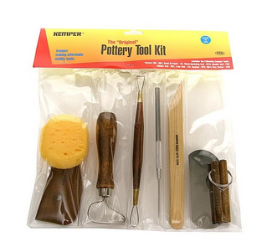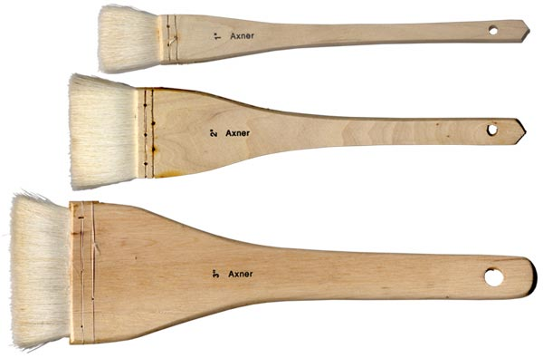[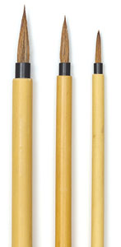](http://www.dickblick.com/zz054/09/%23photos)

# Kemper-Pottery Tool Kit or other starter kit- can be purchased at Clayworks Supplies and other retailers.

Hake and Bamboo Brushes are in the ink section at art supply stores or at Clay Works Supplies.

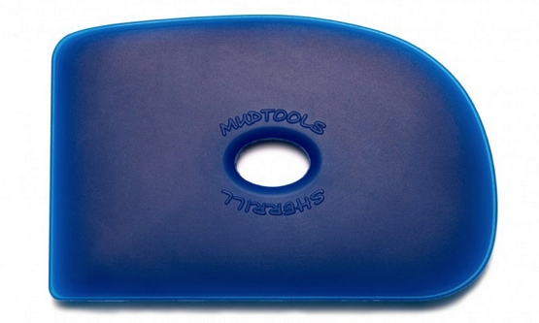 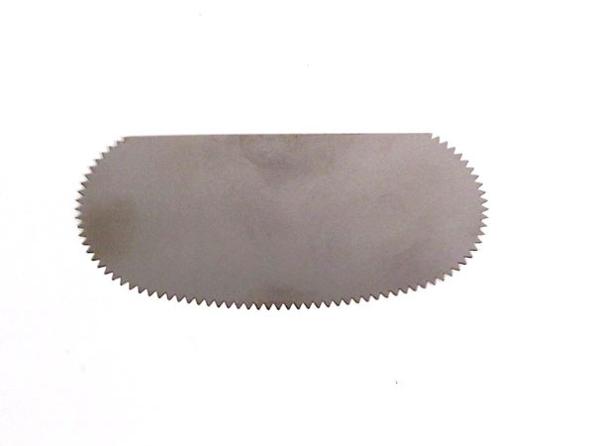 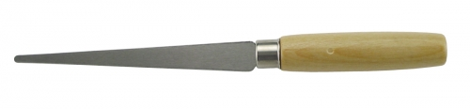

Soft Rib tool, Serrated Rib Tool, Fettling Knife

|  |  |
| --- | --- |
| **Total Points Assigned for Semester: 100** |  |
| **Project Title** | **Points Available** |
| Project 1- Replication and Modernization  (recommend clay- Standard 200, Phoenix or Soldate) | 25 |
| Project 2- Multiples  (recommended slip- cone 6 white stone ware) | 25 |
| Project 3- Figure Studies  (recommend clay- Standard 200, Phoenix or Soldate) | 10 |
| Project 4- Busts  (recommend clay- Phoenix or Soldate) | 25 |
| Artist Statement | 10 |
| Sketch book/Idea File | (5 points from Project 1, 2 and 4 are attributed to your sketchbook) |
| Participation | 5 (this includes required sketchbook notes) |

\*\*\*The course syllabus provides a general plan for the course; deviations may be necessary\*\*\*

**Spring 2016 Semester Calendar**

**Changes may be made to the schedule during the semester- all changes will be announced during class. Students will receive a handout for each assignment that will include current due dates and critique dates.**

**\*** See NOVA’s academic calendar for all Drop/Withdraw dates, official holidays, and other important academic dates.

Week 1- T 8/23 First Day of Class, Syllabus and Expectations, Review Clay and Processes, Wedging and Coiling/ slab roller and extruder, Intro to **Project 1-** **Replication and Modernization**, **HW:** Project 1 work sheet

TH 8/25 Work day- Project 1 worksheet due, fiber/paper clay demo

Week 2- T 8/30 **Wet surface decoration demo day-** Work Day- Replication and Modernization

TH 9/1 Work Day- Replication and Modernization

\*\*\***M 9/5** **Labor Day- No Classes (No open studio hours)\*\*\***

Week 3- T 9/6 Small group in-progress critiques- Work Day-Replication and Modernization

TH 9/8 Work Day- Replication and Modernization

Week 4- T 9/13 Final in-class work day for Project 1 (apply slip and oxide wash as needed), **Introduce Project 2- Multiples, HW: 5 sculpture sketches and objects due 9/20,** Bisque firing refresher

TH 9/15 Project 1 greenware critique (objects should be bone dry by 9/22)

Week 5- T 9/20 **Bisque surface decoration demo day and Mold Making demo-** Objects due!

TH 9/22 **Mold making demo part 2/** work day (load bisque kiln- project 1)

Week 6- T 9/27 Work Day- Multiples, glaze project 1

TH 9/29 Work Day- Multiples (load glaze kiln- project 1)

Week 7- T 10/4 **Introduction to Project 3- Figure Studies**, 1:1 Multiples check-ins- work day

TH 10/6 Work Day- Multiples, Turn in Sketchbooks

Week 8- T 10/11 **Professional development day for faculty- No Classes (Open studio hours available)**

TH 10/13 Figure model sitting, return sketchbooks

**\*\*\*Saturday 10/15- 9:30am RAKU day- work must be glazed and ready by 10/13- NO OPEN STUDIO HOURS\*\*\***

Work must be made of Soldate. You may raku two small pieces- no bigger than 8 inches tall or wide.

Week 9- T 10/18 Figure model sitting

TH 10/20 **Into to Artist Statements**; Intro to **Project 4- Busts**, **HW:** 5 sketches, Work day- refining clay sketches

Week 10- T 10/25 Work day busts and multiples, Sketches due (load bisque kiln- figure studies)

TH 10/27 Work day busts and multiples, Artist Statement Draft Due by 11:59pm

Week 11- T 11/1 Work day busts and multiples, Peer feedback on Artist Statements due by 11:59pm

TH 11/3 **In-progress critique of Multiples**, Work day busts and multiples (load glaze kiln- figure studies)

Week 12- T 11/8 **Critique of Figure Studies**, Work day busts and multiples

TH 11/10 Work day busts and multiples, Discuss cold surface options, **HW:** 3 additional sketches of surface treatment

Week 13- T 11/15 Work day busts and multiples, additional sketches due

TH 11/17 Work day busts and multiples, Post revised artist statement by 11:59pm

Week 14- TH 11/22 Work day- Hollow Busts and begin to dry (forms must be bone dry by 12/6- *do not rush them- dry slowly!*)

TH 11/24 **Non-instructional day- No classes- College offices closed**

**\*\*\* November 23-27- Thanksgiving holiday- College closed (No open studio hours)\*\*\***

Week 15- T 11/29 Final wet day for Busts (should be past leather hard and only require final touches/oxide wash)- forms must be bone dry before class next Tuesday

TH 12/1 **Multiples Critique**, Turn in Sketchbooks

Week 16- T 12/6 Last week of Classes, **Load Final Bisque Kilns**, wrap up of unfinished work

TH 12/8 **Load Final Glaze Kilns**, ***Mandatory Class Clean up*!**

Finals Week- T 12/13 and TH 12/15- **Final Meetings**