Introduction to Biotechnology Techniques

Objectives:
- Define biotechnology and discuss its uses.
- Demonstrate proper use of a micropipette to move small volumes of liquid.
- Define transformation.
- Perform gel electrophoresis and interpret the results.
- Observe transformation in E. coli and discuss the difference between DNA and protein.

Introduction:
Would you like to be able to cure tragic diseases, alleviate world hunger, and clean up the environment? While these may have once seemed impossible feats, progress on each is being made using biotechnology.
The fast-growing field of biotechnology combines biological sciences with technological advances. With biotechnology, biological materials and processes are used to produce a variety of useful products, such as fuel, medicine, food, and information. Thanks to biotechnology, we can now mass produce human insulin for diabetics, create biofuels with bacteria, and modify crops like rice and corn to be more resistant to disease and pests.
There are many tools used in biotechnology. In this lab you will learn to use a few of the most commonly used tools, like micropipettes, microcentrifuges, and gel electrophoresis.

Activity 1: Using a Micropipette and microcentrifuge
A micropipette is an instrument that is used to measure very small volumes of liquid, often measured in microliters, which is 1/1000 of a ml. Different types of micropipettes measure different amounts, usually ranging from 0.5-1,000 µl. In this lab, we will be using micropipettes that can measure volumes of liquid ranging from 0.5-10 µl and 20-200 µl. In activity 1, you will learn to properly use a micropipette to transfer tiny volumes of liquid accurately. This is a skill that requires practice and will be used again to load a gel in activities 2 and 3.
As seen in Figure 1, the top of the micropipette features a plunger that is used to draw up and expel liquid samples. A disposable plastic tip is added to the end of the micropipette. The amount of liquid is determined by the setting on the volume window. This setting can be adjusted by turning the volume setting dial. It can also be changed by turning the plunger. After the liquid has been transferred, the plastic tip is ejected into a waste container by depressing the tip ejector, a separate button connected to a metal releasing lever.

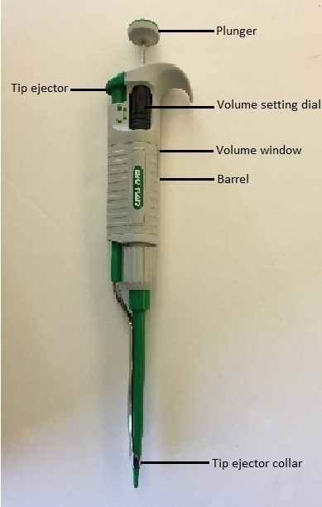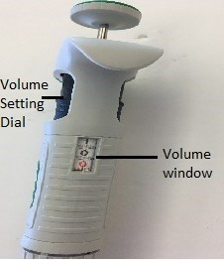
Figure 1: The image on the left shows a micropipette on its side. The image on the right shows the volume window of a micropipette that is set to 10.0 µl.

Your instructor will demonstrate the proper use of a micropipette.
Procedure: Work individually
- Put on gloves. It is always important to wear gloves in a biotech lab.
- Pour 20 ml of colored water from each of the class stock bottles into the 50 ml beakers in your tray.
- Take a weigh boat and put it on your balance. Zero, or tare, your balance.
- Using a P200 micropipette, rotate the volume setting dial so the numbers in the window read 100. Have your instructor check that your micropipette is set correctly and initial below.
Instructor’s Initials: _________
- Hold the micropipette so that your thumb can reach the plunger. The tip ejector button should be near the heel of your hand, so that it is easy for your thumb to reach it. Figure 2 shows how to hold a micropipette.

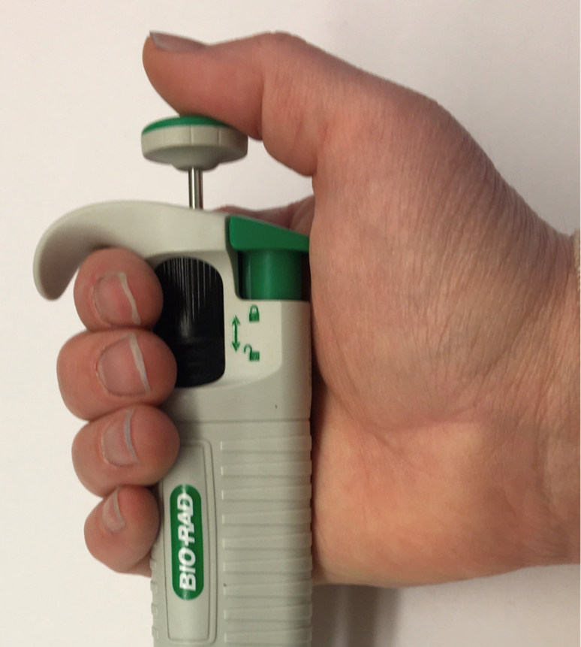
Figure 2: How to hold a micropipette. Your thumb should rest on the plunger and your other fingers should wrap around the barrel.

- Open the 20-200 µl tip box. The tips should be yellow. Add a tip to the micropipette by firmly pressing the end of the micropipette onto the top of a tip.
- Then, use your thumb to press down on the plunger until you feel some light resistance. Hold the plunger down in this position. This is called the “first stop.”
- While still holding the plunger down at the first stop, put the tip into the colored liquid you poured into the beaker and then slowly release your thumb from the plunger. There is now exactly 100 µl of fluid in the tip. If you see air bubbles, you haven’t obtained the proper volume. Note: depressing the plunger below the first stop will cause an inaccurate measurement.
- Always hold your micropipette upright. Turning it upside down with liquid in it can damage the micropipette.
- Now transfer the fluid into the weigh boat on the scale. To do this, depress the plunger until you feel some light resistance (the first stop). Then push a bit harder on the plunger with your thumb, to the “second stop.” (The second stop has more resistance than the first. When you reach the second stop, you will not be able to depress it any further.) You should see a tiny drop of fluid ejected into the weigh boat.
- Once the tip has been emptied, eject the tip into the "Used Tips” container by pressing the tip ejector button with your thumb.
- The weight should be the same in grams as what you just measured in microliters, so 100 µl should be 0.1 g.
Record the weight of the liquid you just pipetted: _________________ How accurate was your pipetting? ____________________________
- Wipe out the weigh boat for your lab partners to use.

Next you will use a micropipette to transfer different volumes of the colored liquid you obtained to microcentrifuge tubes and check your results with your instructor. This is a skill, so don’t worry if you struggle at first. Work individually to make all four tubes.
- Use a sharpie to label four 1.5 ml microcentrifuge tubes A, B, C, and D.
- Using Table 1 below, set your micropipette to the volume under the “yellow dye” column that corresponds with your tube letter (A, B, C, or D).
- Use your micropipette to transfer the volume of yellow dye indicated on the chart to your microcentrifuge tube. Don’t forget to add the plastic tip first! When adding the liquid, press the plastic tip of the microcentrifuge to the side wall of the microcentrifuge tube at a slight angle, then push down on the plunger.
- Discard your tip by pushing on the tip ejector while holding the micropipette over the beaker labeled “Used Tips.”
- Repeat steps 2 and 3 above with the other three colors of dye (green, blue, and red). You must use a new plastic tip each time you switch colors.

Table 1: Volumes to add to the microcentrifuge tubes.
Tube | Yellow Dye (µl) | Green Dye (µl) | Blue Dye (µl) | Red Dye (µl)
A | 199 | 115 | 177 | 152
B | 102 | 21 | 68 | 36
C | 110 | 30 | 112 | 159
D | 27 | 73 | 34 | 28

- Once you have added all four colors of dye to your microcentrifuge tubes, follow the steps below to spin the tubes in a microcentrifuge for a few seconds to bring the mixture of liquids to the bottom of the tubes. To do this:
  - Plug in the small microcentrifuge. Open the lid and insert your four tubes (A, B, C, D). Be sure to balance the microcentrifuge by placing the tubes opposite each other. An unbalanced microcentrifuge is a safety hazard.
  - Completely close the lid of the microcentrifuge and press the switch on the side to turn it on.
  - Allow it to spin for about 5 seconds, then turn the switch off. Allow the microcentrifuge to come to a complete stop before opening the lid to remove your tubes.
- Compare your tubes with the “key” tubes made by your instructor. Is the color the same? Is the volume the same?
Tube | Is the color the same? | Is the volume the same?
A
B
C
D

Have your instructor check and initial here: ______________
*If your tubes do not match the instructor key, repeat the procedure. *
- When you have finished, discard your four microcentrifuge tubes into the trash.

Background for Activity 2: Understanding Genetically Modified Organisms: Transformation and Gel Electrophoresis
Gel Electrophoresis
Gel electrophoresis is a widely used biotechnology technique for analyzing DNA. It is commonly used in biomedical sciences to compare variation in DNA sequences such as between diseased and normal, in evolutionary science to compare the DNA of related species, in forensic sciences to compare DNA from a suspect with that recovered from a crime scene, and to confirm whether transformation has successfully occurred.
In each case, a DNA sample is isolated and restriction enzymes, which cut specific sequences of DNA, are used to “digest” the DNA into specific fragments at specific sequence locations. These fragments will be different sizes and will separate when “run” on an agarose gel. See Figure 3 for the making, loading, and running of a gel.

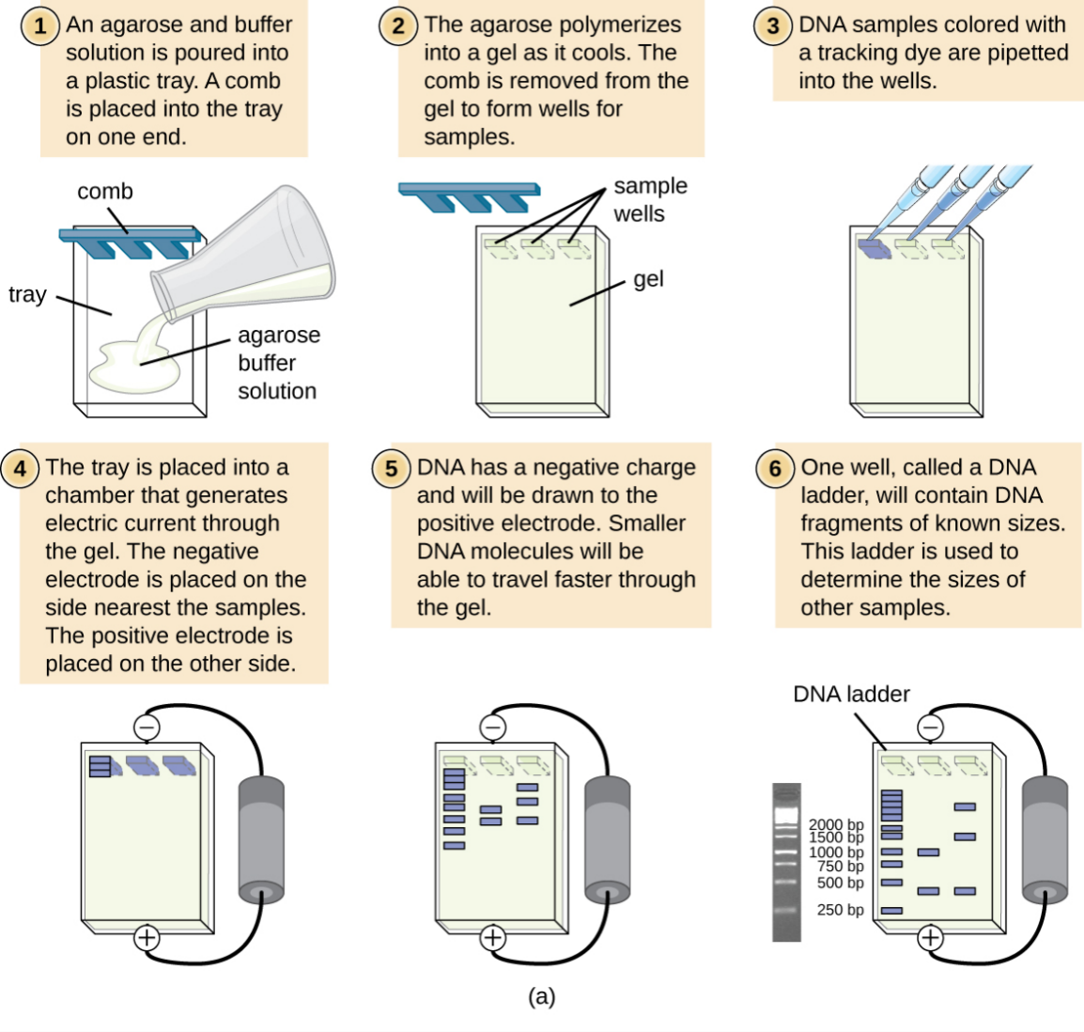
Figure 3: The making, loading, and running of a gel. Image courtesy of OPENSTAX.

Activity 2: Practice Loading a Gel
You will start by loading a practice gel.
- Carefully remove a practice gel from the labeled bag. Place it on a paper towel. Your practice gel will have two rows of tiny slits, called wells, to maximize practice opportunities.
- Set the 10 µl micropipette to 10 µl (it should say 10.0). Open a box of 10 µl micropipette tips (they are clear). Securely attach a pipet tip to the bottom of the pipet by pressing down firmly on the top of a tip.
- You will practice loading the colored water from Activity 1. Pick any color. Draw up a 10.0 µl sample of colored water into your micropipette tip.
- To transfer the sample, place the micropipette directly over a well of your gel. You will need to be very steady! Brace your elbows on the table to ensure that your arms and hands remain steady. Use your dominant hand to load the gel and use your other hand to steady your loading hand.
- Insert the micropipette tip just to the top edge of the well. Gently push the plunger down to the first stop and then to the second stop. The sample will be released from the micropipette and should sink to the bottom of the well. Delay a moment to ensure that all the liquid seeps out of the pipette tip and into the well. Gently pull the tip out of the well. You have now loaded the well.
- Discard the tip.
- Repeat steps 1-6 until all wells are used and you can reliably perform this technique. Be sure to use a fresh tip each time.
Have your instructor check your work and initial here ___________
- After your instructor has initialed above, rinse out your gel in the sink and put it well-side down on a paper towel.

Activity 3: Using gel electrophoresis to determine whether samples contain genes for Golden Rice
You are a regulator at the FDA evaluating applications from companies that have produced the GMO golden rice. Your job today is to evaluate whether the correct genes have been inserted.
First, you will need some background. Golden rice was developed to fight vitamin A deficiency, which can cause blindness and even death. Vitamin A is produced by the body from beta carotene, a compound found in our diet. Two genes, phytoene synthase and carotene desaturase, work together to produce beta carotene. These two genes can be inserted into rice through a process called transformation. The transformed rice produces beta carotene.

Transformation
The process of transferring a gene from one organism into another is called transformation. Transformation is used to manufacture Genetically Modified Organisms (GMOs). The genes inserted into a GMO will usually cause the cells of that organism to produce a new protein (Figure 4).
Many crops are GMOs that have been created by transformation to give them desirable traits such as pest resistance, larger size, increased nutrition, better-taste, or drought resistance. Collectively, these modifications enable farmers to improve their crop yield and/or to serve the people who eat them.
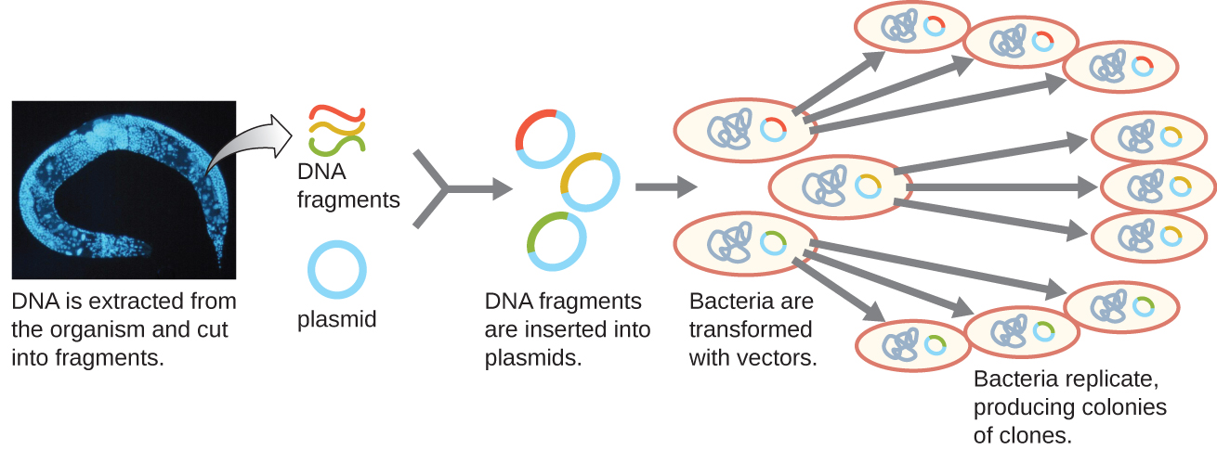
Figure 4: DNA is first extracted from an organism containing the gene of interest. The gene, or genes, are inserted into a plasmid, which is then inserted into bacteria. The bacteria can now make the new genes whenever the DNA in the plasmid is expressed.

Although Figure 4 shows transformation in bacteria, transformation can occur in a wide variety of organisms, including plants and animals.
Procedure: Testing samples for the presence of two genes
Now you are ready to load your samples onto the actual gel. You have four samples in front of you, labeled 1, 2, 3, and 4. These are from four different companies applying for FDA approval for their golden rice. Since transformation does not have a 100% success rate, it is important to test the samples to make sure the process worked. Your job is to evaluate whether any of the samples contain both of the genes needed to produce beta carotene. There are also two controls. The first, labeled “C” for control, is a gene known to exist in all forms of rice. The second, labeled “Golden Rice,” has only the two genes being added (it does not contain any normal rice genes).
- Using your gloved hand remove the sample gel in its tray with 1 row of wells from the labeled bag and carefully place it in the electrophoresis chamber, oriented so that the wells face the negative (black electrode) end. The samples will run to the red end of the chamber, which is the positive end. (“Run to the Red.”)
- Fill the chamber with electrophoresis buffer until the liquid is slightly higher than the gel and all wells are completely covered. Make note of the “Max” fill line and stay at or below that level.
- Set the 10 µl micropipette to 10 µl. Draw up exactly 10 µl of the control sample, labeled C on red tape, into the micropipette and transfer it to the first well of the gel. Remember to brace your elbows and put the tip into the well itself before you start dispensing the liquid from the micropipette. Once the sample is loaded, carefully withdraw the micropipette tip from the well. Discard the tip.
- Use the Table 2 below to record what sample goes in each lane.
- Take turns loading the gel. Get a new tip and use it to draw up and transfer 10 µl of the control golden rice genes, labeled “Golden Rice” on blue tape. Dispense it into well 2. Discard the tip.
- Into well 3, load 10 µl of the first company’s sample, labeled 1 on yellow tape. Discard the tip.
- Into well 4, load 10 µl of the second company’s sample, labeled 2 on green tape. Discard the tip.
- Into well 5, load 10 µl of the third company’s sample, labeled 3 on pink tape. Discard the tip.
- Into well 6, load 10 µl of the fourth company’s sample, labeled 4 on orange tape. Discard the tip.
Table 2: Samples loaded onto the gel
Well | Sample Loaded
1
2
3
4
5
6
- Once the gel is loaded, place the lid on the electrophoresis chamber, aligning the red and black electrodes of the lid with the corresponding positions on the chamber.
- Plug your chamber into the PowerPac and turn the PowerPac on.
- Set the PowerPac to run at 120 mV.
- Press the Run button. (The Run button has a figure of a person running.) You should see bubbles forming in the buffer solution.
- Set a timer for 20 minutes. While your gel is running, start Activity 4.
- After 20 minutes have passed, check your gel. There should be colorful bands on the gel. Press the “Stop” button to stop the run.
- Using your gloved hand to support the entire gel, carefully remove your gel and place it on a paper towel. Fill in Table 3 below.
  - In the “Color of band(s)” column, note the color of each band observed.
  - In the “Distance traveled” column, use a ruler to measure the distance, in mm, from the well to the end of the specific band. (If you have multiple bands or colors, you will have multiple measurements).
- Once you have recorded the data, discard the gels in the trash, empty the buffer into the sink, and rinse and dry the gel electrophoresis apparatus.

Table 3: Sample data run on gel at 120 mV
Well | Sample Loaded | Color of band(s) seen | Distance travelled for each band (mm)
1
2
3
4
5

6

Questions:
- Compare the control band to the samples from the companies. Are they the same or different? What does this tell you about the samples?

- Compare the four test samples to the control bands. Did any of the samples have both the phytoene synthase and the carotene desaturase?
 | Sample 1 | Sample 2 | Sample 3 | Sample 4
Colors (genes) Found

- Which of the products from companies #1-4 would you recommend for approval by the FDA? Why?

- What are the benefits of using biotechnology to produce GMO products in general? What is a benefit in this simulation specifically?

Activity 4: Observing bacterial transformation in E. coli
You have just tested whether transformation has occurred using gel electrophoresis, comparing whether two genes introduced gene were successfully introduced to rice.
Bacteria contain genomic DNA which is not contained within a nucleus. In addition, they can have a separate circular piece of DNA called a plasmid. Biotechnology capitalizes on the presence of this extra-chromosomal piece of DNA to help transfer genes of interest. When the plasmid copies itself, the new gene is copied as well. Since bacteria trade plasmids, the inserted gene can easily be transferred amongst colonies of bacteria.
When the gene is expressed, the resulting Green Florescent Protein (GFP) glows green when viewed under ultraviolet (UV) light.
In your tray are petri dishes containing E. coli that were transformed by the Cell Biology (BIO 206) class. These bacteria have had the pGLO plasmid, which contains the gene for GFP, inserted. First we will test whether the GFP protein is being actively expressed by the bacteria. Your tray also contains a microcentrifuge tube containing only the pGLO plasmid, without bacteria. Secondly, we will use the technique of gel electrophoresis to confirm that the pGLO plasmid contains the GFP gene. The genomic bacterial DNA is too large to be run on a gel, but the plasmid is small enough and can be run on a gel.

Procedure
- Compare the transformed and the control plates. Do you expect either plate to glow green?
Yes / No

- Observe the small 1.5 ml tube labeled plasmid DNA. This tube contains isolated plasmid, not bacteria. This plasmid contains the GFP gene. Do you expect it to glow green under a UV light? Circle your prediction.
Yes / No

- Shine the UV light over the plasmid. Does it glow green? Circle your observation.
Yes / No

- Turn on the UV light. Does the transformed plate glow green? Circle your observation.
Yes / No

- Does the control plate glow green?

Yes / No

- Consider your answer to questions #3-5. What does this result tell you about the pGLO plasmid and about the GFP protein?

- Which of the items (petri dish or microcentrifuge tube) glowed under the UV light? Why would one glow and not the other? What is the difference between what is in the petri dish and what is in the microcentrifuge tube? Which (petri dish or microcentrifuge tube) contains the entire organism, proteins and all? What is in the other container?

Figure Citations:
Figures 3 and 4. © 2022 OpenStax Microbiology, Visualizing and Characterizing DNA, RNA, and Protein licensed under CC BY 4.0.
Original artwork by M. Williamson: Figures 1, 2. Introduction to Biotechnology Techniques © 2023 by M. Williamson is licensed under CC BY-NC-SA 4.0

