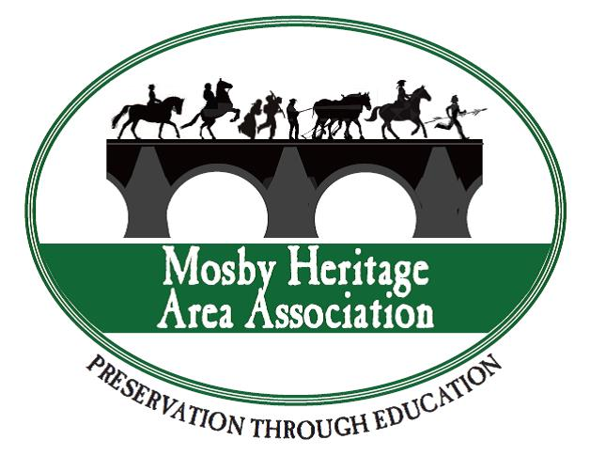
FOR IMMEDIATE RELEASE
Contact: Jennifer Moore, MHAA 540-687-6681

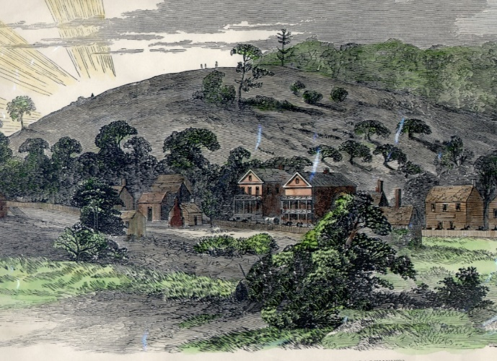
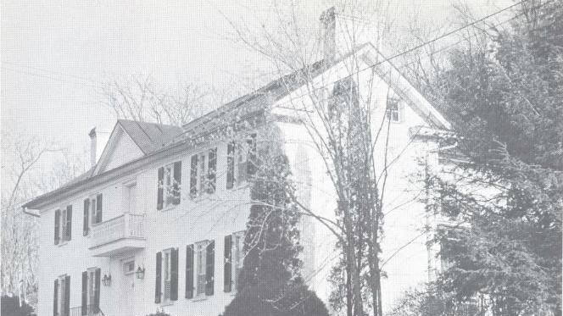

Left, Woodburn Tavern and Right, Aldie Gap

Area Organizations Partner to Bring “History of Aldie Village” Event on Feb. 15^{th,} In Response to Demolition Plans

MIDDLEBURG, VA, January 29, 2018, A program on “The History of Aldie Village” on Thursday, February 15th, from 5:30pm-7:00pm at the Aldie United Methodist Church, 39325 John S Mosby Hwy, Aldie, VA 20105. The speakers at this program will discuss the historical importance of Aldie and the buildings which are threatened with demolition so that a new firehouse can be built.

The Loudoun County Board of Supervisors have distributed a plan outlining the demolition of three historic buildings: The Woodburn Tavern, 39491 John Mosby Highway, a Victorian residence at 39469 John Mosby Highway, and a cottage at 39493 John Mosby Highway. Additionally, alterations will be required to the floodplains, the steep slopes, and other environmental impediments to install a facility on the proposed scale. Area citizens are upset with these plans and a petition with over 3,000+ signatures seek relocation of this firehouse. This program is sponsored by the Mosby Heritage Area Association, the Aldie Heritage Association, Lovettsville Historical Society, the Civil War Trust, and other area nonprofits.

The proposed Aldie Fire Station No. 7 would be directly on the core battlefield of the June, 17, 1863 Battle of Aldie, which was the opening battle of the “Prelude to Gettysburg” cavalry battles including the later battles of Middleburg and Upperville. The Southern cavalry under Gen. J.E.B. Stuart performed a screening movement as Gen. Robert E. Lee’s troops moved across the Potomac invading the North again. This cavalry action prevented the Union from reaching the Blue Ridge Mountains, therefore allowing Lee to move successfully north and eventually resulting in the Battle of Gettysburg July 1-3, 1863.

Featured speakers on Feb. 15th include: Florian Hauswiesner of the Aldie Heritage Association, Kristen Pawlak of the Civil War Trust, area historian Wynne Saffer, and Kevin Pawlak of the Mosby Heritage Area Association, among others. Members of the Press are urged to attend. For more information, call 540-687-6681.

The mission of the nonprofit Mosby Heritage Area Association, formed in 1995, is to help preserve the Northern Virginia Piedmont and increase public knowledge about this historic area. MHAA provides classroom history programs for elementary, middle, and high school students, sponsors lectures, programs, publications, guides, and field trips, and brings nationally known scholars to the area for its award-winning annual Civil War Conference. For more information, visit www.mosbyheritagearea.org.

