HISTORICAL GEOLOGY (GOL 106)
LAB PRACTICAL II FOSSIL STUDY SET

By Jim Buecheler
Geology Program Assistant
NOVA, Annandale
2011.
INTRODUCTION
This fossil practice set has been assembled for use by student geologists who wish to better familiarize themselves with identifying the various fossils, their modes of preservation, and their life habits. Use your laboratory manual (Historical Geology Interpretations and Applications, Poort & Carlson, Pearson Prentice Hall, 6th ed., 2005.), completed labs, textbook, notes and any other available resources to fill out the attached fossil identification worksheets. The more you practice with and familiarize yourself with these fossils, the quicker and easier it will become to identify the various fossil organisms and the features that distinguish them from one another.
Work with only one basket/cup at a time. When finished, return the specimens to the basket they came from before moving on to the next one. This will prevent samples from getting mixed up and placed in the wrong numbered baskets and will maintain the integrity of the answer key. Also, handle the specimens carefully and with respect so that others may also make use of the study set. Remember, some of these fossils have survived hundreds of millions of years before finding their way to the NOVA Science Learning Center for you to observe and enjoy!

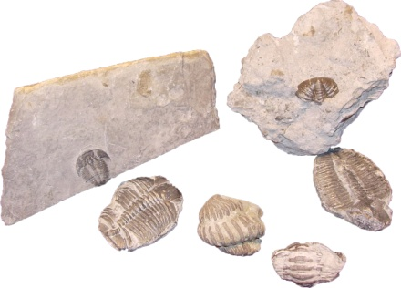 | - Identify the name/class of these fossils:  What phylum do these fossils belong?  What type of symmetry do these fossils exhibit?  During what geologic period did this organism first appear and when did it go extinct?  Was this species typically benthonic, nektonic, or planktonic?  What process occurs as this organism grows?
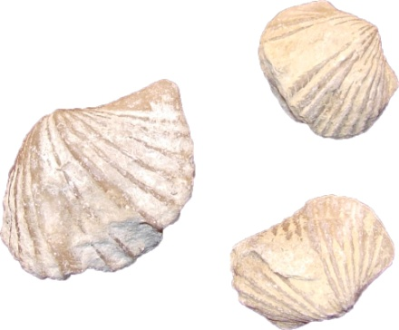 | - Identify the name/class of these fossils:  Are these organisms predominantly benthic, nektonic, or planktonic?  These organisms are common index fossils for what geologic Era (Paleozoic, Mesozoic, or Cenozoic)?
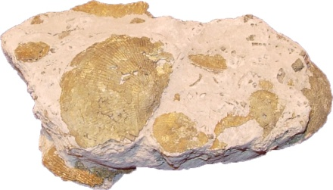 | What mode of preservation is exhibited in this sample?
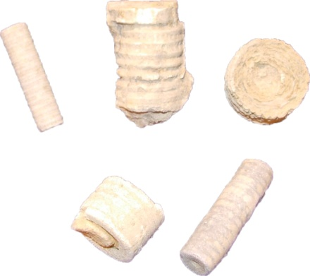 | - Identify the name/class of these fossils:  Are these primarily sessile or vagrant organisms?  During what geologic period were these organisms most abundant?
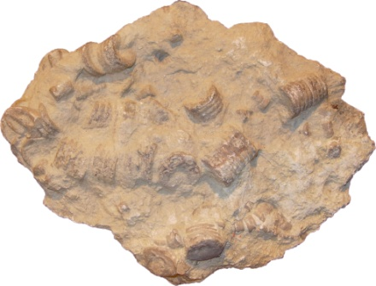 | What is the name of this sedimentary rock composed primarily of the fossil remains of this organism?
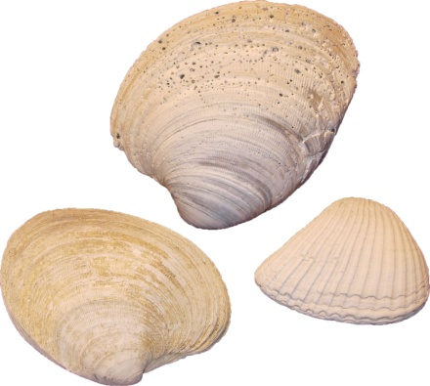 | - Identify the name/class of these fossils:  What type of symmetry do these fossils exhibit?  One of these shells is littered with lots of small holes. What are these called?  What is indicated by the size of the pallial sinus?
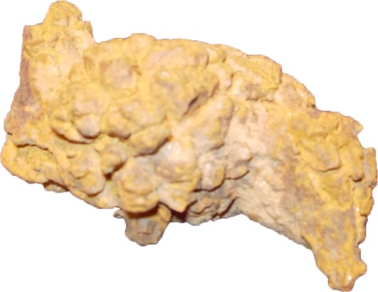 | - Identify this “special” trace fossil:  From studying these types of fossils, what type of information might a paleontologist be able to determine about the organism that produced this specimen?
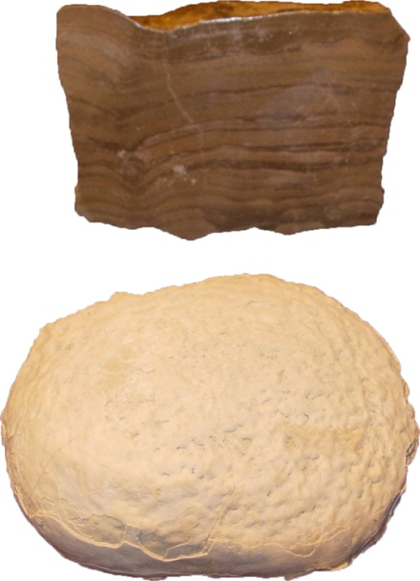 | - Identify the name/class of these fossils:  In what Kingdom do these organisms belong?  Are these fossils good geopetal indicators?  When in geologic time were these organisms the most abundant?
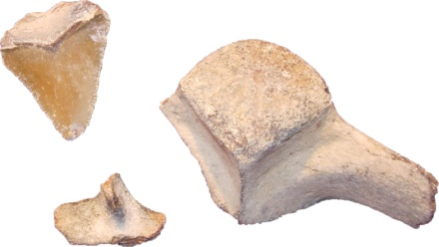 | - What mode of preservation is represented by these samples (permineralization, recrystallization, replacement, external molds, internal molds, or unaltered materials)  Can you broadly identify these fossils?
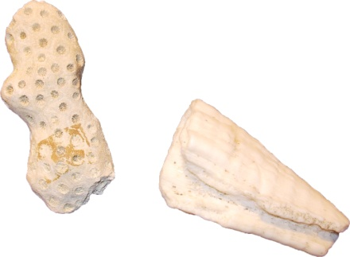 | - Identify the phylum and class for all of these fossils:  Identify these fossils:  In what geologic period did these organisms first appear?  Are these organisms solitary, colonial, or both?  Are these organisms well-attached, poorly attached, or unattached to the bottom?
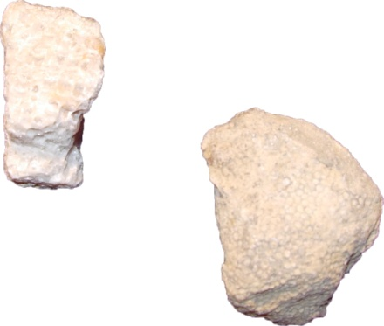 | Identify these fossils:  During what geologic period did this organism first appear and when did it go extinct?  Were these organisms solitary, colonial, or both?  Were these organisms well-attached, poorly attached, or unattached to the bottom?
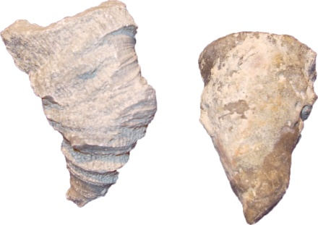 | Identify these fossils:  During what geologic period did this organism first appear and when did it go extinct?  Were these organisms solitary, colonial, or both?  Were these organisms well-attached, poorly attached, or unattached to the bottom?
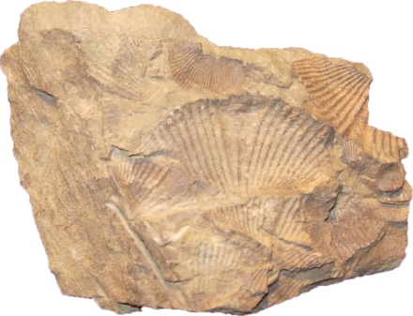 | - Identify the name/class of these fossils:  What mode of preservation is exhibited in this sample?
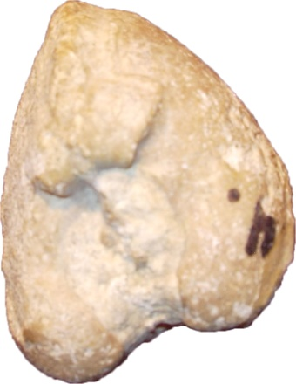 | - Identify the name/class of this fossil:  What mode of preservation is exhibited in this sample?
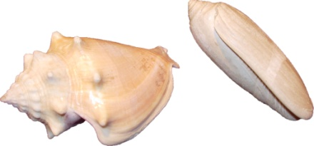 | - Identify the phylum for all of these fossils:  Identify the name/class of these fossils:  Are these organisms benthic, nektonic, or planktonic?  Are their shells single or multi-chambered?
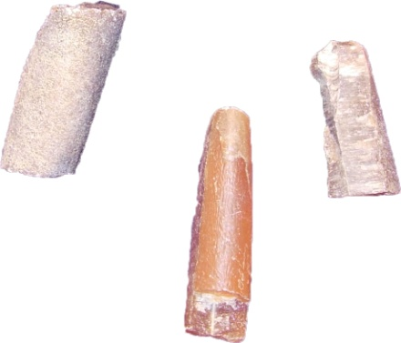 | Identify the class and subclass of these fossils:  These organisms are thought to be related to what modern species?
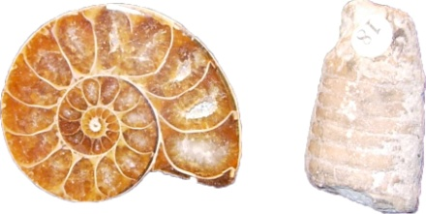 | Identify the class and subclass of these fossils:  Are these organisms benthic, nektonic, or planktonic?  Do these organisms have simple or complex sutures?  In what geologic period did this organism first appear?
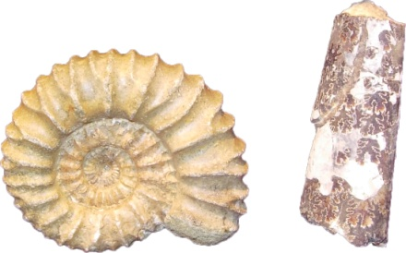 | Identify the class and subclass of these fossils:  Do these organisms have simple or complex sutures?  What Cretaceous reptile made these organisms their prey?
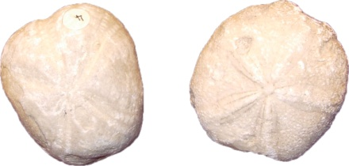 | - Identify the phylum for all of these fossils:  Identify the name/class of these fossils:  What type of symmetry do these organisms exhibit?  Are these organisms benthic, nektonic, or planktonic?  Are these sessile or vagrant organisms?
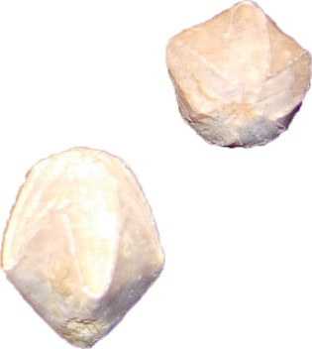 | Identify the name/class of these fossils:  Are these sessile or vagrant organisms?  During what geologic period did this organism first appear and when did it go extinct?
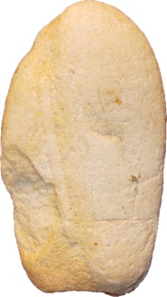 | - This sample preserves what type of trace fossil?  What is this dwelling trace preserved in a quartzose beach sandstone (Cambrian) called?
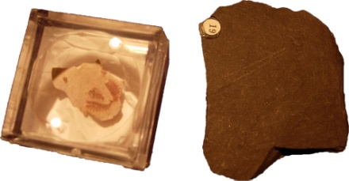 | - Identify the name/class of these fossils:  During what geologic period did this organism first appear and when did it go extinct?  Were these organisms benthic, nektonic, or planktonic?
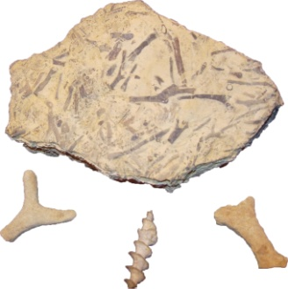 | - Identify the name/class of these fossils:  In what geologic period did these organisms first appear?  Are these organisms solitary, colonial, or both?  Are these sessile or vagrant organisms?
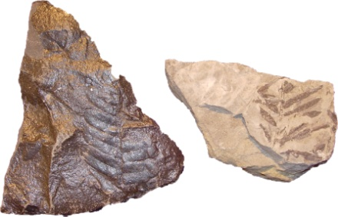 | - What mode of preservation is exhibited in this sample?  Are these fossil remains more likely associated with the Pennsylvanian or the Cretaceous?

