COMMON MINERAL IDENTIFICATION PRACTICE SET
By Jim Buecheler
Geology Program Assistant
NOVA, Annandale
2017.
INTRODUCTION
This mineral practice set has been assembled for use by student geologists who wish to better familiarize themselves with some of the common rock forming minerals and their identification. The ability to recognize and identify minerals is an important skill that you will use, not just to identify individual minerals, but to identify and classify the different types of rocks as well. They also provide useful information about the conditions under which rocks were formed and provide clues to the geologic history of the region where they are located.
The following mineral practice set includes 44 samples of 23 common rock forming minerals. Use the mineral identification kits provided (orange baskets), mineral identification charts, and the figures & mineral database in this handout to fill out the worksheets and identify the samples. The more you practice with and familiarize yourself with these minerals, the easier it will become to recognize and identify them both individually and as components within the rocks.

GUIDELINES FOR ROCK & MINERAL IDENTIFICATION
- Work with only one category of unknown samples at a time (minerals, igneous, sedimentary or metamorphic). Return the complete sample set to the geology cabinet before moving on to another unknown sample set.
- Each basket contains two distinctly different samples for identification/classification. It is suggested that you select one of the two samples from the basket to work with before returning it and working with the second sample.
- Work with only one basket (2 samples) at a time. When finished, return both samples to the basket they came from before moving on to the next one. This will prevent samples from getting mixed up and placed in the wrong numbered baskets and will maintain the integrity of the answer key.
- Use the mineral identification kits (orange baskets) to help you identify minerals and classify the rocks as needed. An optical microscope is also available in the Science Learning Center (SLC) for closer examination. Remember to use caution and good judgment when using the bottles of HCl. Although the acid test is often good fun, try to limit your use of HCl to those samples that you believe have a reasonable chance of fizzing. There is no need to hit every sample with HCl.
- Use your textbook, lab manual, class notes, or other available resources to help you identify minerals and classify the variety of rocks.
- Have fun! Some of the samples found in these sets are intended to challenge you, so don’t be discouraged if you’re stumped…in the field, not every rock or mineral you encounter will be a pristine museum quality sample. Geology is rarely so simple. ☺

MINERAL IDENTIFICATION PROCEDURE
A Step-by-Step Guide

Basic rock-forming mineral identification is mostly a process of elimination based on the observable properties of the sample. For each unknown, make note of the observable properties in the tables provided, and once you have made an identification, answer the trio of follow-up questions about that mineral.

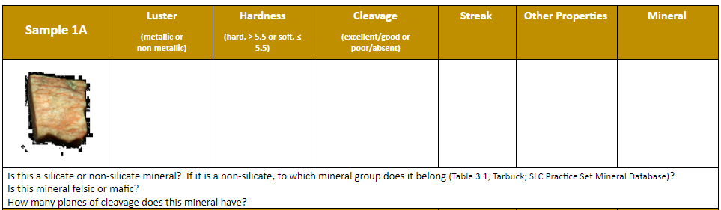

STEP 1: What is the mineral’s luster? Is it metallic or non-metallic? Make note of the luster on the table.

STEP 2: If the mineral is non-metallic, determine whether it is a light- or dark-colored mineral.

STEP 3: You should now have enough enough information to narrow down your possibilities to either metallic, dark-colored non-metallic, or light-colored non-metallic minerals. Consult the SLC mineral practice set identification chart, your course handouts, or your Geology lab manual to focus on that subset of possibilities.

STEP 4: Using the Mohs hardness scale, determine whether the mineral is hard (greater than 5.5) or soft (less than or equal to 5.5). It is usually not necessary to determine the specific numerical hardness of the mineral for identification; only whether it is hard or soft. Make note of the hardness on the table. You have now further reduced the possibilities.

PRO TIP: Use the glass plate and masonry nail for this test. Both have a hardness of ~5.5 and can be used to quickly determine whether the mineral is hard or soft. Soft minerals will not scratch the glass plate, but can be scratched and “powdered” off the sample with the masonry nail. Hard minerals will scratch the glass plate, but cannot be scratched or “powdered” with the masonry nail.

STEP 5: Examine the mineral to determine whether the mineral has good to excellent cleavage or if cleavage is absent or poor. As with hardness, don’t worry about the specific type of cleavage or how many cleavage planes there are. Simply determine whether it has cleavage or not. Make note of the cleavage on the table. You have new reduced the possibilities even further.

PRO TIP: Rotate the sample around look for flat, parallel, and reflective surfaces that capture the light form overhead. Does the sample exhibit any geometry (layered sheets, cubes, rhombohedrons, octahedrons, etc.)? These are often indicators of mineral cleavage. However, be cautious of minerals which may exhibit crystal forms such as prisms (quartz) or octahedrons (garnet), but do not have cleavage. Remember, if you smash a beautiful quartz prism or garnet octahedron with a hammer, it won’t cleave into more prisms or octahedrons, but will shatter into lots of pieces! That’s fracture.

STEP 6: At this point, you may have some idea as to what mineral you are trying to identify, but may need to make a few more observations to confirm your suspicions. Use the white or black porcelain streak plates to determine the streak color of the mineral and make note of the color on the table. For some minerals, this may be enough information to make an identification. For others, you may need to continue checking for other properties.

STEP 7: Observe and test the sample for other properties and make note of them on the table. Properties to look and test for include:
- Reaction with acid (HCl): Use a few drops from the acid bottle to test for effervescence. Reacts with calcite and powdered dolomite.
- Striations or exsolution lamellae/perthitic wisps: Striations are straight, parallel grooves that appear on the cleavage surfaces of some plagioclase feldspars. Exsolution lamellae or perthitic wisps are subparallel, discontinuous lines that appear within the mineral, not on the cleavage surface, of potassium feldspars. Look for these features to help distinguish between the feldspars.
- Magnetism: Use the magnet in the mineral test kit and see if it sticks. If so, it’s magnetite.
- Color: Although color is a terrible way to identify minerals, it may be useful once you have first considered all the other properties. Colors such as olive or apple green for olivine, dark red for garnets, and pink or salmon for potassium feldspar.

STEP 8: Now that you have identified the mineral, take a few moments to answer the trio of follow-up questions about the sample. Use the figures and SLC Practice Set Mineral Database at the end of this packet or other course materials to answer these questions.

STEP 9: Check your answers with the answer key. Do not hesitate to consult the answer key as you work, or if you are having difficulty identifying a sample. Better to check the answer key and then work through the various properties to determine what you missed or had confused about the sample.

PRO TIP: Check the SLC schedule and visit during geology tutoring times with NOVA geology program assistant Jim Buecheler. If these times do not work with your schedule, contact him to coordinate an appointment for additional help and identification tips.

Sample 1A | Luster | Hardness | Cleavage | Streak | Other Properties | Mineral
 | (metallic or non-metallic) | (hard, > 5.5 or soft, ≤ 5.5) | (excellent/good or poor/absent)
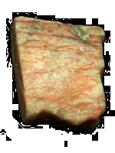
Is this a silicate or non-silicate mineral? If it is a non-silicate, to which mineral group does it belong (Table 3.1, Tarbuck; SLC Practice Set Mineral Database)?
Is this mineral felsic or mafic?
How many planes of cleavage does this mineral have?
Sample 1B | Luster | Hardness | Cleavage | Streak | Other Properties | Mineral
 | (metallic or non-metallic) | (hard, > 5.5 or soft, ≤ 5.5) | (excellent/good or poor/absent)
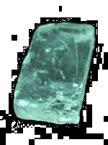
Is this a silicate or non-silicate mineral? If it is a non-silicate, to which mineral group does it belong (Table 3.1, Tarbuck; SLC Practice Set Mineral Database)?
How many planes of cleavage does this mineral have?
This mineral exhibits what type of cleavage?
Sample 2A | Luster | Hardness | Cleavage | Streak | Other Properties | Mineral
 | (metallic or non-metallic) | (hard, > 5.5 or soft, ≤ 5.5) | (excellent/good or poor/absent)
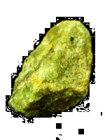
Is this a silicate or non-silicate mineral? If it is a non-silicate, to which mineral group does it belong?
Would you expect this mineral to crystallize at high (~1200 C°) or low (~550 C°) temperatures?
What are some common uses for this mineral?
Sample 2B | Luster | Hardness | Cleavage | Streak | Other Properties | Mineral
 | (metallic or non-metallic) | (hard, > 5.5 or soft, ≤ 5.5) | (excellent/good or poor/absent)
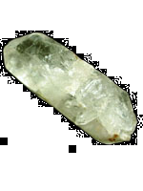
Is this a silicate or non-silicate mineral? If it is a non-silicate, to which mineral group does it belong?
What is the crystal form (habit) of this mineral?
How many planes of cleavage does this mineral have?

Sample 3A | Luster |  | Hardness |  | Cleavage |  | Streak |  | Other Properties |  | Mineral
 | (metallic or non-metallic) |  | (hard, > 5.5 or soft, ≤ 5.5) |  | (excellent/good or poor/absent)
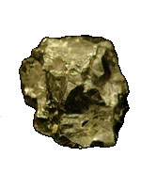
Is this a silicate or non-silicate mineral? If it is a non-silicate, to which mineral group does it belong?
What is the crystal form (habit) of this mineral?
What are some common uses for this mineral?
Sample 3B | Luster |  | Hardness |  | Cleavage |  | Streak |  | Other Properties |  | Mineral
 | (metallic or non-metallic) |  | (hard, > 5.5 or soft, ≤ 5.5) |  | (excellent/good or poor/absent)
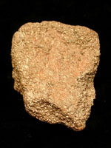
Is this a silicate or non-silicate mineral? If it is a non-silicate, to which mineral group does it belong?
This mineral exhibits what type of cleavage?
Did this sample most likely form in igneous environments associated with molten rock, in sedimentary environments associated with the chemical precipitation of dissolved iron from ancient seas, or in metamorphic environments associated with extreme heat and pressure?
Sample 4A |  | Luster |  | Hardness |  | Cleavage |  | Streak |  | Other Properties | Mineral
 |  | (metallic or non-metallic) |  | (hard, > 5.5 or soft, ≤ 5.5) |  | (excellent/good or poor/absent)
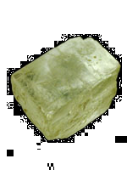
Is this a silicate or non-silicate mineral? If it is a non-silicate, to which mineral group does it belong?
What is the crystal form (habit) of this mineral?
What is the chemical formula of this mineral?
Sample 4B |  | Luster |  | Hardness |  | Cleavage |  | Streak |  | Other Properties | Mineral
 |  | (metallic or non-metallic) |  | (hard, > 5.5 or soft, ≤ 5.5) |  | (excellent/good or poor/absent)
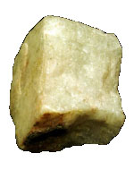
Is this a silicate or non-silicate mineral? If it is a non-silicate, to which mineral group does it belong?
How many planes of cleavage does this mineral have?
This mineral exhibits what type of cleavage?

Sample 5A | Luster | Hardness | Cleavage | Streak | Other Properties | Mineral
 | (metallic or non-metallic) | (hard, > 5.5 or soft, ≤ 5.5) | (excellent/good or poor/absent)
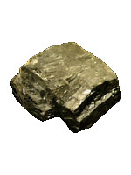
Is this a silicate or non-silicate mineral? If it is a non-silicate, to which mineral group does it belong?
How many planes of cleavage does this mineral have?
What is the chemical formula for this mineral?
Sample 5B | Luster | Hardness | Cleavage | Streak | Other Properties | Mineral
 | (metallic or non-metallic) | (hard, > 5.5 or soft, ≤ 5.5) | (excellent/good or poor/absent)
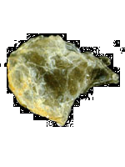
Is this a silicate or non-silicate mineral? If it is a non-silicate, to which mineral group does it belong?
How many planes of cleavage does this mineral have?
Would you expect this mineral to crystallize at high (~1200 C°) or low (~550 C°) temperatures?

Sample 6A | Luster | Hardness | Cleavage | Streak | Other Properties | Mineral
 | (metallic or non-metallic) | (hard, > 5.5 or soft, ≤ 5.5) | (excellent/good or poor/absent)
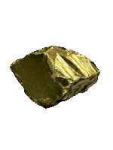
Is this a silicate or non-silicate mineral? If it is a non-silicate, to which mineral group does it belong?
How many planes of cleavage does this mineral have?
What is the chemical formula for this mineral?
Sample 6B | Luster | Hardness | Cleavage | Streak | Other Properties | Mineral
 | (metallic or non-metallic) | (hard, > 5.5 or soft, ≤ 5.5) | (excellent/good or poor/absent)
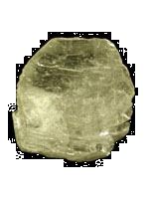
Is this a silicate or non-silicate mineral? If it is a non-silicate, to which mineral group does it belong?
This mineral often exhibits what type of cleavage?
What is the crystal form (habit) of this sample? What other crystal forms can this mineral exhibit?

Sample 7A | Luster | Hardness | Cleavage | Streak | Other Properties | Mineral
 | (metallic or non-metallic) | (hard, > 5.5 or soft, ≤ 5.5) | (excellent/good or poor/absent)
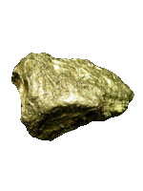
Is this a silicate or non-silicate mineral? If it is a non-silicate, to which mineral group does it belong?
What is the chemical formula for this mineral?
What are some common uses for this mineral?
Sample 7B | Luster | Hardness | Cleavage | Streak | Other Properties | Mineral
 | (metallic or non-metallic) | (hard, > 5.5 or soft, ≤ 5.5) | (excellent/good or poor/absent)
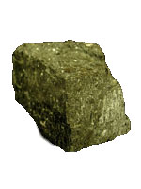
Is this a silicate or non-silicate mineral? If it is a non-silicate, to which mineral group does it belong?
This mineral often exhibits what type of cleavage?
This mineral is characterized by two prominent cleavage directions that intersect at approximately what angles?

Sample 8A | Luster | Hardness | Cleavage | Streak | Other Properties | Mineral
 | (metallic or non-metallic) | (hard, > 5.5 or soft, ≤ 5.5) | (excellent/good or poor/absent)
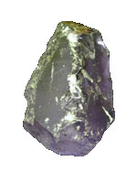
Is this a silicate or non-silicate mineral? If it is a non-silicate, to which mineral group does it belong?
What is the crystal form (habit) of this mineral?
What is the specific hardness of this mineral?
Sample 8B | Luster | Hardness | Cleavage | Streak | Other Properties | Mineral
 | (metallic or non-metallic) | (hard, > 5.5 or soft, ≤ 5.5) | (excellent/good or poor/absent)
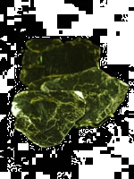
Is this a silicate or non-silicate mineral? If it is a non-silicate, to which mineral group does it belong?
How many planes of cleavage does this mineral have?
This mineral exhibits what type of cleavage?

Sample 9A | Luster | Hardness | Cleavage | Streak | Other Properties | Mineral
 | (metallic or non-metallic) | (hard, > 5.5 or soft, ≤ 5.5) | (excellent/good or poor/absent)
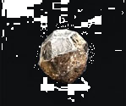
Is this a silicate or non-silicate mineral? If it is a non-silicate, to which mineral group does it belong?
What is the crystal form (habit) of this mineral?
Does this mineral form in igneous environments associated with molten rock, in sedimentary environments at the earth’s surface associated with evaporation of ancient seas, or in metamorphic environments associated with extreme heat and pressure?
Sample 9B | Luster | Hardness | Cleavage | Streak | Other Properties | Mineral
 | (metallic or non-metallic) | (hard, > 5.5 or soft, ≤ 5.5) | (excellent/good or poor/absent)
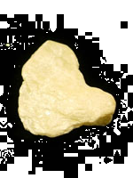
Is this a silicate or non-silicate mineral? If it is a non-silicate, to which mineral group does it belong?
How many planes of cleavage does this mineral have?
What are some common uses for this mineral?
Sample 10A | Luster | Hardness | Cleavage | Streak | Other Properties | Mineral
 | (metallic or non-metallic) | (hard, > 5.5 or soft, ≤ 5.5) | (excellent/good or poor/absent)
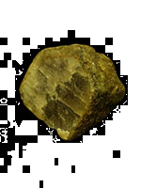
Is this a silicate or non-silicate mineral? If it is a non-silicate, to which mineral group does it belong?
What is the crystal form (habit) of this mineral?
This mineral often exhibits what type of cleavage?
Sample 10B | Luster | Hardness | Cleavage | Streak | Other Properties | Mineral
 | (metallic or non-metallic) | (hard, > 5.5 or soft, ≤ 5.5) | (excellent/good or poor/absent)
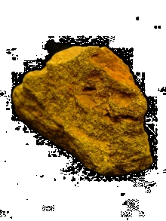
Is this a silicate or non-silicate mineral? If it is a non-silicate, to which mineral group does it belong?
Does this mineral form in igneous environments associated with molten rock, in sedimentary environments at the earth’s surface associated with the weathering of other silicate minerals, or in metamorphic environments associated with extreme heat and pressure?
What are some common uses for this mineral?
Sample 11A | Luster | Hardness | Cleavage | Streak | Other Properties | Mineral
 | (metallic or non-metallic) | (hard, > 5.5 or soft, ≤ 5.5) | (excellent/good or poor/absent)
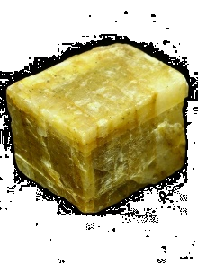
Is this a silicate or non-silicate mineral? If it is a non-silicate, to which mineral group does it belong?
This mineral exhibits what type of cleavage?
This mineral has three prominent cleavage directions that intersect at approximately what angles?
Sample 11B | Luster | Hardness | Cleavage | Streak | Other Properties | Mineral
 | (metallic or non-metallic) | (hard, > 5.5 or soft, ≤ 5.5) | (excellent/good or poor/absent)
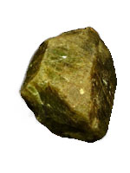
Is this a silicate or non-silicate mineral? If it is a non-silicate, to which mineral group does it belong?
What is the crystal form (habit) of this mineral?
This mineral often exhibits what type of cleavage?

Sample 12A |  | Luster |  | Hardness |  | Cleavage |  | Streak |  | Other Properties |  | Mineral
 |  | (metallic or non-metallic) |  | (hard, > 5.5 or soft, ≤ 5.5) |  | (excellent/good or poor/absent)
Is this a silicate or non-silicate mineral? If it is a non-silicate, to which mineral group does it belong?
How many planes of cleavage does this mineral have?
This mineral exhibits what type of cleavage?
Sample 12B |  | Luster |  | Hardness |  | Cleavage |  | Streak |  | Other Properties |  | Mineral
 |  | (metallic or non-metallic) |  | (hard, > 5.5 or soft, ≤ 5.5) |  | (excellent/good or poor/absent)
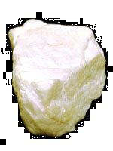
Is this a silicate or non-silicate mineral? If it is a non-silicate, to which mineral group does it belong?
What are some common uses for this mineral?
Depending on the igneous chemistry and environment during crystallization, two different ions (elements) may substitute for one another in this mineral. What are they?
Sample 13A | Luster |  | Hardness |  | Cleavage |  | Streak |  | Other Properties |  | Mineral
 | (metallic or non-metallic) |  | (hard, > 5.5 or soft, ≤ 5.5) |  | (excellent/good or poor/absent)
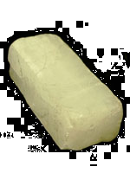
Is this a silicate or non-silicate mineral? If it is a non-silicate, to which mineral group does it belong?
What type of bond forms this mineral (ionic, covalent, metallic)?
How many planes of cleavage does this mineral have?
Sample 13B | Luster |  | Hardness |  | Cleavage |  | Streak |  | Other Properties |  | Mineral
 | (metallic or non-metallic) |  | (hard, > 5.5 or soft, ≤ 5.5) |  | (excellent/good or poor/absent)
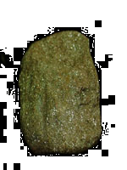
Is this a silicate or non-silicate mineral? If it is a non-silicate, to which mineral group does it belong?
This mineral exhibits what type of cleavage?
What is the chemical formula of this mineral?

Sample 14A | Luster | Hardness | Cleavage | Streak | Other Properties | Mineral
 | (metallic or non-metallic) | (hard, > 5.5 or soft, ≤ 5.5) | (excellent/good or poor/absent)
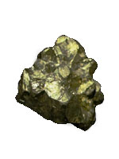
Is this a silicate or non-silicate mineral? If it is a non-silicate, to which mineral group does it belong?
This mineral exhibits what type of cleavage?
What is the chemical formula for this mineral?
Sample 14B | Luster | Hardness | Cleavage | Streak | Other Properties | Mineral
 | (metallic or non-metallic) | (hard, > 5.5 or soft, ≤ 5.5) | (excellent/good or poor/absent)
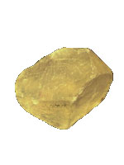
Is this a silicate or non-silicate mineral? If it is a non-silicate, to which mineral group does it belong?
This mineral exhibits what type of cleavage?
How many planes of cleavage does this mineral have?

Sample 15A | Luster | Hardness | Cleavage | Streak | Other Properties | Mineral
 | (metallic or non-metallic) | (hard, > 5.5 or soft, ≤ 5.5) | (excellent/good or poor/absent)
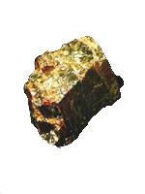
Is this a silicate or non-silicate mineral? If it is a non-silicate, to which mineral group does it belong?
This mineral exhibits what type of cleavage?
What are some common uses for this mineral?
Sample 15B | Luster | Hardness | Cleavage | Streak | Other Properties | Mineral
 | (metallic or non-metallic) | (hard, > 5.5 or soft, ≤ 5.5) | (excellent/good or poor/absent)
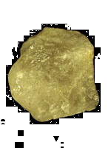
Is this a silicate or non-silicate mineral? If it is a non-silicate, to which mineral group does it belong?
What is the specific hardness of this mineral?
This mineral exhibits what type of cleavage?

Sample 16A | Luster | Hardness | Cleavage | Streak | Other Properties | Mineral
 | (metallic or non-metallic) | (hard, > 5.5 or soft, ≤ 5.5) | (excellent/good or poor/absent)
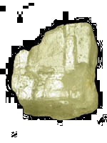
Is this a silicate or non-silicate mineral? If it is a non-silicate, to which mineral group does it belong?
What is the crystal form (habit) of this mineral?
What is the chemical formula for this mineral?
Sample 16B | Luster | Hardness | Cleavage | Streak | Other Properties | Mineral
 | (metallic or non-metallic) | (hard, > 5.5 or soft, ≤ 5.5) | (excellent/good or poor/absent)
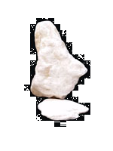
Is this a silicate or non-silicate mineral? If it is a non-silicate, to which mineral group does it belong?
What is the specific hardness of this mineral?
This mineral exhibits what type of cleavage?

Sample 17A | Luster | Hardness | Cleavage | Streak | Other Properties | Mineral
 | (metallic or non-metallic) | (hard, > 5.5 or soft, ≤ 5.5) | (excellent/good or poor/absent)
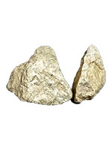
Is this a silicate or non-silicate mineral? If it is a non-silicate, to which mineral group does it belong?
This mineral exhibits what type of cleavage?
What is the chemical formula for this mineral?
Sample 17B | Luster | Hardness | Cleavage | Streak | Other Properties | Mineral
 | (metallic or non-metallic) | (hard, > 5.5 or soft, ≤ 5.5) | (excellent/good or poor/absent)
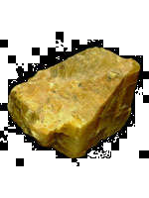
Is this a silicate or non-silicate mineral? If it is a non-silicate, to which mineral group does it belong?
How many planes of cleavage does this mineral have?
What is the crystal form (habit) of this mineral?

Sample 18A |  | Luster |  | Hardness |  | Cleavage |  | Streak |  | Other Properties |  | Mineral
 |  | (metallic or non-metallic) |  | (hard, > 5.5 or soft, ≤ 5.5) |  | (excellent/good or poor/absent)
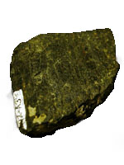
Is this a silicate or non-silicate mineral? If it is a non-silicate, to which mineral group does it belong?
Is this mineral felsic or mafic?
How many planes of cleavage does this mineral have?
Sample 18B |  | Luster |  | Hardness |  | Cleavage |  | Streak |  | Other Properties |  | Mineral
 |  | (metallic or non-metallic) |  | (hard, > 5.5 or soft, ≤ 5.5) |  | (excellent/good or poor/absent)
Is this a silicate or non-silicate mineral? If it is a non-silicate, to which mineral group does it belong?
How many planes of cleavage does this mineral have?
Does this mineral form in igneous environments associated with molten rock, in sedimentary environments at the earth’s surface associated with evaporation of ancient seas, or in metamorphic environments associated with extreme heat and pressure?
Sample 19A | Luster |  | Hardness |  | Cleavage |  | Streak |  | Other Properties |  | Mineral
 | (metallic or non-metallic) |  | (hard, > 5.5 or soft, ≤ 5.5) |  | (excellent/good or poor/absent)
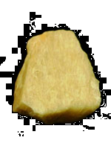
Is this a silicate or non-silicate mineral? If it is a non-silicate, to which mineral group does it belong?
Is this mineral felsic or mafic?
What are some common uses for this mineral?
Sample 19B | Luster |  | Hardness |  | Cleavage |  | Streak |  | Other Properties |  | Mineral
 | (metallic or non-metallic) |  | (hard, > 5.5 or soft, ≤ 5.5) |  | (excellent/good or poor/absent)
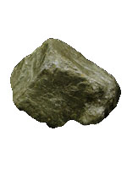
Is this a silicate or non-silicate mineral? If it is a non-silicate, to which mineral group does it belong?
Does this mineral have a relatively high or low specific gravity?
What are some common uses for this mineral?

Sample 20A | Luster |  | Hardness |  | Cleavage |  | Streak |  | Other Properties |  | Mineral
 | (metallic or non-metallic) |  | (hard, > 5.5 or soft, ≤ 5.5) |  | (excellent/good or poor/absent)
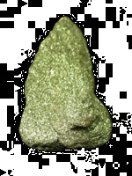
Is this a silicate or non-silicate mineral? If it is a non-silicate, to which mineral group does it belong?
How many planes of cleavage does this mineral have?
Did this sample most likely form in igneous environments associated with molten rock, in sedimentary environments associated with the chemical precipitation of dissolved iron from ancient seas, or in metamorphic environments associated with extreme heat and pressure?
Sample 20B | Luster |  | Hardness |  | Cleavage |  | Streak |  | Other Properties |  | Mineral
 | (metallic or non-metallic) |  | (hard, > 5.5 or soft, ≤ 5.5) |  | (excellent/good or poor/absent)
Is this a silicate or non-silicate mineral? If it is a non-silicate, to which mineral group does it belong?
Is this mineral felsic or mafic?
This mineral has two prominent cleavage directions that intersect at approximately what angles?
Sample 21A |  | Luster |  | Hardness |  | Cleavage |  | Streak |  | Other Properties |  | Mineral
 |  | (metallic or non-metallic) |  | (hard, > 5.5 or soft, ≤ 5.5) |  | (excellent/good or poor/absent)
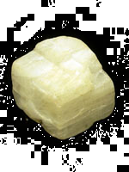
Is this a silicate or non-silicate mineral? If it is a non-silicate, to which mineral group does it belong?
How many planes of cleavage does this mineral have?
This mineral exhibits what type of cleavage?
Sample 21B |  | Luster |  | Hardness |  | Cleavage |  | Streak |  | Other Properties |  | Mineral
 |  | (metallic or non-metallic) |  | (hard, > 5.5 or soft, ≤ 5.5) |  | (excellent/good or poor/absent)
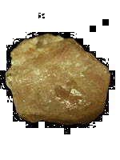
Is this a silicate or non-silicate mineral? If it is a non-silicate, to which mineral group does it belong?
Is this mineral felsic or mafic?
What is the chemical formula for this mineral?

Sample 22A | Luster | Hardness | Cleavage | Streak | Other Properties | Mineral
 | (metallic or non-metallic) | (hard, > 5.5 or soft, ≤ 5.5) | (excellent/good or poor/absent)
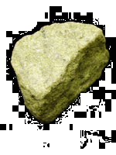
Is this a silicate or non-silicate mineral? If it is a non-silicate, to which mineral group does it belong?
This mineral exhibits what type of cleavage?
Is this mineral more felsic or mafic?
Sample 22B | Luster | Hardness | Cleavage | Streak | Other Properties | Mineral
 | (metallic or non-metallic) | (hard, > 5.5 or soft, ≤ 5.5) | (excellent/good or poor/absent)
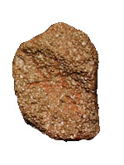
Is this a silicate or non-silicate mineral? If it is a non-silicate, to which mineral group does it belong?
What is the chemical formula for this mineral?
What are some common uses for this mineral?

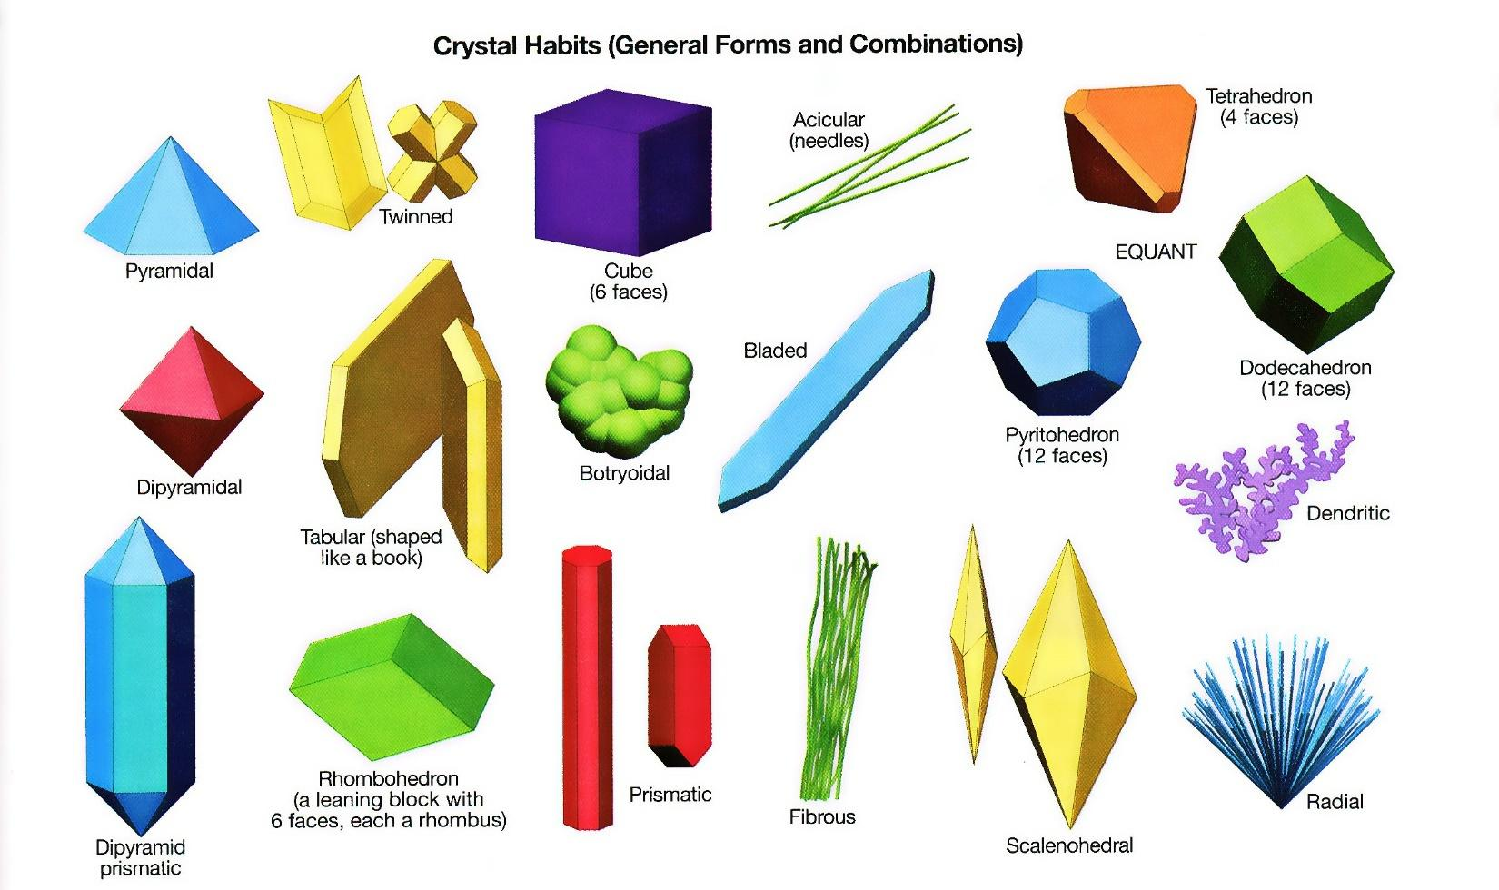
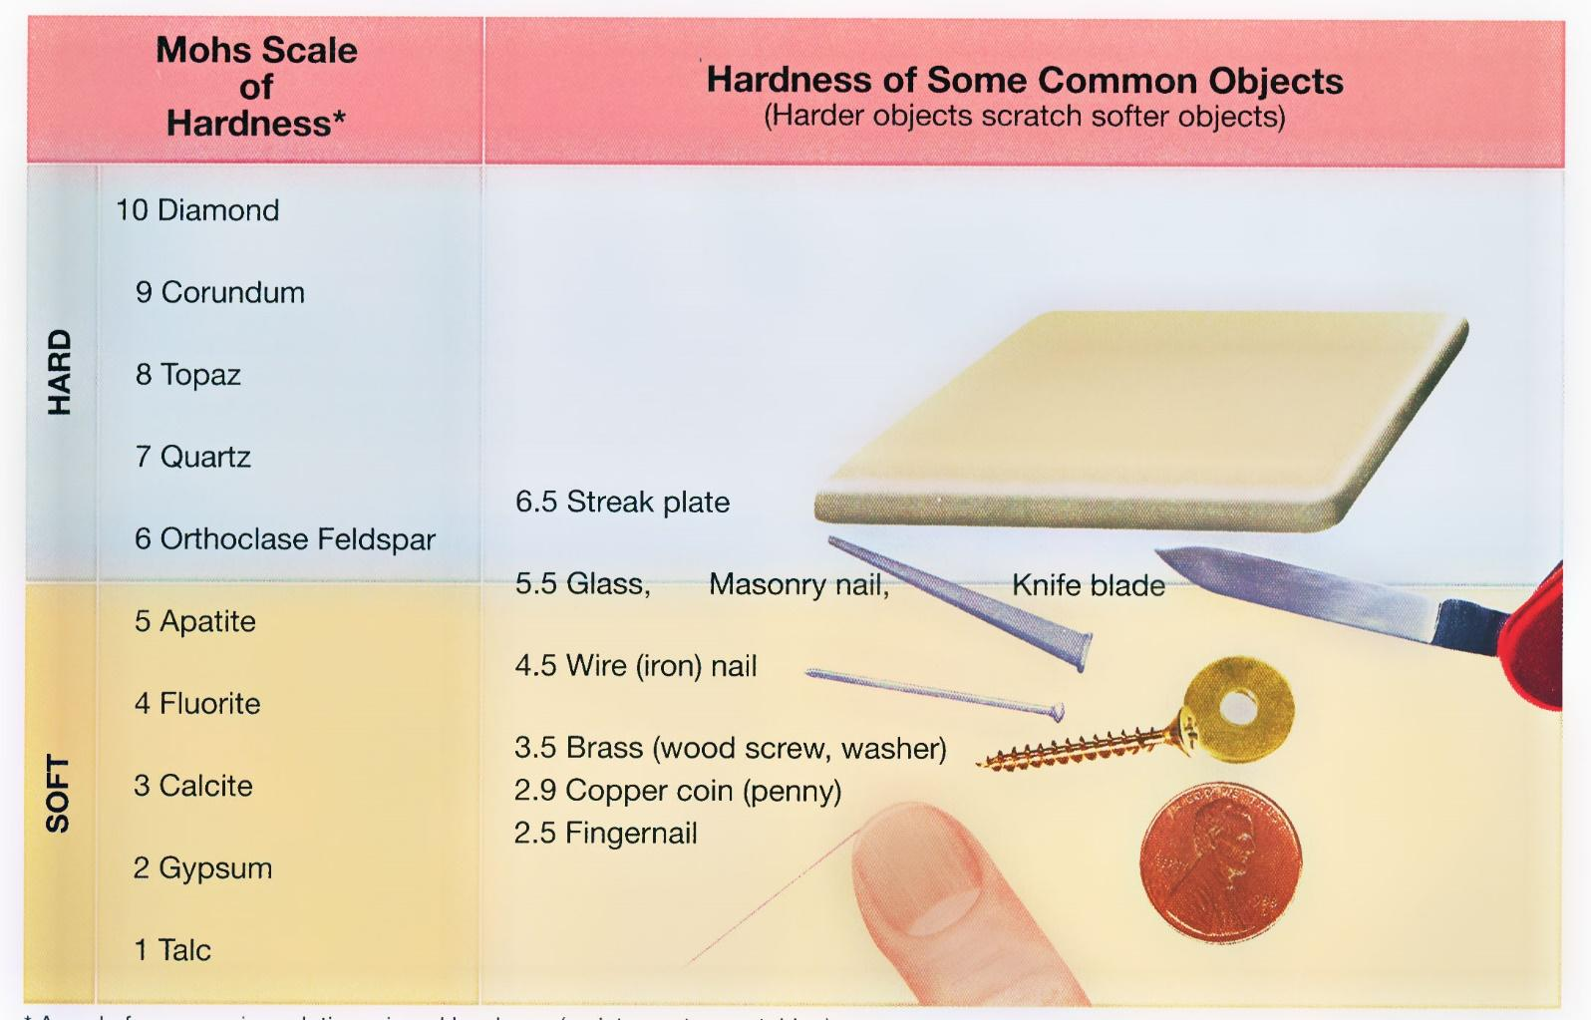
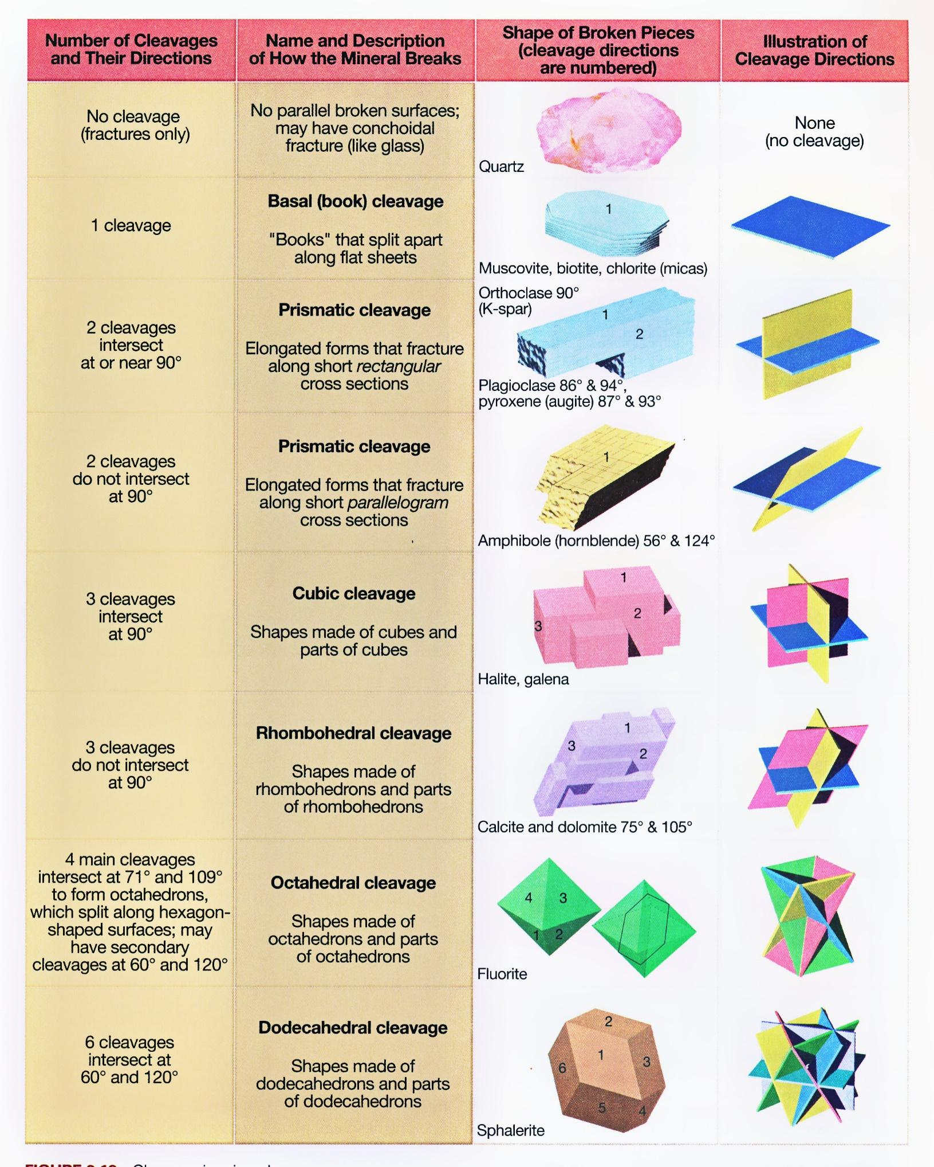

SLC PRACTICE SET MINERAL DATABASE
MINERAL | CRYSTAL HABIT & CRYSTAL SYSTEM |  |  | HARDNESS | STREAK |  |  | PROPERTIES |  | USES
Apatite  Ca₅F(PO₄)₃  calcium fluorophosphates  phosphate group | Prismatic  Hexagonal |  |  | 5 | White |  |  | Color pale or dark green, brown, blue, white, or purple; Sometimes colorless; Transparent or opaque; Brittle; Conchoidal fracture; Forms hexagonal prisms; SG = 3.1 – 3.4. |  | Used mostly to make fertilizer, pesticides; Transparent varieties sold as gemstones.
Augite  (pyroxene)  calcium ferromagnesian silicate  silicate group | Prismatic  Monoclinic |  |  | 5.5 – 6 | White to pale gray |  |  | Color dark green to brown or black; Forms short, 8-sided prisms; Two good cleavages that intersect at 87° and 93° (nearly right angles); SG = 3.2 – 3.5. |  | Ore of lithium, used to make lithium batteries, ovenware glazes, high temperature grease, and to treat depression.
Biotite  K(Mg,Fe)₃(Al, Si₃O₁₀)(OH, F)₂  ferromagnesian potassium, hydrous aluminum silicate  silicate group | Prismatic  Monoclinic |  |  | 2.5 – 3 | Gray-brown to white |  |  | Color black, green-black, or brown-black; Cleavage excellent; Forms very short prisms that split easily into very thin, flexible sheets; SG = 2.7 – 3.1. |  | Used for fire-resistant tiles, rubber, paint.
Calcite  CaCO₃  calcium carbonate  carbonate group | Rhombohedron  Hexagonal |  |  | 3 | White |  |  | Usually colorless, white, or yellow, but may be green, brown, or pink; Opaque or transparent; Excellent cleavage in 3 directions, two prominently at 75° and 105°; Forms prisms, rhombohedrons, or scalenohedrons that break into rhombohedrons; Effervesces in dilute HCl; SG = 2.5 – 2.8. |  | Used to make antacid tablets, fertilizer, cement; Ore of calcium.
Chalcopyrite  CuFeS2  copper-iron sulfide  sulfide group | Tetrahedron  Isometric |  |  | 3.5 – 4 | Dark gray |  |  | Color bright silvery gold; Tarnishes broneze brown, brassy gold, or iridescent blue-green and red; Brittle; No cleavage; Forms dense masses or elongate tetrahedrons; SG = 4.1 – 4.3. |  | Ore of copper, used to make pipes, electrical wire, coins, ammunition, bronze, brass; added to vitamin pills for healthy hair and skin.
Corundum  Al₂O₃  aluminum oxide  oxide group | Prismatic  Hexagonal |  |  | 9 | White* |  |  | Gray, white, black, or colored (red, blue, brown, yellow) hexagonal prisms with flat striated ends; Opaque to transparent; Cleavage absent; SG = 3.9 – 4.1. |  | Used for abrasive powders to polish lenses; emery cloth; gemstones:  black = emery  red = ruby  blue = sapphire
* Streak cannot be determined with a streak plate for minerals harder than 6.5. They scratch the streak plate.
SLC PRACTICE SET MINERAL DATABASE
MINERAL | CRYSTAL HABIT & CRYSTAL SYSTEM |  |  | HARDNESS | STREAK |  |  | PROPERTIES |  | USES
Dolomite  CaMg(CO₃)₂  magnesian calcium carbonate  carbonate group | Rhombohedron  Hexagonal |  |  | 3.5 – 4 | White |  |  | Color white, gray, crème, or pink; Usually opaque; Excellent cleavage in 3 directions, two prominently at 75° and 105°; Breaks into rhombohedrons; Resembles calcite, but will effervesce in dilute HCl only if powdered; SG = 2.8 – 2.9. |  | Ore of magnesium used to make paper; lightweight frames for jet engines, rockets, cell phones, laptops; pills for good brain, muscle, and skeletal health.
Fluorite  CaF₂  calcium fluoride  halide group | Cube  Isometric |  |  | 4 | White |  |  | Colorless, purple, blue, gray, green, or yellow; Cleavage excellent; Crystals usually cubes; Transparent or opaque; Brittle; SG = 3.0 – 3.3. |  | Ore of fluorine used in fluoride toothpaste, refrigerant gases, rocket fuel.
Galena  PbS  lead sulfide  sulfide group | Cube/Octahedron  Isometric |  |  | 2.5 | Gray to dark gray |  |  | Color bright silvery gray; Tarnishes dull gray; Forms cubes and octahedrons; Brittle; Cleavage good in three directions, so breaks into cubes; SG = 7.4 – 7.6. |  | Ore of lead for television glass, auto batteries, solder, ammunition; May be an ore of bismuth (an impurity) used as a lead substitute in pipe solder and fishing sinkers; May be an ore of silver (an impurity) used in jewelry, electrical circuit boards.
Garnet  complex silicate  silicate group | Dodecahedron  Isometric |  |  | 7 | White* |  |  | Color usually red, black, or brown, sometimes yellow, green, pink; Forms dodecahedrons; Cleavage absent but may have parting; Brittle; Translucent to opaque; SG = 3.5 – 4.3. |  | Used as an abrasive; Red gemstone.
Graphite  C  carbon  native element | Prismatic  Hexagonal |  |  | 1 | Dark gray |  |  | Color dark silvery gray to black; Forms flakes, short hexagonal prisms, and earthy masses; Greasy feel; Very soft; Cleavage excellent in 1 direction; SG = 2.0 – 2.3. |  | Used for pencils, anodes (negative ends) of most batteries, synthetic motor oil, carbon steel, fishing rods, golf clubs.
Gypsum  CaSO₄ ∙ 2H₂O  hydrated calcium sulfate  sulfate group | Tabular/Prismatic/Bladed  Monoclinic |  |  | 2 | White |  |  | Colorless, white, or gray; Forms tabular crystals, prisms, blades, or needles (satin spar variety); Transparent to translucent; Very soft; Cleavage good; SG = 2.3. |  | Plaster-of-paris, wallboard, drywall, art sculpture medium (alabaster).
* Streak cannot be determined with a streak plate for minerals harder than 6.5. They scratch the streak plate.
SLC PRACTICE SET MINERAL DATABASE
MINERAL |  | CRYSTAL HABIT & CRYSTAL SYSTEM | HARDNESS |  |  | STREAK | PROPERTIES |  | USES
Halite  NaCl  sodium chloride  halide group |  | Cube  Isometric | 2.5 |  |  | White | Colorless, white, yellow, blue, brown, or red; Transparent to translucent; Brittle; Forms cubes; Cleavage excellent in 3 directions, so breaks into cubes; Salty taste; SG = 2.1 – 2.6. |  | Table salt, road salt; Used in water softeners and as a preservative; Sodium ore.
Hematite  Fe2O3  iron oxide  oxide group |  | Tabular/Massive  Hexagonal | 1 – 6 |  |  | Red to  red-brown | Color silvery gray, reddish silver, black, or brick red; Tarnishes red; Opaque; Soft (earthy) and hard (metallic) varieties have same streak; Forms thin tabular crystals or massive; May be attracted to a magnet; SG = 4.9 – 5.3. |  | Red ochre pigment in paint and cosmetics. Ore of iron for iron and steel used in machines, buildings, bridges, nails, tools, file cabinets; Added to pills and foods to aid hemoglobin production in red blood cells.
Hornblende  (amphibole)  calcium ferromagnesian aluminum silicate  silicate group |  | Prismatic  Monoclinic | 5.5 – 6 |  |  | White to pale gray | Color dark gray to black; Forms prisms with good cleavage at 56° and 124°; Brittle; Splintery or asbestos forms; SG = 3.0 – 3.3. |  | Fibrous varieties used for fire-resistant clothing, tiles, brake linings.
Limonite  Fe₂O₃∙nH₂O  hydrated iron oxide and/or  FeO(OH)∙nH₂O  hydrated iron oxide hydroxide  hydroxide group |  | Massive  Amorphous | 1 – 5.5 |  |  | Yellow-brown | Color yellow-brown to dark brown; Tarnishes yellow to brown; Amorphous masses; Luster dull or earthy; Hard or soft; SG = 3.3 – 4.3. |  | Yellow ochre pigment in paint and cosmetics. Ore of iron for iron and steel used in machines, buildings, bridges, nails, tools, file cabinets; Added to pills and foods to aid hemoglobin production in red blood cells.
Magnetite  Fe₃O₄  iron oxide  oxide group |  | Octahedron  Isometric | 6 – 6.5 |  |  | Dark gray | Color silvery gray to black; Opaque; Forms octahedrons; Tarnishes gray; No cleavage; Attracted to a magnet and can be magnetized; SG = 5.0 – 5.2. |  | Ore of iron for iron and steel used in machines, buildings, bridges, nails, tools, file cabinets; Added to pills and foods to aid hemoglobin production in red blood cells.
* Streak cannot be determined with a streak plate for minerals harder than 6.5. They scratch the streak plate.
SLC PRACTICE SET MINERAL DATABASE
MINERAL |  | CRYSTAL HABIT & CRYSTAL SYSTEM | HARDNESS |  |  | STREAK | PROPERTIES |  | USES
Muscovite  KAl₂(Al, Si₃O₁₀)(OH, F)₂  potassium hydrous aluminum silicate  silicate group |  | Prismatic  Monoclinic | 2 – 2.5 |  |  | White | Colorless, yellow, brown, or red-brown; Forms short opaque prisms; Cleavage excellent in 1 direction, can be split into thin flexible transparent sheets; SG = 2.7 – 3.0. |  | Computer chip substrates, electrical insulation, roof shingles; Cosmetics with a satiny sheen.
Olivine  (Fe, Mg)₂SiO₄  ferromagnesian silicate  silicate group |  | Granular/Prismatic  Orthorhombic | 7 |  |  | White* | Color pale or dark olive-green to yellow, or brown; Forms short crystals that may resemble sand grains; Conchoidal fracture; Cleavage absent; Brittle; SG = 3.3 – 3.4. |  | Green gemstone (peridot); Ore of magnesium used to make paper; lightweight frames for jet engines, cell phones, laptops; pills for good brain, muscle, and skeletal health.
Plagioclase Feldspar  NaAlSi₃O₈ to CaAl₂Si₂O₈  calcium-sodium aluminum silicate  silicate group |  | Tabular/Bladed  Triclinic | 6 |  |  | White | Colorless, white, gray, or black; May have iridescent play of color from within; Translucent; Forms striated tabular crystals or blades; Cleavage good in two directions at nearly 90°; SG = 2.6 – 2.8. |  | Used to make ceramics, glass, enamel, soap, false teeth, scouring powders.
Potassium Feldspar  KAlSi₃O₈  potassium aluminum silicate  silicate group |  | Prismatic  Monoclinic | 6 |  |  | White | Color orange, brown, white, green, or pink; Forms translucent prisms with subparallel exsolution lamellae; Cleavage excellent in two directions at nearly 90°; SG = 2.5 – 2.6. |  | Used to make ceramics, glass, enamel, soap, false teeth, scouring powders.
Pyrite  FeS₂  iron sulfide  sulfide group |  | Cube/Pyritohedron/  Massive  Isometric | 6 – 6.5 |  |  | Dark gray | Color silvery gold; Tarnishes brown; Cleavage absent to poor; Brittle; Forms opaque masses, cubes (often striated), or pyritohedrons; SG = 4.9 – 5.2. |  | Ore of sulfur for matches, gunpowder, fertilizer, rubber hardening (car tires), fungicide, insecticide, paper pulp processing.
* Streak cannot be determined with a streak plate for minerals harder than 6.5. They scratch the streak plate.

SLC PRACTICE SET MINERAL DATABASE
MINERAL | CRYSTAL HABIT & CRYSTAL SYSTEM | HARDNESS | STREAK | PROPERTIES | USES
Quartz  SiO₂  silicon dioxide  silicate group | Prismatic  Hexagonal | 7 | White* | Usually colorless, white, or gray but uncommon varieties occur in all colors; Transparent to translucent; Luster greasy; No cleavage; Forms hexagonal prism and pyramids; SG = 2.6 – 2.7.  - Flint (opaque black or dark gray)  - Smoky (transparent gray)  - Citrine (transparent yellow-brown)  - Amethyst (purple)  - Chert (opaque gray)  - Milky (white)  - Jasper (opaque red or yellow)  - Rock crystal (colorless)  - Rose (pink)  - Chalcedony (translucent, waxy luster) | Used as an abrasive; Used to make glass, gemstones.
Talc  Mg₃Si₄O₁₀(OH)₂  hydrous magnesian silicate  silicate group | Massive  Monoclinic | 1 | White | Color white, gray, pale green, or brown; Forms cryptocrystalline masses that show no cleavage; Luster silky to greasy; Feels greasy or soapy (talcum powder); Very soft; SG = 2.7 – 2.8. | Used for talcum powder, facial makeup; Used as a “filler” (to take up space and reduce cost) in plastics for car parts, appliances; Massive pieces carved into art sculptures.
* Streak cannot be determined with a streak plate for minerals harder than 6.5. They scratch the streak plate.

