IGNEOUS ROCK CLASSIFICATION PRACTICE SET
By Jim Buecheler
Geology Program Assistant
NOVA, Annandale
2017.
INTRODUCTION
This igneous rock practice set has been assembled for use by student geologists who wish to better familiarize themselves with some of the various types of igneous rocks and their classification. The ability to classify these rocks will rely on both your ability to identify visible minerals when possible in the rock, as well as your ability to distinguish between the various textures these rocks exhibit. They also provide useful information about the conditions under which the rocks were formed and provide clues to the geologic history of the region where they are located.
The following igneous rock practice set includes 24 rock samples (two per basket). Use the igneous rock classification chart and other figures in this handout, your course materials, and any other available resources to fill out the attached igneous rock classification tables. The more you practice with and familiarize yourself with these rocks, the easier it will become to identify the various textures and compositions that distinguish them from one another.

GUIDELINES FOR ROCK & MINERAL IDENTIFICATION
- Work with only one category of unknown samples at a time (Mineral Composition, igneous, sedimentary or metamorphic). Return the complete sample set to the geology cabinet before moving on to another unknown sample set.
- Each basket contains two distinctly different samples for identification/classification. It is suggested that you select one of the two samples from the basket to work with before returning it and working with the second sample.
- Work with only one basket (2 samples) at a time. When finished, return both samples to the basket they came from before moving on to the next one. This will prevent samples from getting mixed up and placed in the wrong numbered baskets and will maintain the integrity of the answer key.
- Use the mineral identification kits (orange baskets) to help you identify Mineral Composition and classify the rocks as needed. An optical microscope is also available in the Science Learning Center (SLC) for closer examination. Remember to use caution and good judgment when using the bottles of HCl. Although the acid test is often good fun, try to limit your use of HCl to those samples that you believe have a reasonable chance of fizzing. There is no need to hit every sample with HCl.
- Use your textbook, lab manual, class notes, or other available resources to help you identify Mineral Composition and classify the variety of rocks.
- Have fun! Some of the samples found in these sets are intended to challenge you, so don’t be discouraged if you’re stumped…in the field, not every rock or mineral you encounter will be a pristine museum quality sample. Geology is rarely so simple.

IGNEOUS ROCK CLASSIFICATION PROCEDURE
A Step-by-Step Guide
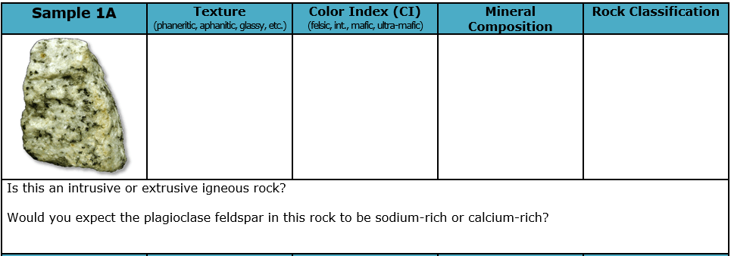
Igneous rock classification is achieved based on a few observable properties of the sample. For each unknown, make note of these properties in the tables provided, and once you have made a classification, answer the two follow-up questions about that igneous rock.
STEP 1: The first observation that you should make is to identify the igneous rock texture and make note of it in the sample table. There are seven primary textures that you should be looking for:
Pegmatitic | Phaneritic | Porphyritic | Aphanitic | Glassy | Vesicular | Pyroclastic
Large, visible crystals  >1 cm. | Visible crystals  1–10 mm. | Both visible and  non-visible crystals. | Small,  non-visible crystals  <1 mm. | Smooth & reflective like glass. May exhibit conchoidal fracture. | Preserved gas bubbles and/or frothy appearance. May be lightweight (floats in water). | Particles of ash, cinders, and/or other volcanic rock material.
Intrusive  (magma) |  | Intrusive & Extrusive | Extrusive  (lava)
If the sample has a glassy, vesicular, or pyroclastic texture, skip to Step 4. Otherwise, proceed to Step 2.
STEP 2: Examine the sample and estimate the rock’s color index (CI) which is a visual estimate of the overall composition of the sample. Determine whether the sample is primarily light in color (felsic), dark in color (mafic), somewhere in between (intermediate), or green (ultramafic) and make note in the table.
Felsic | Intermediate | Mafic | Ultramafic

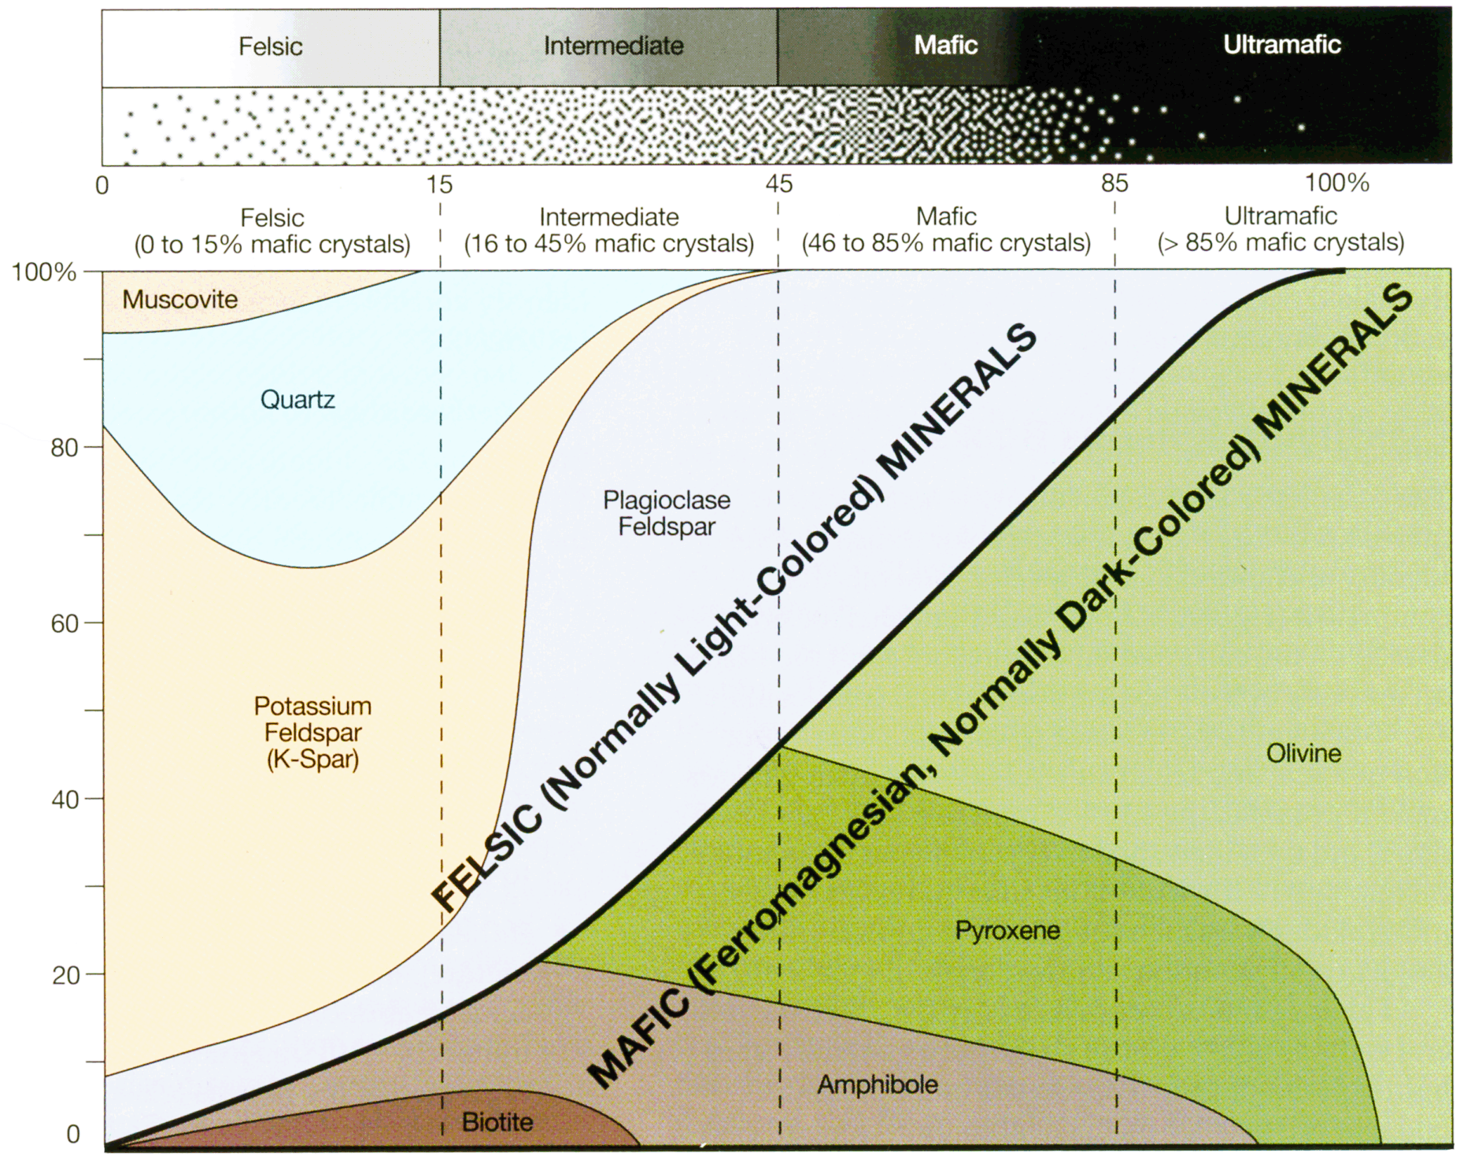
STEP 3: Use the igneous rock classification chart to estimate which Bowen’s minerals are likely to be found in the sample. In pegmatitic, phaneritic, or porphyritic samples, you should be able to visually identify some of these minerals. Make note of the likely and/or visible minerals you identified in the table.
STEP 4: Consult the igneous rock classification chart and use your observations of rock texture, color index, and where applicable, mineral composition to classify the sample and make note of it in the table.
STEP 5: If the sample has a glassy, vesicular, or pyroclastic texture, skip the color index and mineral composition* and consult the igneous rock classification chart to classify and make note of it in the table.
Glassy = obsidian.
Vesicular = pumice, scoria, or vesicular basalt*.
Pyroclastic = volcanic tuff or volcanic breccia.
(* For samples of vesicular basalt, the color index and mineral composition should be noted in the table.)
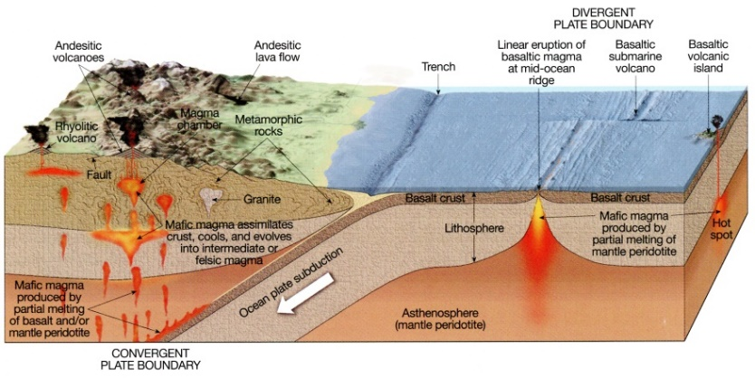
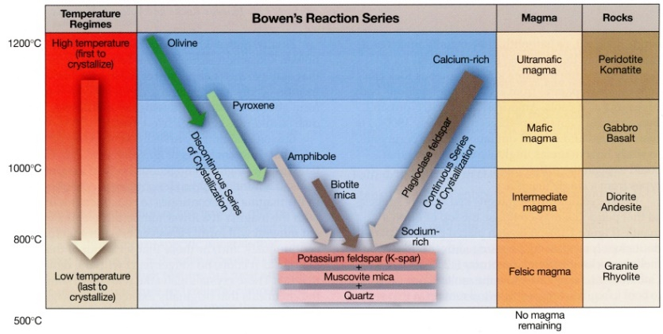
STEP 6: As you make your observations and classify the igneous rock sample, be thinking about the temperatures and conditions under which the rock formed. Specifically, pay attention to the relationship between mineral composition and Bowen’s reaction series, and the rock texture and geologic settings and conditions of formation (intrusive vs. extrusive cooling). Use the figures at the end of this packet or other course materials to answer the follow-up questions.
STEP 9: Check your answers with the answer key. Do not hesitate to consult the answer key as you work, or if you are having difficulty identifying a sample. Better to check the answer key and then work through the various properties to determine what you missed or had confused about the sample.

Sample 1A | Texture  (phaneritic, aphanitic, glassy, etc.) | Color Index (CI)  (felsic, int., mafic, ultra-mafic) | Mineral Composition | Rock Classification
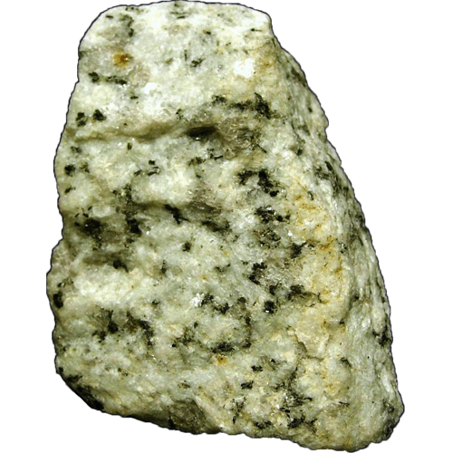
Is this an intrusive or extrusive igneous rock?

Is this rock silica-rich or silica-poor?
Sample 1B | Texture  (phaneritic, aphanitic, glassy, etc.) | Color Index (CI)  (felsic, int., mafic, ultra-mafic) | Mineral Composition | Rock Classification
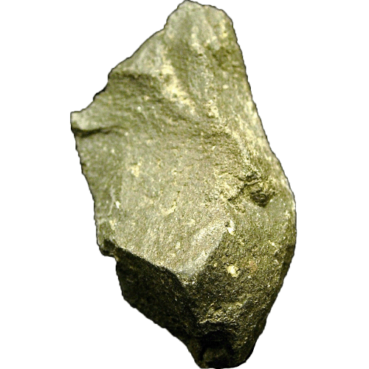
Would you expect to find this rock in continental or oceanic crust?

Did this rock experience slow or rapid cooling?
Sample 2A | Texture  (phaneritic, aphanitic, glassy, etc.) | Composition  (felsic, int., mafic, ultra-mafic) | Mineral Composition | Rock Classification
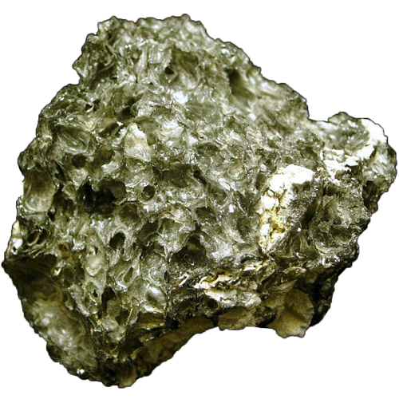
Would you expect to find this rock near a composite volcano or a shield volcano?

Is this rock silica-rich or silica-poor?
Sample 2B | Texture  (phaneritic, aphanitic, glassy, etc.) | Composition  (felsic, int., mafic, ultra-mafic) | Mineral Composition | Rock Classification
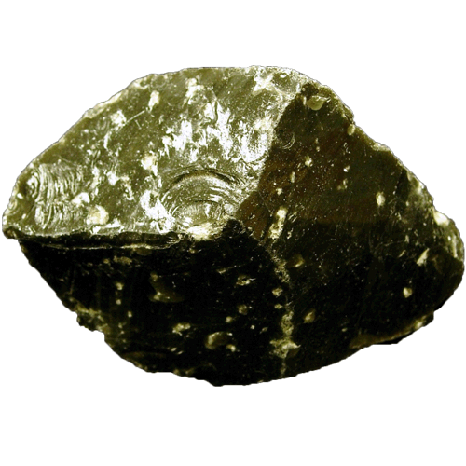
Is this an intrusive or extrusive igneous rock?

This rock often exhibits what type of fracture?
Sample 3A | Texture  (phaneritic, aphanitic, glassy, etc.) | Composition  (felsic, int., mafic, ultra-mafic) | Mineral Composition | Rock Classification
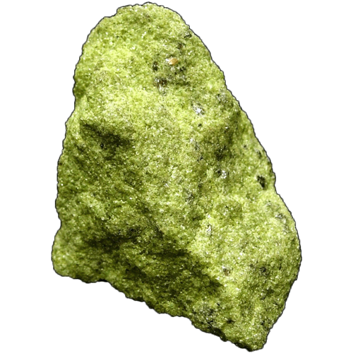
Did the minerals in this rock crystallize at high temperatures (>1000°C) or low temperatures (<800°C)?

Where is the formation of this rock most prominent?
Sample 3B | Texture  (phaneritic, aphanitic, glassy, etc.) | Composition  (felsic, int., mafic, ultra-mafic) | Mineral Composition | Rock Classification
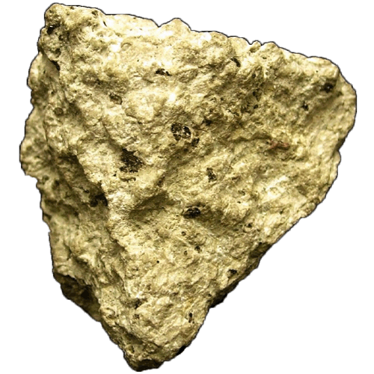
Would you expect to find this rock in continental or oceanic crust?

Is this rock silica-rich or silica-poor?
Sample 4A | Texture  (phaneritic, aphanitic, glassy, etc.) | Composition  (felsic, int., mafic, ultra-mafic) | Mineral Composition | Rock Classification
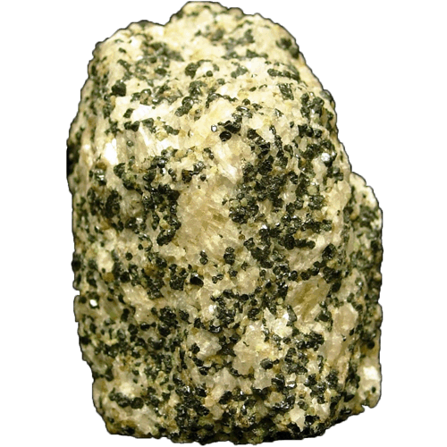
Is this an intrusive or extrusive rock?

What felsic mineral is a primary component of this rock?
Sample 4B | Texture  (phaneritic, aphanitic, glassy, etc.) | Composition  (felsic, int., mafic, ultra-mafic) | Mineral Composition | Rock Classification
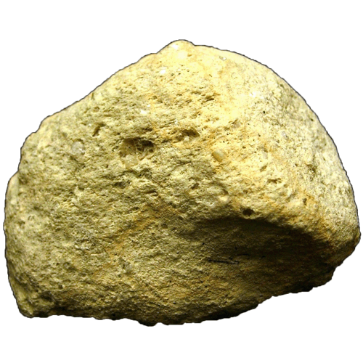
Did this rock experience slow or rapid cooling?

Is this rock silica-rich or silica-poor?
Sample 5A | Texture  (phaneritic, aphanitic, glassy, etc.) | Composition  (felsic, int., mafic, ultra-mafic) | Mineral Composition | Rock Classification
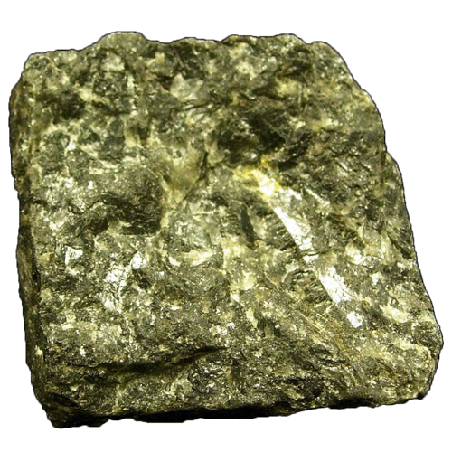
Would you be more likely to find this rock in a dike or a lava flow?

Would you be more likely to find this rock near a convergent or divergent plate boundary?
Sample 5B | Texture  (phaneritic, aphanitic, glassy, etc.) | Composition  (felsic, int., mafic, ultra-mafic) | Mineral Composition | Rock Classification
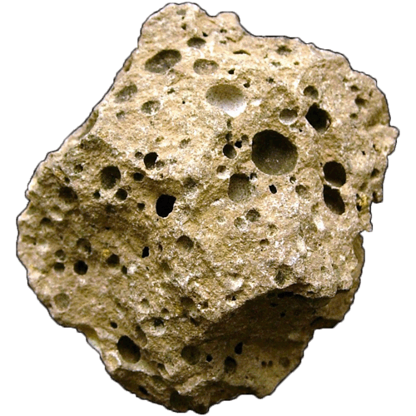
Is this an intrusive or extrusive rock?

Is this rock silica-rich or silica-poor?
Sample 6A | Texture  (phaneritic, aphanitic, glassy, etc.) | Composition  (felsic, int., mafic, ultra-mafic) | Mineral Composition | Rock Classification
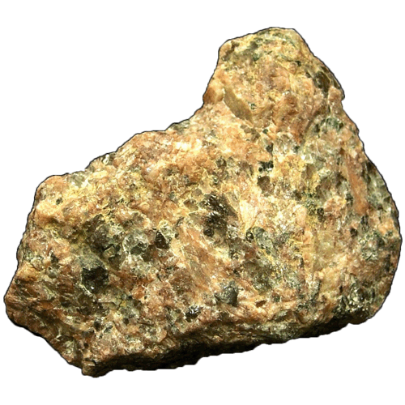
Did the minerals in this rock crystallize at high temperatures (>1000°C) or low temperatures (<800°C)?

What mineral is responsible for the pink color of this rock?
Sample 6B | Texture  (phaneritic, aphanitic, glassy, etc.) | Composition  (felsic, int., mafic, ultra-mafic) | Mineral Composition | Rock Classification
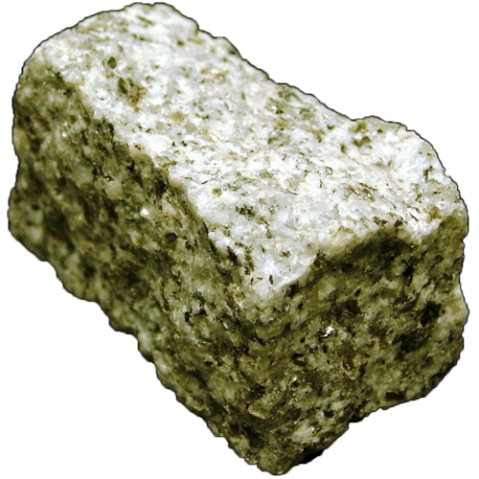
Would you expect to find this rock in continental or oceanic crust?

Did this rock experience slow cooling or rapid cooling?
Sample 7A | Texture  (phaneritic, aphanitic, glassy, etc.) | Composition  (felsic, int., mafic, ultra-mafic) | Mineral Composition | Rock Classification
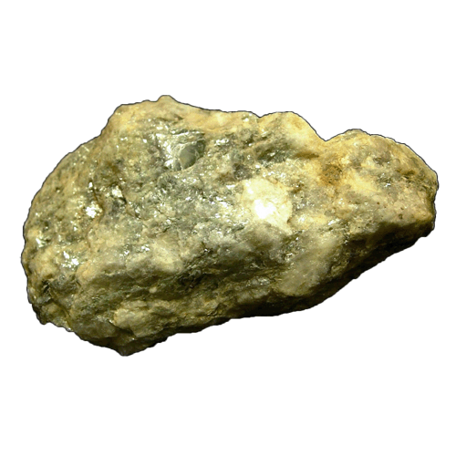
Would you expect this rock to have crystallized from a H₂O-rich or H₂O-poor magma?

Would you expect to find this rock in continental or oceanic crust?
Sample 7B | Texture  (phaneritic, aphanitic, glassy, etc.) | Composition  (felsic, int., mafic, ultra-mafic) | Mineral Composition | Rock Classification
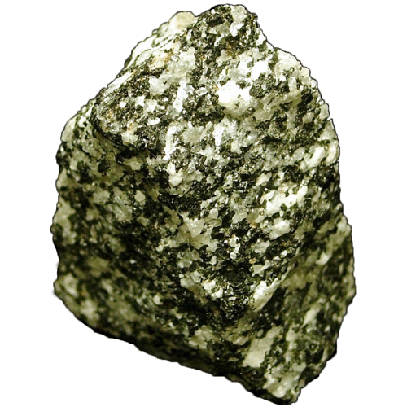
Is this an intrusive or extrusive rock?

Would you be more likely to find this rock near a convergent or divergent plate boundary?
Sample 8A | Texture  (phaneritic, aphanitic, glassy, etc.) | Composition  (felsic, int., mafic, ultra-mafic) | Mineral Composition | Rock Classification
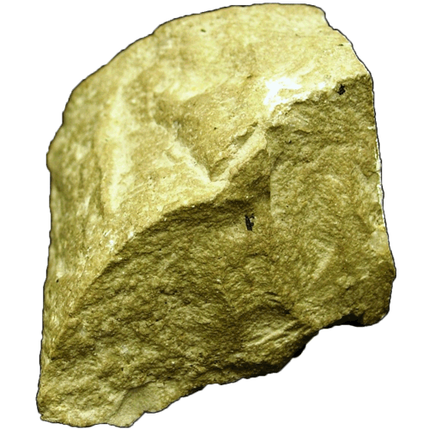
Did this rock experience slow or rapid cooling?

Would you expect to find this rock near a composite or a shield volcano?
Sample 8B | Texture  (phaneritic, aphanitic, glassy, etc.) | Composition  (felsic, int., mafic, ultra-mafic) | Mineral Composition | Rock Classification
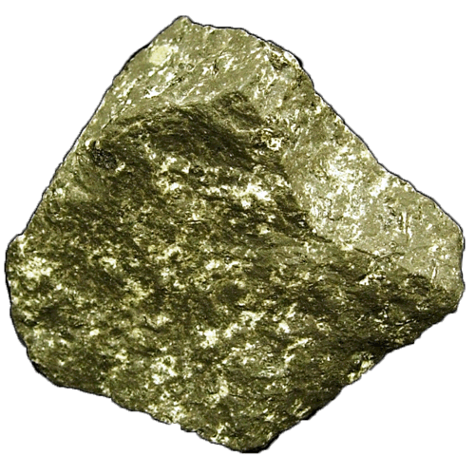
Is this an intrusive or extrusive rock?

Is this rock silica-rich or silica-poor?
Sample 9A | Texture  (phaneritic, aphanitic, glassy, etc.) | Composition  (felsic, int., mafic, ultra-mafic) | Mineral Composition | Rock Classification
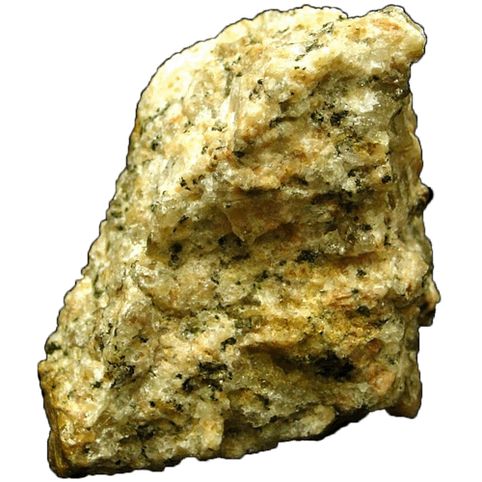
Would you be more likely to find this rock in a sill or lava flow?

Is this rock silica-rich or silica-poor?
Sample 9B | Texture  (phaneritic, aphanitic, glassy, etc.) | Composition  (felsic, int., mafic, ultra-mafic) | Mineral Composition | Rock Classification
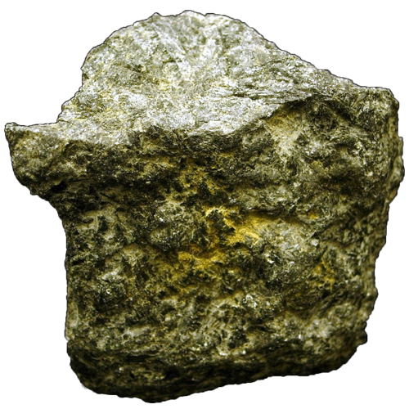
Did this rock experience slow or rapid cooling?

Did the minerals in this rock crystallize at high temperatures (>1000°C) or low temperatures (<800°C)?

Sample 10A | Texture  (phaneritic, aphanitic, glassy, etc.) | Composition  (felsic, int., mafic, ultra-mafic) | Mineral Composition | Rock Classification
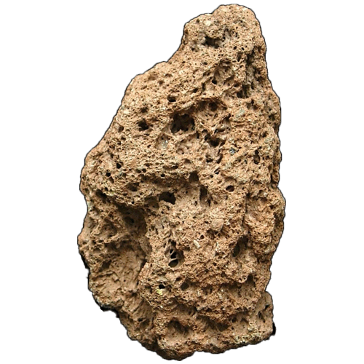
Is this an intrusive or extrusive rock?

What are some of the possible volcanic gases that may be responsible for the texture of this rock?
Sample 10B | Texture  (phaneritic, aphanitic, glassy, etc.) | Composition  (felsic, int., mafic, ultra-mafic) | Mineral Composition | Rock Classification
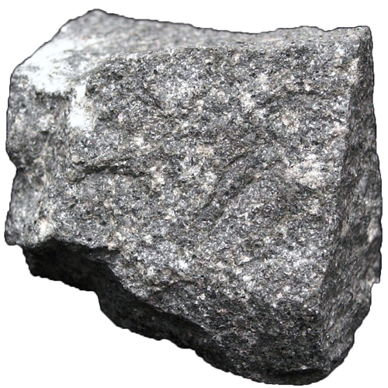
Would you be more likely to find this rock in a batholith or a lava flow?

Is this rock silica-rich or silica-poor?
Sample 11A | Texture  (phaneritic, aphanitic, glassy, etc.) | Composition  (felsic, int., mafic, ultra-mafic) | Mineral Composition | Rock Classification
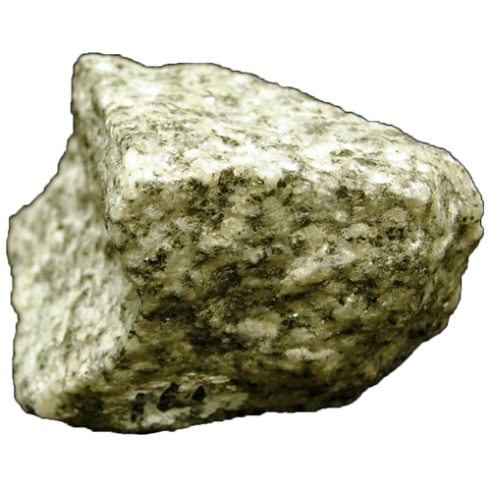
Did this rock experience slow or rapid cooling?

As this rock cooled from a molten state, what mineral(s) may have crystallized last?
Sample 11B | Texture  (phaneritic, aphanitic, glassy, etc.) | Composition  (felsic, int., mafic, ultra-mafic) | Mineral Composition | Rock Classification
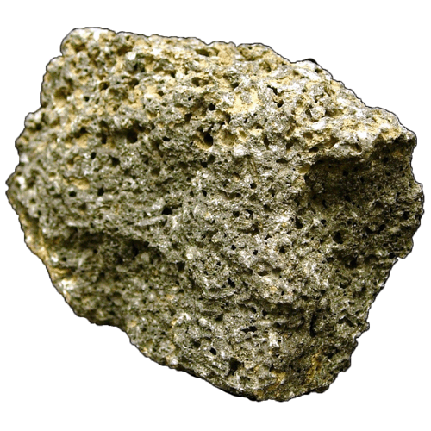
Would you be more likely to find this rock near a convergent plate boundary or volcanic hot spot?

Is this rock silica-rich or silica-poor?
Sample 12A | Texture  (phaneritic, aphanitic, glassy, etc.) | Composition  (felsic, int., mafic, ultra-mafic) | Mineral Composition | Rock Classification
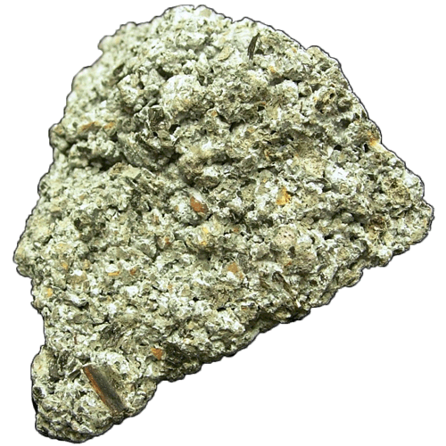
Is this an intrusive or extrusive rock?

Would you expect to find this rock near a composite volcano or a shield volcano?
Sample 12B | Texture  (phaneritic, aphanitic, glassy, etc.) | Composition  (felsic, int., mafic, ultra-mafic) | Mineral Composition | Rock Classification
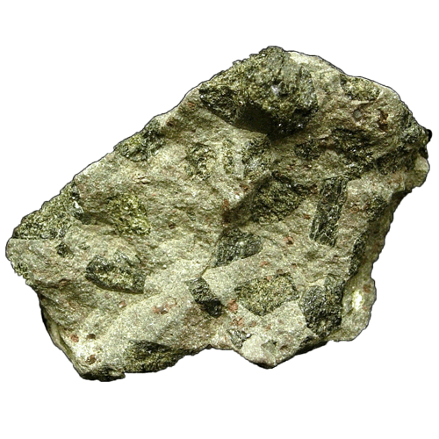
Did this rock experience slow cooling, rapid cooling, or both?

Is this rock silica-rich or silica-poor?

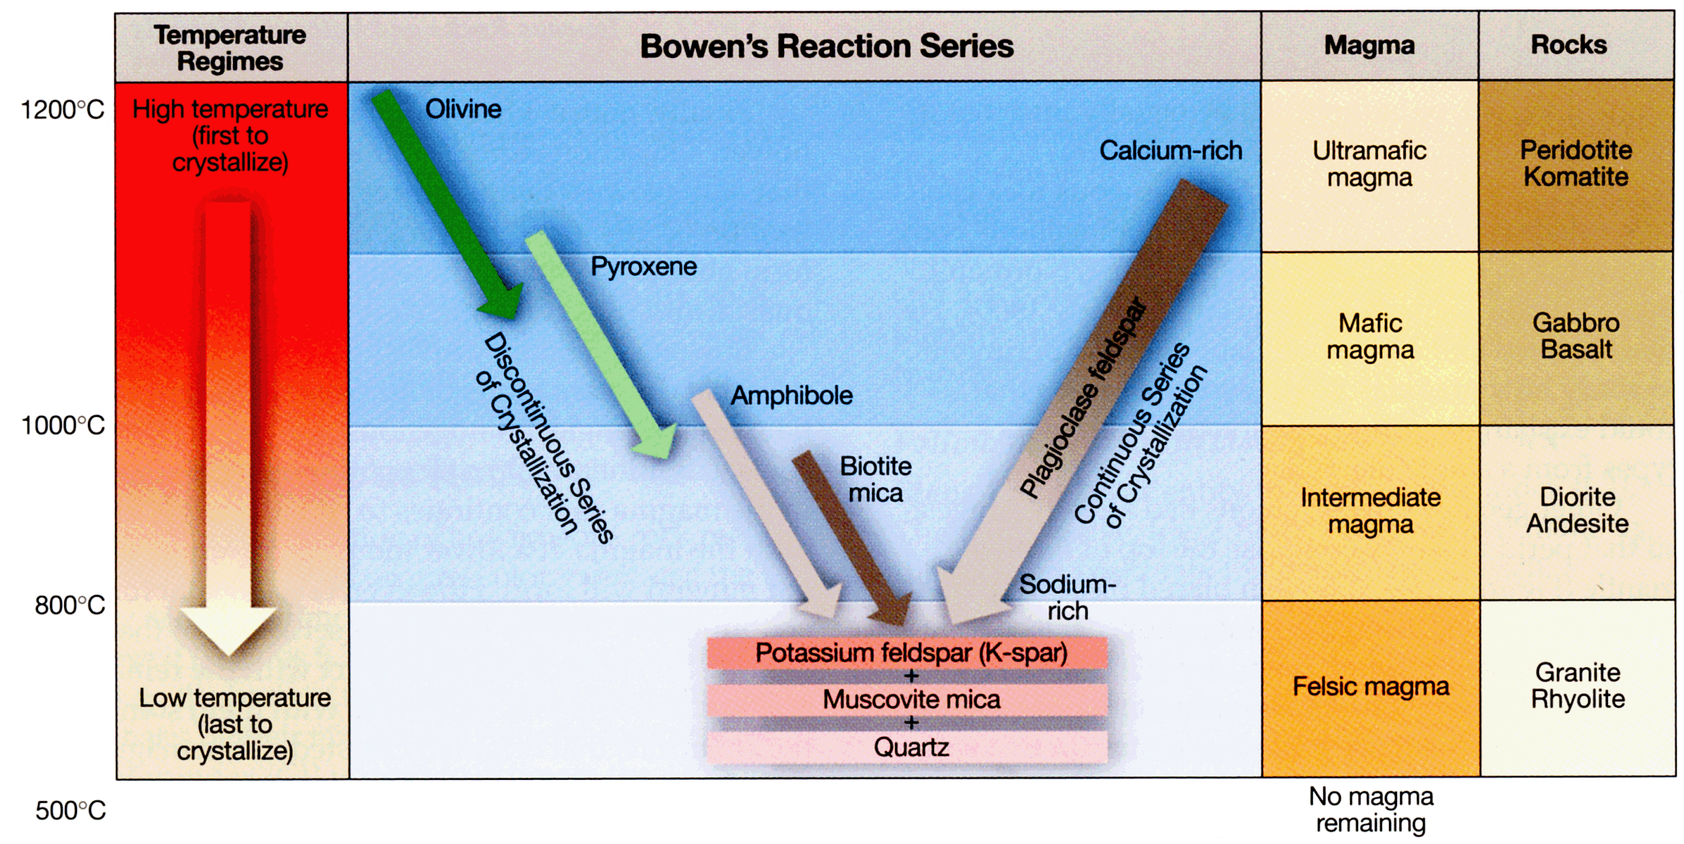
Figure 2: Mineral composition of igneous rocks may be estimated based on the color index (CI) of the sample. Samples with pegmatitic, phaneritic, or porphyritic textures will have minerals that may be visually identified, whereas aphanitic textures will not.
Figure 1: Basic rock forming minerals crystalize at different temperatures as a magma or lava flow cools. Mafic to ultramafic minerals such as olivine, pyroxenes (e.g. augite), amphiboles (e.g. hornblende), or calcium-rich plagioclase feldspar will crystallize first at high temperatures, whereas intermediate to felsic minerals such as biotite, sodium-rich plagioclase feldspar, potassium feldspar, muscovite, and quartz.

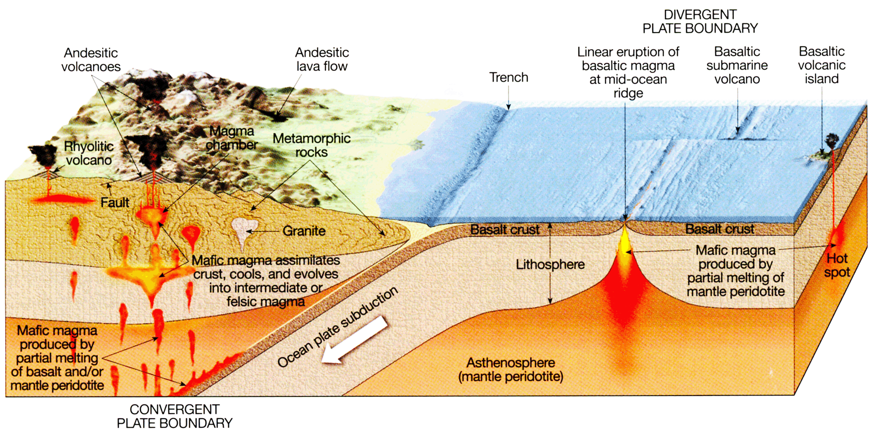
Figure 3: As you make observations and identify the igneous rock samples, consider the likely geologic settings where the rock may have formed. In general, felsic to intermediate igneous rocks are associated with continental crust and convergent plate boundaries, whereas mafic to ultramafic igneous rocks are associated with oceanic crust and divergent plate boundaries.

