METAMORPHIC ROCK CLASSIFICATION PRACTICE SET
By Jim Buecheler
Geology Program Assistant
NOVA, Annandale
2017.
INTRODUCTION
This metamorphic rock practice set has been assembled for use by student geologists who wish to better familiarize themselves with some of the common types of metamorphic rocks and their classification. The ability to classify metamorphic rocks requires recognition of both textural features and common metamorphic index minerals that often form during the metamorphism of preexisting igneous, sedimentary, or even other metamorphic rocks. Proper classification of metamorphic rocks is useful to the geologist as it can provide such information as the tectonic conditions under which the rocks were formed and other clues to the geologic history of the region where they are located.
The following metamorphic rock practice set includes 20 samples of some of the different types and variations of common metamorphic rocks. Use the mineral identification kits provided (orange baskets), your laboratory manual (Laboratory Manual in Physical Geology, Busch & Tasa, American Geological Institute, 9th ed., 2011.), textbook, notes and any other available resources to fill out the attached metamorphic rock classification worksheets. The more you practice with and familiarize yourself with these rocks, the easier it will become to identify the rocks and make interpretations about their history and origin.
GUIDELINES FOR ROCK & MINERAL IDENTIFICATION
- Work with only one category of unknown samples at a time (minerals, igneous, sedimentary or metamorphic). Return the complete sample set to the geology cabinet before moving on to another unknown sample set.
- Each basket contains two distinctly different samples for identification/classification. It is suggested that you select one of the two samples from the basket to work with before returning it and working with the second sample.
- Work with only one basket (2 samples) at a time. When finished, return both samples to the basket they came from before moving on to the next one. This will prevent samples from getting mixed up and placed in the wrong numbered baskets and will maintain the integrity of the answer key.
- Use the mineral identification kits (orange baskets) to help you identify minerals and classify the rocks as needed. An optical microscope is also available in the Science Learning Center (SLC) for closer examination. Remember to use caution and good judgment when using the bottles of HCl. Although the acid test is often good fun, try to limit your use of HCl to those samples that you believe have a reasonable chance of fizzing. There is no need to hit every sample with HCl.
- Use your textbook, lab manual, class notes, or other available resources to help you identify minerals and classify the variety of rocks.
- Have fun! Some of the samples found in these sets are intended to challenge you, so don’t be discouraged if you’re stumped…in the field, not every rock or mineral you encounter will be a pristine museum quality sample. Geology is rarely so simple.

Sample | Texture/  Textural Features | Mineral Composition/  Other Features | Rock Classification
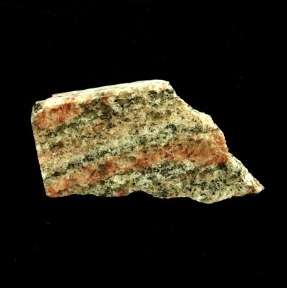
1a.) Has this rock been altered by contact or regional metamorphism?
Did this rock undergo low-grade, medium-grade or high-grade metamorphism?
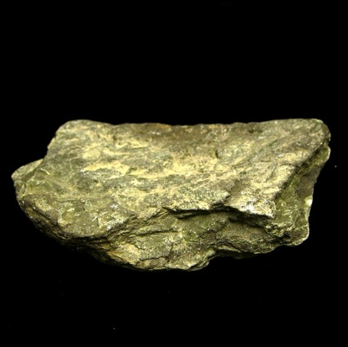
1b.) Was this rock subjected to confining pressure or differential pressure (stress)?
What are some common uses for this type of metamorphic rock?
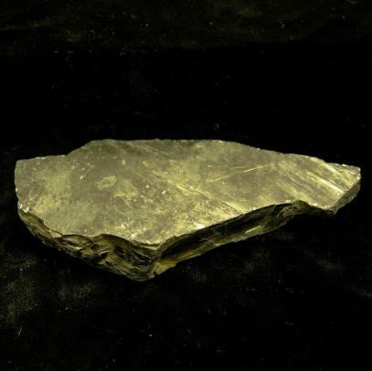
2a.) What are the protoliths for this metamorphic rock?
Did this rock undergo low-grade, medium-grade or high-grade metamorphism?
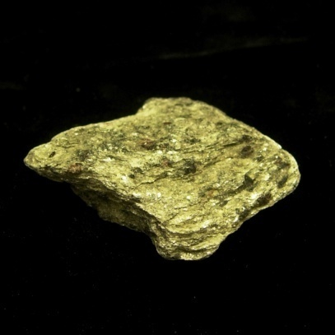
2b.) Was this rock subjected to confining pressure or differential pressure (stress)?
Did this rock undergo low-grade, medium-grade or high-grade metamorphism?
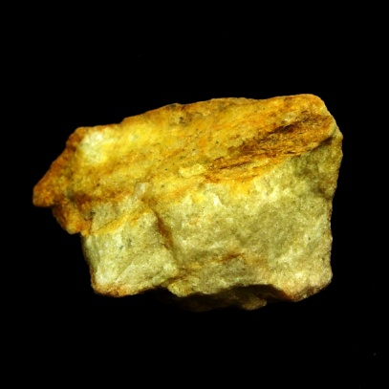
3a.) Has this rock more likely been altered by contact or regional metamorphism?
What is the protolith for this metamorphic rock?
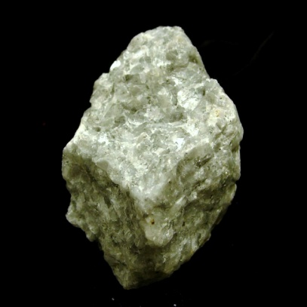
3b.) What is the protolith for this metamorphic rock?
Was this rock more likely subjected to confining pressure or differential pressure (stress)?
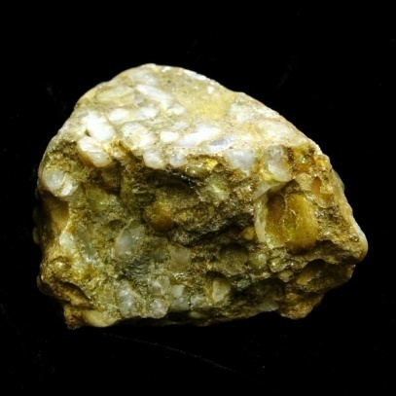
4a.) Has this rock been altered by contact or regional metamorphism?
What would be a likely depositional environment for the protolith of this metamorphic rock?
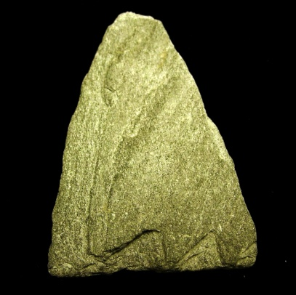
4b.) What are the possible protoliths for this metamorphic rock?
Was this rock subjected to confining pressure or differential pressure (stress)?
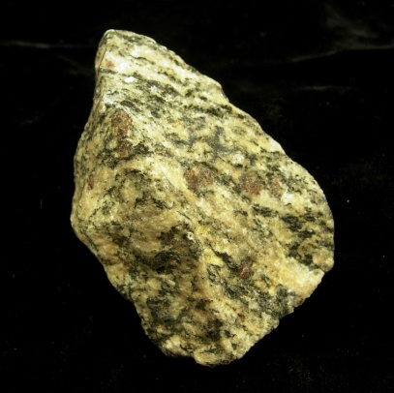
5a.) What type of igneous rock would be a likely protolith of this metamorphic rock?
Was this rock subjected to confining pressure or differential pressure (stress)?
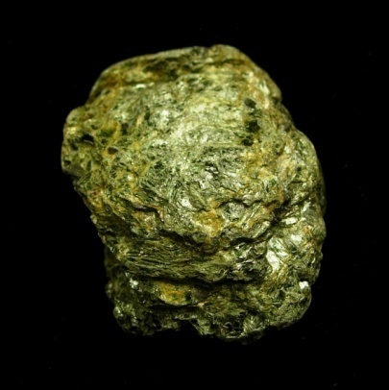
5b.) What are the possible protoliths for this metamorphic rock?
Was this rock more likely to have been metamorphosed at a convergent or divergent plate boundary?
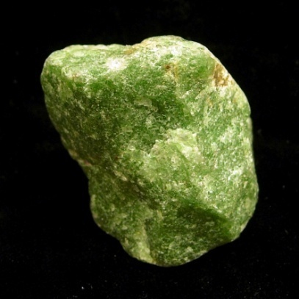
6a.) What is the protolith for this metamorphic rock?
Would this type of metamorphic rock be good for creating an outdoor sculpture that was meant to stand the test of time? Why?
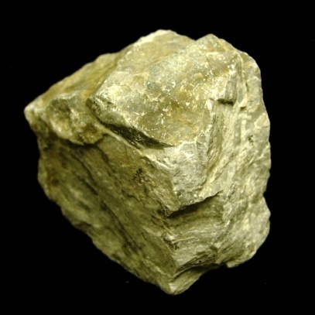
6b.) Has this rock more likely been altered by contact or regional metamorphism?
What are some common uses for this type of metamorphic rock?
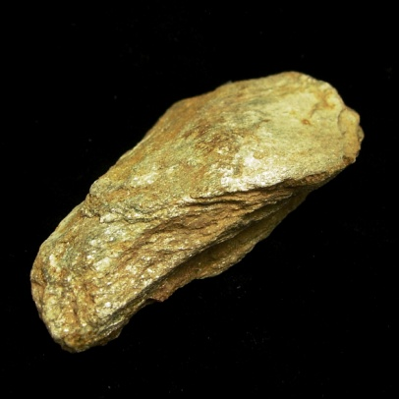
7a.) Was this rock subjected to confining pressure or differential pressure (stress)?
What metamorphic rock would you expect to form next if higher-grade metamorphism continued on this rock?
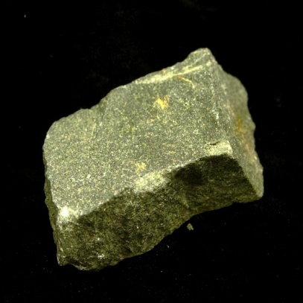
Hint: This one may be a bit tricky as the metamorphic rock name of this sample is not listed in Fig 7.15 (pg 165) of the Lab Manual. Pay close attention to the texture, consider the possible protoliths, and classify this rock as a meta-<blank>?
7b.) Was this rock more likely to have been metamorphosed at a convergent or divergent plate boundary?
Was this rock subjected to confining pressure or differential pressure (stress)?
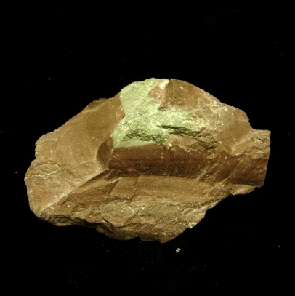
8a.) Did this rock undergo low-grade, medium-grade or high-grade metamorphism?
What is the protolith for this metamorphic rock?
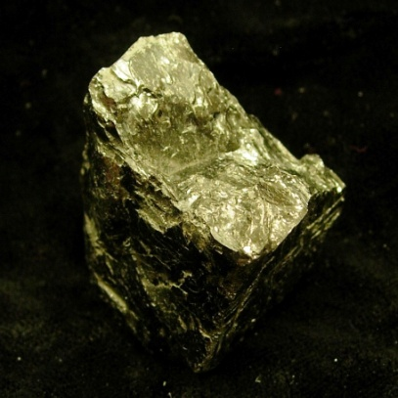
8b.) What type of fracture is exhibited in this metamorphic rock?
Despite its benefits, why is the use and mining of this metamorphic rock not more common?
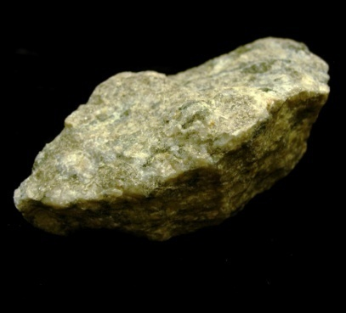
9a.) What other type of metamorphic rock would be a likely protolith for this sample?
Was this rock more likely to have been metamorphosed at a convergent or divergent plate boundary?
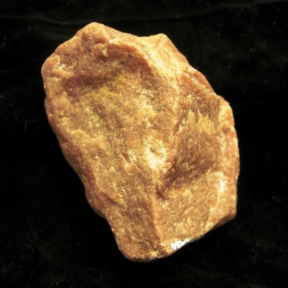
9b.) What is the protolith for this metamorphic rock?
What are some common uses for this type of metamorphic rock?
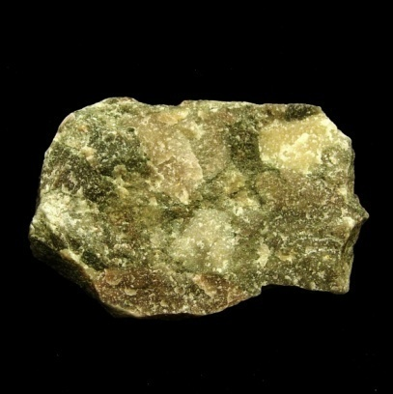
10a.) Would this type of metamorphic rock be good for creating an outdoor sculpture that was meant to stand the test of time? Why?
What would be a likely depositional environment for the protolith of this metamorphic rock?
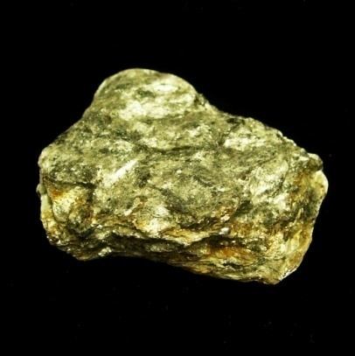
10b.) Did this rock undergo low-grade, medium-grade or high-grade metamorphism?
Was this rock more likely to have been metamorphosed at a convergent or divergent plate boundary?

