SEDIMENTARY ROCK CLASSIFICATION PRACTICE SET
By Jim Buecheler
Geology Program Assistant
NOVA, Annandale
2017.
INTRODUCTION
This sedimentary rock practice set has been assembled for use by student geologists who wish to better familiarize themselves with the classification and interpretation of sedimentary rocks. The ability of a geologist to distinguish and interpret sedimentary rocks is an important skill that may, with a little practice, provide a lot of useful information. A single, sedimentary rock may provide such information as the past environment of deposition, the source of those deposits, the conditions under which they were formed, the geologic history of the region where they are located, and much more!
The following sedimentary rock practice set includes 34 samples of different sedimentary rocks. Use the mineral identification kits provided (orange baskets), laboratory manual (Laboratory Manual in Physical Geology, Busch & Tasa, American Geological Institute), textbook, notes and any other available resources to fill out the attached sedimentary rock identification worksheets. The more you practice with and familiarize yourself with these samples, the easier it will become to identify and interpret sedimentary rocks in both the classroom and in the field.
GUIDELINES FOR ROCK & MINERAL IDENTIFICATION
- Work with only one category of unknown samples at a time (minerals, igneous, sedimentary or metamorphic). Return the complete sample set to the geology cabinet before moving on to another unknown sample set.
- Each basket contains two distinctly different samples for identification/classification. It is suggested that you select one of the two samples from the basket to work with before returning it and working with the second sample.
- Work with only one basket (2 samples) at a time. When finished, return both samples to the basket they came from before moving on to the next one. This will prevent samples from getting mixed up and placed in the wrong numbered baskets and will maintain the integrity of the answer key.
- Use the mineral identification kits (orange baskets) to help you identify minerals and classify the rocks as needed. An optical microscope is also available in the Science Learning Center (SLC) for closer examination. Remember to use caution and good judgment when using the bottles of HCl. Although the acid test is often good fun, try to limit your use of HCl to those samples that you believe have a reasonable chance of fizzing. There is no need to hit every sample with HCl.
- Use your textbook, lab manual, class notes, or other available resources to help you identify minerals and classify the variety of rocks.
- Have fun! Some of the samples found in these sets are intended to challenge you, so don’t be discouraged if you’re stumped…in the field, not every rock or mineral you encounter will be a pristine museum quality sample. Geology is rarely so simple.

Sample | Composition | Texture | Other Properties | Rock Classification
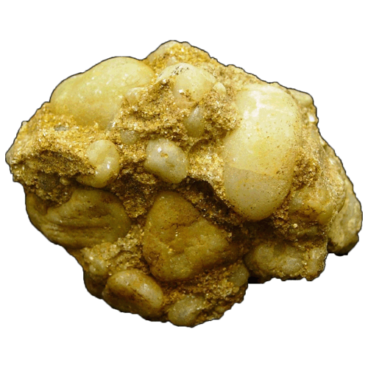
1a.) Was this rock deposited in a turbulent, high-energy environment or a quiet, low-energy environment?
Were the clasts in this rock deposited close to their source area or were they transported away from their source area?
Sample | Composition | Texture | Other Properties | Rock Classification
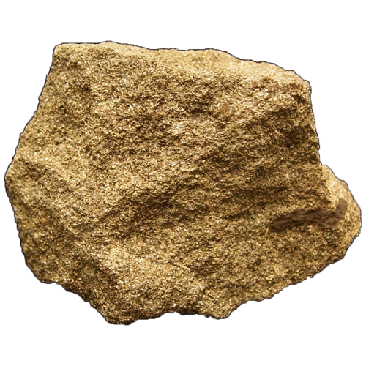
1b.) Is this rock texturally mature or immature?
In what depositional environment would you expect this rock to form (Pick one: beach, floodplain, alluvial fan, swamp, lake or reef)?
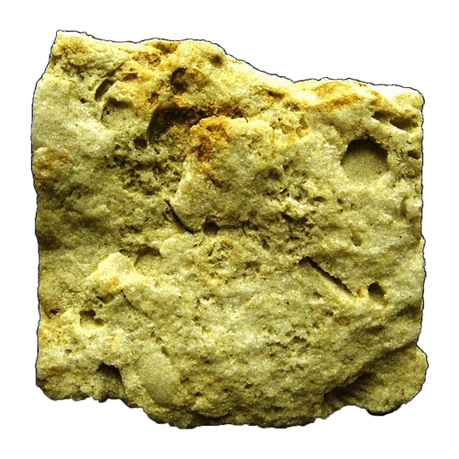
2a.) Were the clasts in this rock deposited close to their source area or were they transported away from their source area?
Is this rock texturally mature or immature?
Sample | Composition | Texture | Other Properties | Rock Classification
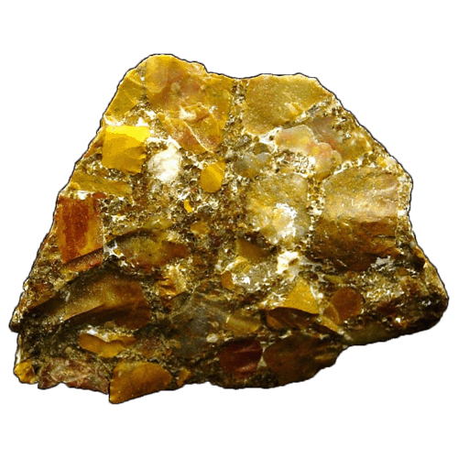
2b.) Were the clasts in this rock deposited close to their source area or were they transported away from their source area?
In what depositional environment would you expect this rock to form (Pick one: beach, alluvial fan, deep sea, swamp, meandering river or reef)?
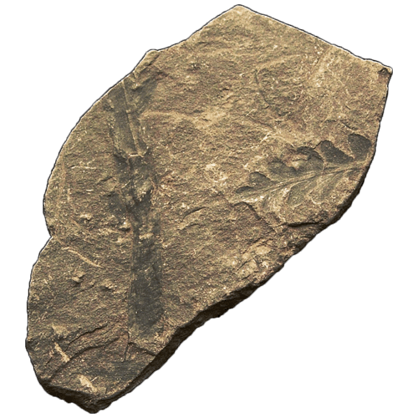
3a.) Was this rock deposited in a turbulent, high-energy environment or a quiet, low-energy environment?
Was this rock deposited in an oxygen-rich or oxygen-poor environment?
Sample | Composition | Texture | Other Properties | Rock Classification
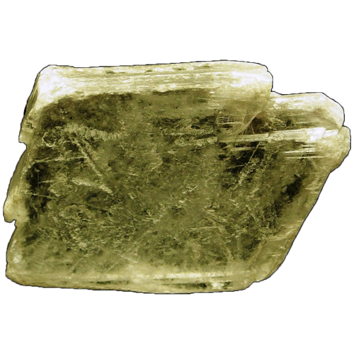
3b.) What is the primary mechanism responsible for this sedimentary deposit?
In what depositional environment would you expect this rock to form (Pick one: beach, swamp, deep sea, playa lake, meandering river or reef)?
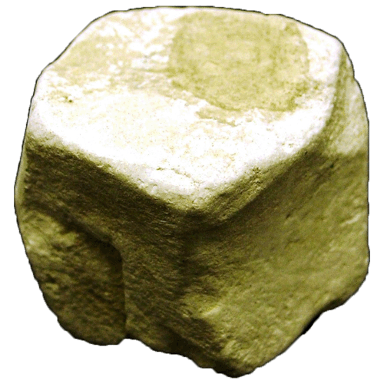
4a.) What is the primary component that composes this soft, porous rock?
In what depositional environment would you expect this rock to form (Pick one: river, floodplain, deep sea, shallow sea, tidal flat or delta)?
Sample | Composition | Texture | Other Properties | Rock Classification
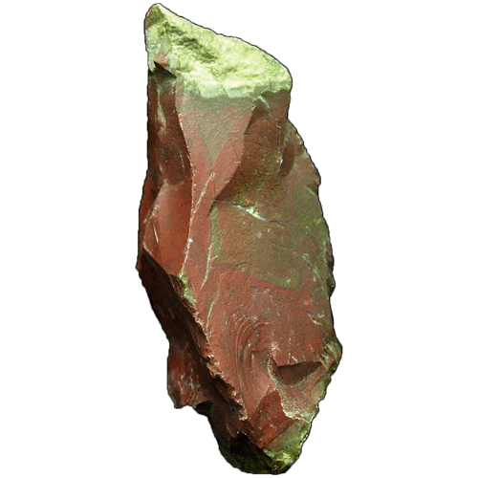
4b.) What is responsible for the red coloration of this rock?
What type of fracture does this rock exhibit?
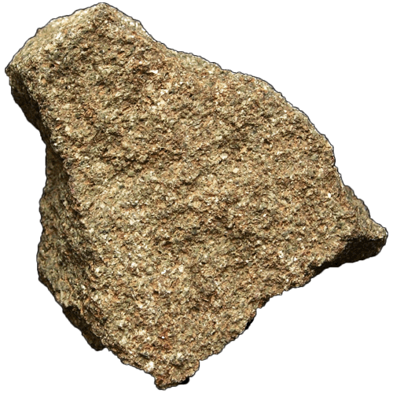
5a.) Is this rock texturally mature or immature?
What dense, sediment-choked torrents are frequently associated with the deposition of this type of rock?
Sample | Composition | Texture | Other Properties | Rock Classification
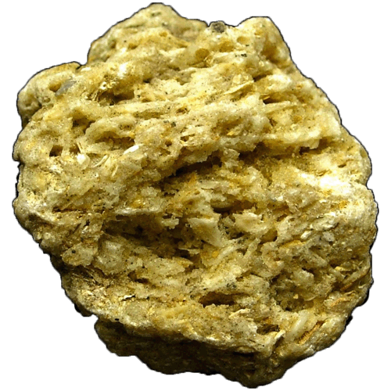
5b.) Was this rock deposited in a turbulent, high-energy environment or a quiet, low-energy environment?
Were the clasts in this rock deposited within their source area or were they transported away from their source area?
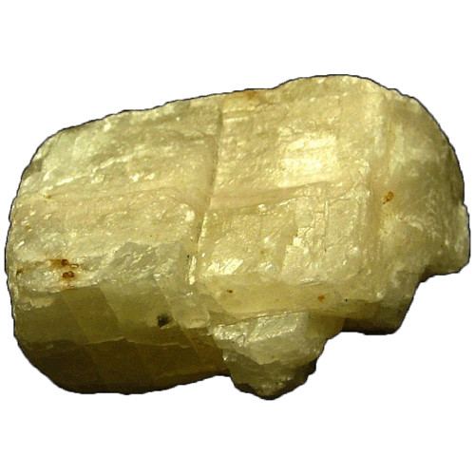
6a.) Would you expect this sample to be primarily organic or inorganic in origin?
In what depositional environment would you expect this rock to form (Pick one: beach, lake, deep sea, swamp, river or reef)?
Sample | Composition | Texture | Other Properties | Rock Classification
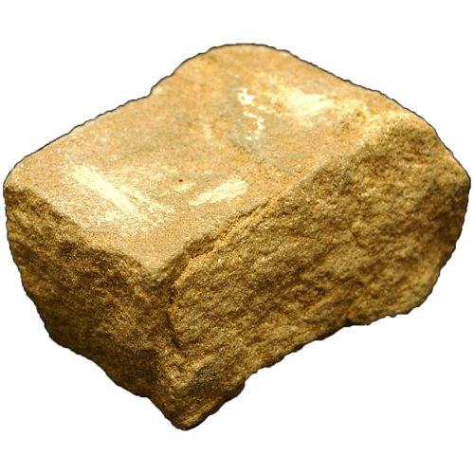
6b.) Was this rock deposited in a turbulent, high-energy environment or a quiet, low-energy environment?
Was this rock deposited in an oxygen-rich or oxygen-poor environment?
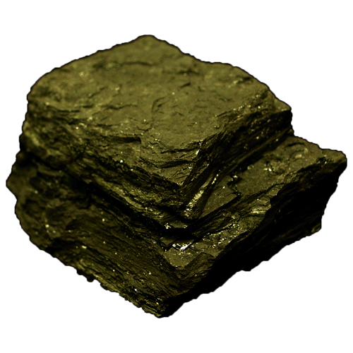
7a.) Name two, soft sedimentary layers that are precursors to the formation of this sedimentary rock?
In what depositional environment would you expect this rock to form (Pick one: beach, floodplain, deep sea, swamp, glacial or reef)?
Sample | Composition | Texture | Other Properties | Rock Classification
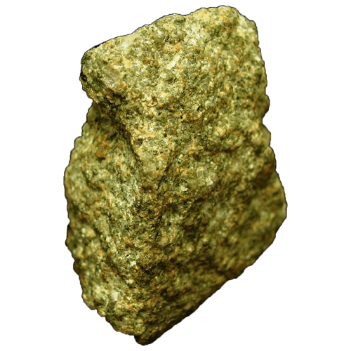
7b.) Were the clasts in this rock deposited relatively close to their source area or were they transported far away from their source area?
In what depositional environment would you expect this rock to form (Pick one: beach, desert, deep sea, lagoon, lake or reef)?
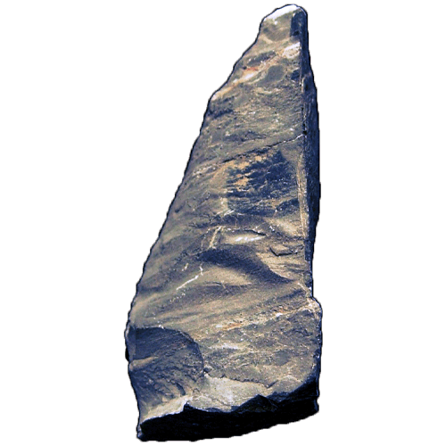
8a.) What are the thin sedimentary layers of strata called that are visible in this rock?
In what depositional environment would you expect this rock to form (Pick one: beach, river, deep sea, swamp, glacial or reef)?
Sample | Composition | Texture | Other Properties | Rock Classification
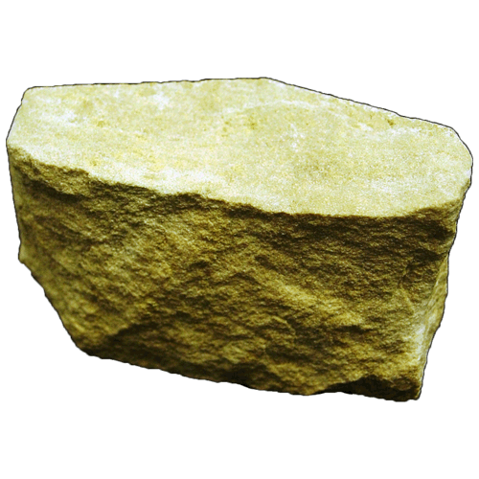
8b.) From what other sedimentary rock does this rock normally originate?
What is the typical age of this type of rock (relatively young or ancient)?
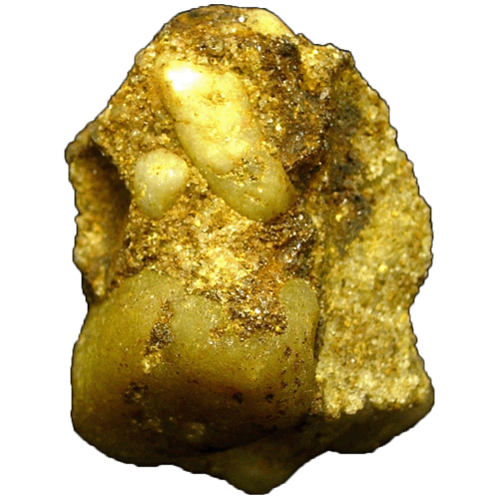
9a.) Is this rock texturally mature or immature?
In what depositional environment would you expect this rock to form (Pick one: beach, alluvial fan, deep sea, playa lake, river or reef)?
Sample | Composition | Texture | Other Properties | Rock Classification
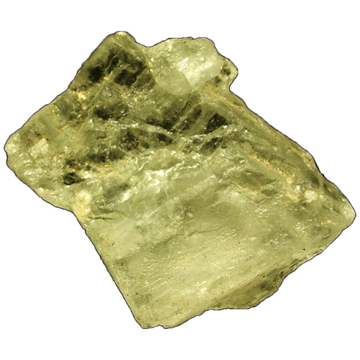
9b.) What is the primary mechanism responsible for this sedimentary deposit?
What are some common uses for this sedimentary deposit?
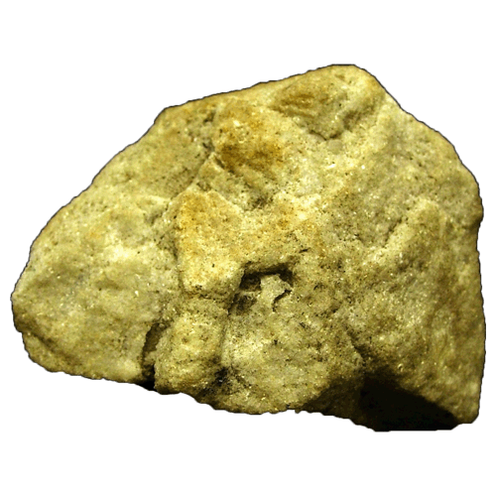
10a.) Is this rock texturally mature or immature?
In what depositional environment would you expect this rock to form (Pick one: beach, mountain stream, deep sea, swamp, desert or carbonate bank)?
Sample | Composition | Texture | Other Properties | Rock Classification
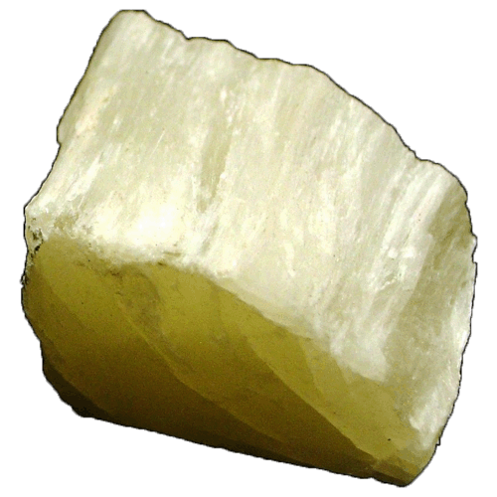
10b.) In what depositional environment would you expect this rock to form (Pick one: beach, playa lake, deep sea, swamp, river or reef)?
What are some common uses for this sedimentary deposit?
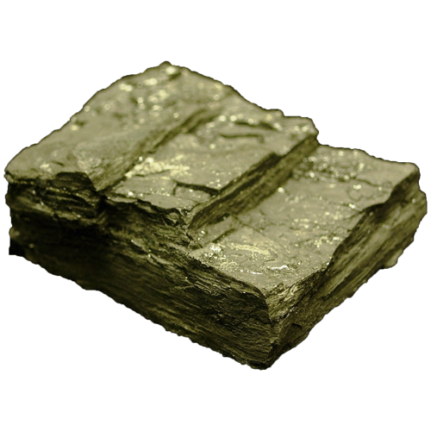
11a.) Was this rock deposited in a turbulent, high-energy environment or a quiet, low-energy environment?
Was this rock deposited in an oxygen-rich or oxygen-poor environment?
Sample | Composition | Texture | Other Properties | Rock Classification
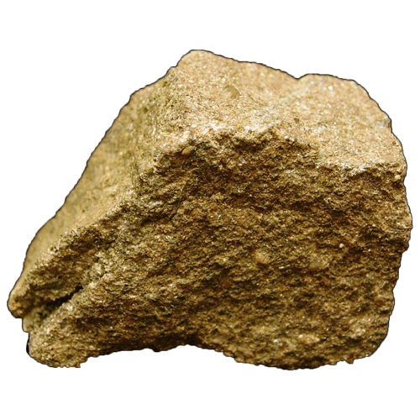
11b.) What mineral is responsible for giving this rock its pink, salmon color?
In what depositional environment would you expect this rock to form (Pick one: beach, meandering river, deep sea, swamp, rift valley or reef)?
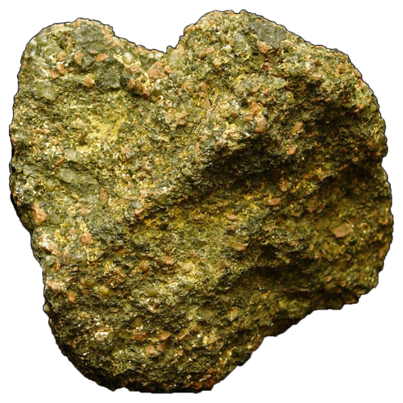
12a.) Is this rock texturally mature or immature?
In what depositional environment would you expect this rock to form (Pick one: beach, deep sea, floodplain, swamp, river or reef)?
Sample | Composition | Texture | Other Properties | Rock Classification
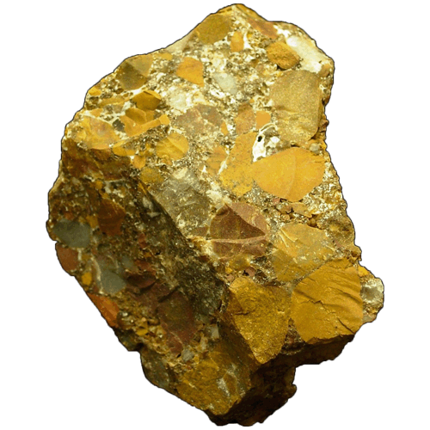
12b.) Were the clasts in this rock deposited close to their source area or were they transported away from their source area?
In what depositional environment would you expect this rock to form (Pick one: beach, meandering river, lake, swamp, reef or alluvial fan)?
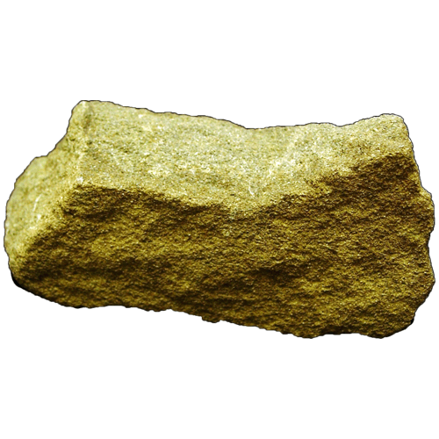
13a.) Were the clasts in this rock deposited relatively close to their source area or were they transported far away from their source area?
In what depositional environment would you expect this rock to form (Pick one: beach, river, swamp, deep sea, lagoon, or reef)?
Sample | Composition | Texture | Other Properties | Rock Classification
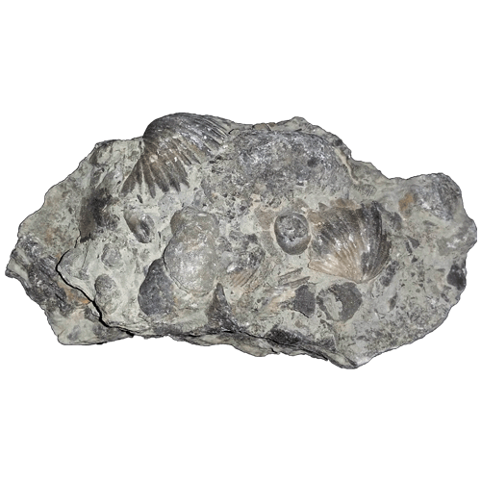
13b.) What general feature included in this rock might play a role in correlating rocks of similar ages from different places?
In what depositional environment would you expect this rock to form (Pick one: beach, river, lake, swamp, reef or floodplain)?
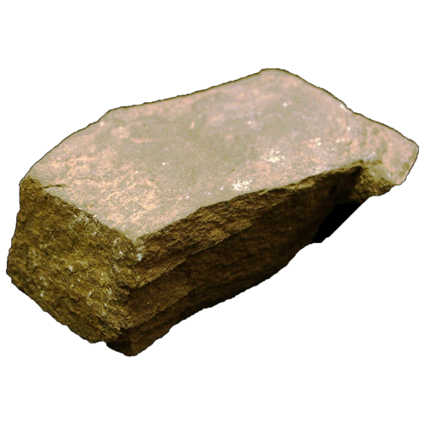
14a.) Is this rock texturally mature or immature?
In what depositional environment would you expect this rock to form (Pick one: beach, river, deep sea, swamp, lake or reef)?
Sample | Composition | Texture | Other Properties | Rock Classification
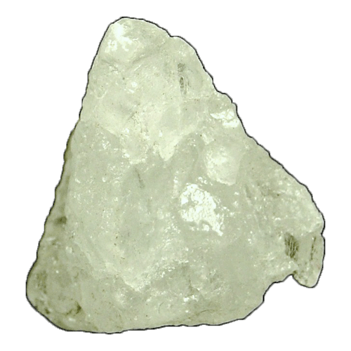
14b.) What is the primary mechanism responsible for this sedimentary deposit?
In what depositional environment would you expect this rock to form (Pick one: desert, beach, deep sea, swamp, playa lake or reef)?
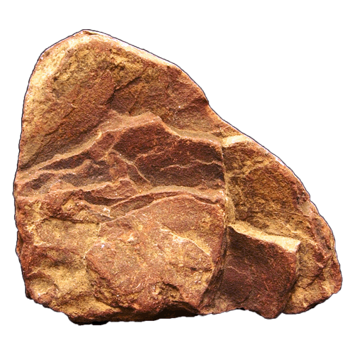
15a.) Would you expect this rock type to form prominent rock outcrops? Why?
In what depositional environment would you expect this rock to form (Pick one: beach, alluvial fan, deep sea, swamp, reef or floodplain)?
Sample | Composition | Texture | Other Properties | Rock Classification
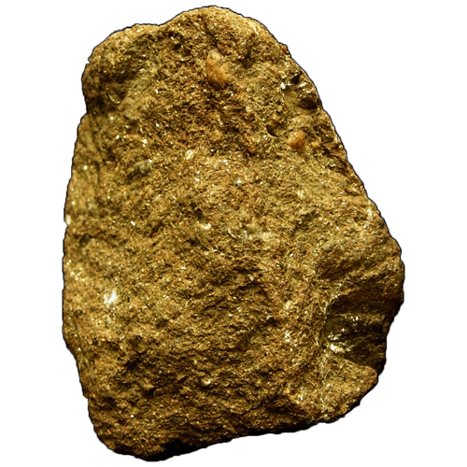
15b.) Would the clasts in this rock be more likely to have been derived from a granitic or gabbroic source rock?
Were the clasts in this rock deposited relatively close to their source area or were they transported away from their source area?
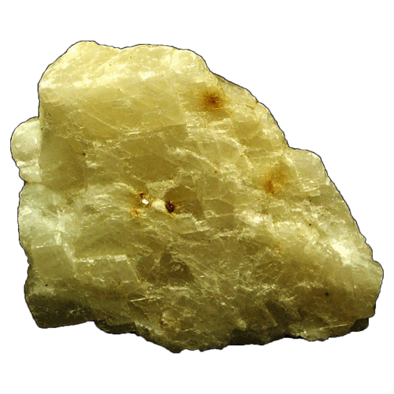
16a.) What similar deposit is also commonly found in caves as a result of water droplets becoming exposed to air within a cavern?
In what depositional environment would you expect this deposit to form (Pick one: beach, swamp, deep sea, reef or river)?
Sample | Composition | Texture | Other Properties | Rock Classification
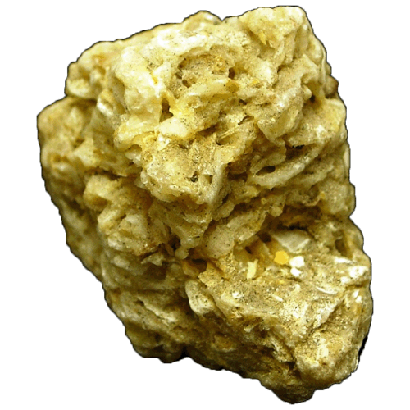
16b.) Is this rock texturally mature or immature?
In what depositional environment would you expect this rock to form (Pick one: beach, tidal flat, reef, deep sea, shallow bay, or delta)?
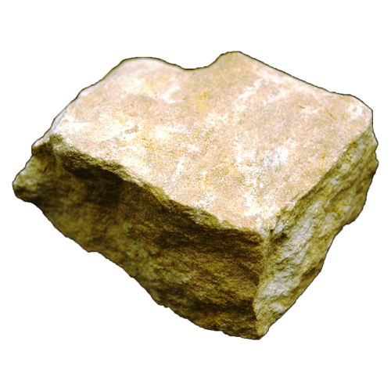
17a.) What cement is primarily responsible for the lithification of this rock (calcite, silica or iron oxide)?
In what depositional environment would you expect this rock to form (Pick one: beach, tidal flat, reef, playa lake, delta, or meandering river)?
Sample | Composition | Texture | Other Properties | Rock Classification
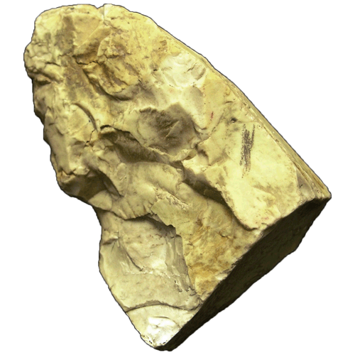
17b.) In what two situations (forms) are these types of deposits commonly found?
What specific water dwelling organisms may be responsible for the origin of this rock?

