
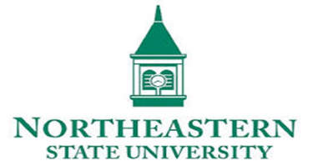

The Transforming the Teaching & Learning Environment virtual conference is sponsored by NOVA Academic Affairs and the office of Faculty Professional Development, and is presented by Northeastern State University. Now in its 13th year, the conference offers the opportunity for NOVA faculty to engage with Higher Ed experts from around the world.
Overview
The conference begins on Monday, February 1st and concludes on Friday, February 12th. Each weekday there will be six one-hour sessions using Zoom as the platform. Each session will be captioned. The conference website has more information about using Zoom.
Schedule
Go to the conference website to see the schedule of sessions.
Joining a session
To join a conference session, go to the schedule page on the conference website. Each session will have a Zoom link associated with it. Just click the Zoom icon. You will be taken to the page below.
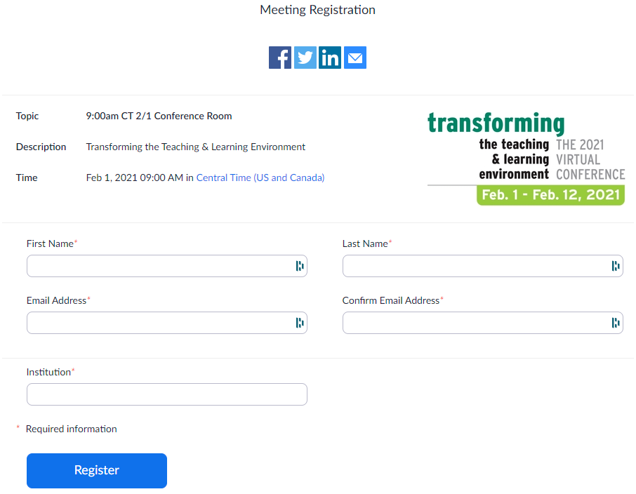
**No additional password or code is needed.

Click Register. You will be taken to the page below. Then, you will be able to add a reminder to your calendar or enter directly into the session.

Recordings
Each session will be recorded and made available within about an hour after the conclusion of each day’s sessions. On the schedule page the link for a session will change from the Zoom icon to “View Recording”. The recordings will be available for at least one month after the conclusion of the conference. Participants will also have access to session recordings from previous conferences.

Regards, Preston
Wm. Preston Davis, Ed.D.
Director of Faculty Professional Development
NOVA | Northern Virginia Community College
