You Will Be Successful!
Enter text here!
MINDSET BLOOM’s | TAXONOMY
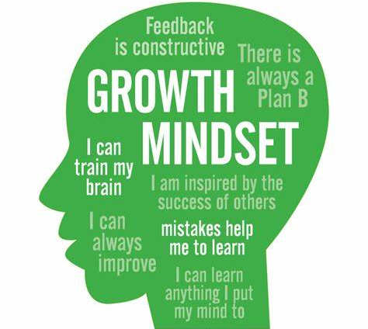 | 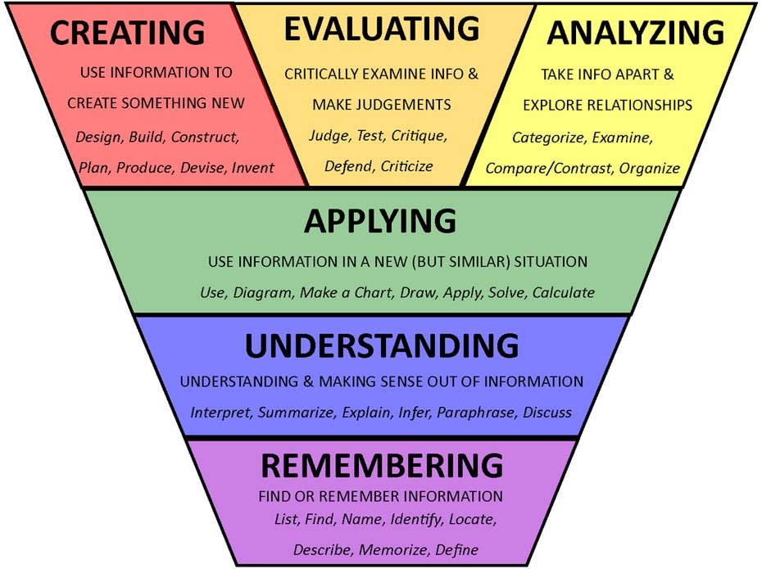
Growth Mindset Adhesive Wall Graphic (sybasigns.com) | Bloom's Taxonomy | Vice Provost (carleton.ca)

ACTIVE LEARNING
“You need to figure out how to study”. This was the overarching advice I constantly heard no matter who I spoke to in the medical field, whether it be current medical students, residents, or experienced attending physicians. I really thought nothing of the matter. ‘I know how to study. How tough can that be to figure out?’ I naively told myself…How To: Superhuman Productivity and Efficiency

What is Active Learning?
Active learning is "a method of learning in which students are actively or experientially involved in the learning process and where there are different levels of active learning, depending on student involvement." Bonwell & Eison (1991) states that "students participate [in active learning] when they are doing something besides passively listening." In a report from the Association for the Study of Higher Education (ASHE), authors discuss a variety of methodologies for promoting active learning. They cite literature that indicates students must do more than just listen in order to learn. They must read, write, discuss, and be engaged in solving problems. This process relates to the three learning domains referred to as knowledge, skills and attitudes (KSA). This taxonomy of learning behaviors can be thought of as "the goals of the learning process." In particular, students must engage in such higher-order thinking tasks as analysis, synthesis, and evaluation. Active learning - Wikipedia

Steps to Active Learning
In and Out
- Capture
- Correct
- Create
- Consolidate
- Connect
In and Out

Getting Started

Take Care of Yourself
Effective, regular studying is obviously key to succeeding in medical school. But don’t forget to take care of yourself. Incorporating regularly timed breaks will keep you from burning out.

Create an effective learning environment
Where you study and what’s around you is just as important as the study methods themselves. You want to make sure you aren’t distracted.
“I found private study cubicles in the library the most helpful since ambient noise was reduced and distractions were minimized,” Dr. Husain offers.
Dr. Reddy did a mix of reviewing material at home and in the library. While both worked, she liked how efficiently she could study in the latter location.
"I think the library’s a good place to go so you’re not distracted by the TV or whatever."
CONSIDER SWITCHING UP YOUR STUDY AND SELF-TEST AREAS
This goes against a lot of advice you may have heard but, according to cognitive research, repeatedly studying in the same place could adversely affect your memory recall. When it’s time to take the exam, the new setting might catch you off guard. Switching up the surroundings you study in will help you remember the material regardless of the environment.

Ask For Help
Many students have a tendency to keep quiet if they’re struggling. But it never works out well to put off seeking help. There’s just too much material to get through.
“You can quickly fall behind,” Dr. Husain warns, “so it is better to ask for help earlier rather than later in the semester.” She adds you can seek assistance from instructors as well as classmates. Physician Tips on How to Study in Medical School | SGU

STUDY EFFECTIVELY AND EFFICIENTLY

A Note on Textbook Readings
Have you felt overwhelmed by the reading assignments? How do you complete your readings? Are the something you feel must be done before you can “start to study”? Reading to learn can look very different from how you read for work or pleasure.
“I used to highlight the textbook and read my highlights several times to review before exams, but that’s a terribly passive way to study. Reviewing your PowerPoint slides or Word documents is equally ineffective. Instead, make it as active as you can, even at the time of initial exposure. Using either your computer or a notepad, summarize what you read into your own words. By doing this, you are identifying the important information and organizing it in a way that you will understand – this will ultimately improve recall come test time.” Study Less, Study Smart | Pre-Med Strategies I Wish I Knew (medschoolinsiders.com)

Try the 3R Method: Read. Recite. Review
- READ a section of the chapter. Then close the book and hide your notes.
- RECITE (speak aloud) everything you can remember about what you've just read. You don’t need fancy equipment. You can recite to yourself, to a friend, to your cat or even to your coffee mug or a plant in your room.
- REVIEW the section by reading it again to correct anything you got wrong, or to revisit important information that you overlooked when you recited.
In one study comparing the effectiveness of various study techniques, students in three groups read long, technical encyclopedia entries (McDaniel, Howard & Einstein, 2009). One group used the 3R technique; a second read the articles twice and did nothing else; a third read the articles once but took notes while reading. A week later, everyone took the same test. The students who had used the 3R technique did much better on the test than students who used the other techniques. What’s more, it took students less time to use the 3R technique than reading and taking notes.
One reason this method works so well is that when you practice the second R, you see immediately what you had trouble understanding, learning and remembering, so you know what to concentrate on when you do the third R: review. The nine secrets of learning (apa.org)

Use the Study Cycle Structure
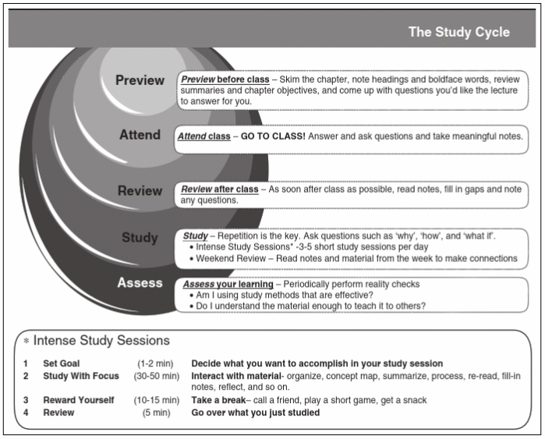

Limit Study Sessions
Cramming is ineffective for two reasons: you’ll eventually lose focus in one long night of studying, and you’ll forget most of the information by the next day. You’ll remember more of the material if you spread your studying out across short, multiple sessions instead of a massive three-hour binge. 7 Study Strategies Every Medical Student Should Use | AUA (auamed.org)

The Pomodoro Technique
The video also goes into the Pomodoro technique. This is a time management method which utilizes a timer to break work down into manageable intervals. These intervals are usually 25 minutes in length and are followed by 5-minute breaks. Keys:
- Stay disciplined and stick to the time constraints.
- Taking breaks that are too long is inefficient but skipping breaks or keeping them too short is also detrimental to endurance.
- Everyone is different: tweak your schedule to find one that works for you.
Lessons in Medical School Study Strategies | Med School Insiders

Act Like a Professor
This may require a second person for best results. Take out your notes or textbook and recite the information to your study buddy. When you read the material out loud, you’ll think about the content more. Answering any questions your “student” will help with critical thinking skills. Bonus: you don’t have to grade your student’s term papers.

Memorization
There are a few different methods you can use to memorize the information much faster.

Review Material Regularly
The need to study regularly is one piece of advice just about every doctor recommends. Dr. Inna Husain, Laryngologist and Assistant Residency Program Director for Simulation Education at Rush University Medical Center, realized early on that her habits from college weren’t robust enough for medical school. “I quickly learned that daily review was necessary to keep up with the volume of information,” Dr. Husain says. Trying to play catch-up or cramming at the last minute simply won’t cut it. Physician Tips on How to Study in Medical School | SGU

Write It Down
There’s no denying the vast amount of reading you have to cover in medical school. While covering the text is essential, you probably shouldn’t expect to remember all of it. For Dr. Reddy, writing things down was a must. “I did a lot of note taking as well,” she reflects, saying it was helpful to jot down anything that stood out. Dr. Reddy also mentions flash cards were really helpful for reviewing material when she had a little bit of downtime. Physician Tips on How to Study in Medical School | SGU

Writing vs. Typing Notes
Each has its pros and cons. Typing is faster, which sounds great initially, but if you type faster you are able to transcribe what the professor is saying verbatim. This is not good – it’s PASSIVE. By writing, you generally write slower and therefore have to emphasize the important information and rephrase and organize it in your own words. Writing, in comparison to typing, has also been demonstrated to improve recall, possibly due to the increased motor coordination. When I was in med school, styluses were lacking, and I opted for typing in some classes, and writing on paper for others, particularly for my summary sheets, which we will get to later. Now with the Surface Pro and iPad Pro with Apple Pencil, you can get the best of both worlds. Pros and Cons of Typed, Digitally Handwritten, and Paper Notes | GUTS Tip – Greater University Tutoring Service – UW–Madison (wisc.edu)

Summary Sheets (Condensed/Consolidated Notes)
One of the best ways to memorize is to summarize the information. Let’s say you have three pages of notes. Condense them into one page by organizing and restructuring the information in smaller chunks. And don’t just decrease the font size or adjust the margins. Actually read through your notes carefully and extract the highest yield points and rephrase them again in your own words. This process alone is active learning, and it will reinforce that material and provide you with a condensed study resource to review at a later date.
Additionally, distilling your previously taken notes can help improve your analytical skills. To start, figure out which concepts can be chunked together, and how to express them in the fewest words possible. Pulling all the information together in one place will help you better grasp of the material and understand how it all fits together. Just be careful: some subjects may be more complex and may not fit neatly into one page. Study Less, Study Smart | Pre-Med Strategies I Wish I Knew (medschoolinsiders.com)

Self-test after Studying with Spaced Repetition
One of the most powerful ways to memorize information is spaced repetition.
We know that repetition is key to memorization. The idea here is that after each review, you can increase the interval between reviews. For example, you learn information on day zero, then see it again after 24 hours, then see it after 72 hours.
Instead of reviewing it every day, you only review it right when you’re about to forget.
Using spaced repetition software such as Anki. Make your own flashcards within Anki and review them daily. By making your own cards (versus taking someone else’s), you’re again taking advantage of the active learning process. Reviewing your cards daily is also key, because otherwise you won’t be taking advantage of the space repetition.
The beautiful thing about flashcards is you don’t have to sit down and spend 30 or 60 minutes at once. To get through all my cards each day, I would open the Anki app on my phone at any brief moment of downtime. I would go through cards when I was waiting in line at a restaurant, or getting groceries, or waiting for a friend. In those few minutes of downtime, I was able to perform a handful of cards, but this adds up.
The idea behind this technique is to self-test after studying, wait a few weeks to a month and then retest yourself. Study Less, Study Smart | Pre-Med Strategies I Wish I Knew (medschoolinsiders.com)

Interleaving
Another concept, called interleaving, involves switching topics frequently while you're studying. For example, if you need to study anatomy and chemistry to prepare for an exam, switch between the two topics rather than studying anatomy first and then chemistry.
The trick, though, is to try to make connections between the topics while you're studying them. For instance, if you are studying pharmacology, you may then switch and study physiology. Try and recall the physiological mechanisms that create the drug positive actions and the mechanisms that create side effects. While this technique might feel counterintuitive, interleaving requires you to recall information more frequently, which helps to cement the information.
Using this technique may be harder and slower at the onset, compared to spaced repetition, for example, but the information is better understood in the long run, according to some reports. 9 Essential Tips For Medical Students - Careerguide

Improve Memorization with Mnemonics
Many people have relied on mnemonics, memory tools that help you recall information, at one point or another. For example, elementary students rely on the acronym mnemonic “Roy G. Biv” to remember the order of colors in a rainbow. Research suggests mnemonics can aid in learning large amounts of information, particularly when combined with other strategies.
Both Drs. Husain and Reddy relied on mnemonics to recall crucial information. “Especially when you’re trying to remember all the nerves and things like that, it’s really a good way to keep them straight,” Dr. Reddy offers. 9 Essential Tips For Medical Students - Careerguide

Additional Active Learning Strategies by Learning Style

Consider Forming a Study Group
For those who do learn well when collaborating with others, study groups are a must. Collaborative study groups can be particularly beneficial for the following reasons:
- Provide opportunities to discuss and clarify complex concepts
- Help to ensure participant focus and commitment to studying and time management
- Opportunity to share alternative ways to organize and map information
- Opportunity for members to teach the material to the group, and to also check their comprehension of the concepts
When considering creating a study group, consider the following recommendations and best practices:
- Keep study groups to a maximum of four students.
- Form a group with students who have similar goals.
- Complete a group charter to establish boundaries and leverage member strengths.
  - Record members’ group study session expectations
  - Commit to attending future sessions
  - Establish how you will meet, when you will meet, for how long you will study, and how often you will meet
  - Discuss how you will goal set for each study session as well as the activities the group will complete together
  - Record group members’ strengths to leverage during learning
- Avoid studying with your regular social group.

Create Visuals
If you’re a visual learner, take advantage of opportunities to use imagery. You don’t have to be an artist to sketch out something that could be useful. It’s more about presenting the material in a way that makes sense to you, “Diagrams were helpful for organ systems, such as renal, or reviewing drug metabolism,” Dr. Husain says. “Creating the diagram also reinforced the information.”
DRAW A MAP
If you’re a visual learner, consider becoming a knowledge cartographer. Instead of rereading a textbook, take out a big sheet of paper (or several taped together) and plot each element of information as it relates to the rest of it. For example, if you’re studying Pathology, you might write down all the possible symptoms, visually marking which clusters of symptoms indicate which disease. When you step back, you’ll be able to physically see how the information relates. By the end of the map, you might discover the buried treasure: a passing score on your exam.

Incorporate Auditory Methods
Some individuals find they’re able to recall information better if they hear it. Goljan Audio is an incredibly popular lecture series many medical students swear by. Dr. Reddy is among those who found it useful, “I would listen to those if I was working out or if I was in the car,” she says. “It’s a different way to get the information.”

